Writing a good letter of application
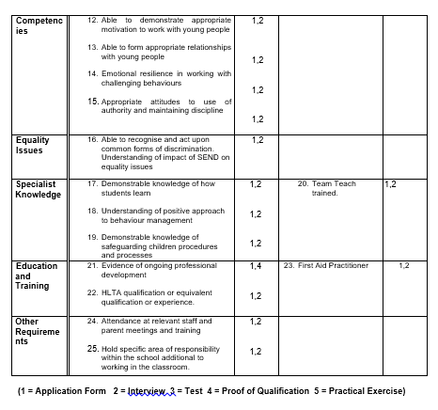
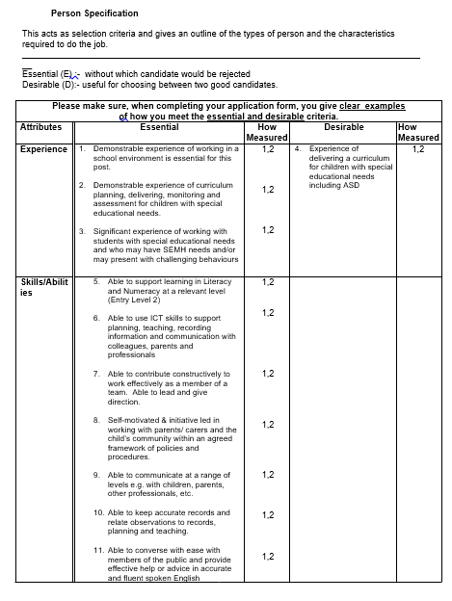

Person specification example

When applying for a job in a school it is really important that you read the Job Description and the Person Specification document. Most adverts will request a letter of application which relates to the Person Specification. In a letter of application you have the opportunity to explain how you have the relevant experience, skills, knowledge, qualifications and competencies in order to get you to the next stage in the application process.
In the letter of application you need to address every point in the Person Specification. When shortlisting who to take to interview, the short listing panel will be looking for the evidence that you have addressed each of these points.
There is no fixed way to write a letter of application, but you need to make it as easy as possible for those who are shortlisting the applications to be able to find the evidence against each criteria in the Person Specification.
Some adverts have pre-set questions in the application form, to ensure you provide the relevant information. Some require you to write a separate letter of application. We recommend that you address each point in the person specification one at a time. We are happy if you do this in a numbered list.
Remember to write about your experience, knowledge, etc. and also to note the impact of this on your practice.
For example, for a job in a school there will always be something in the Person Specification about safeguarding.
In the sample Person Specification above, it states the following as essential criteria:
19. Demonstrable knowledge of safeguarding children procedures and processes
A good example answer may include some of the following:
19. I understand that safeguarding means …………. Safeguarding is everyone’s responsibility. I undertake regular safeguarding training and I am familiar with the requirements in the Keeping Children Safe in Education 2023, including the changes in …..,. I know and follow school procedures for reporting concerns to ….. and following this up by reporting it on……. I regularly add entries to CPOMs and have had some face to face conversations about concerns as well. I know that we have to assume it could happen here and therefore I …..
The answer is not complete - this is on purpose so that if you apply, you can personalise the answer.
Other hints and tips:
- Draft your letter of application in Word – use the spelling and punctuation check (UK English not US English).
- Read over your letter to make sure it makes sense.
- Ask a friend or colleague to read over it as well.

