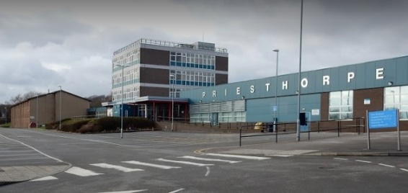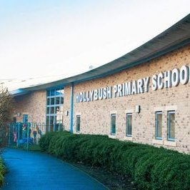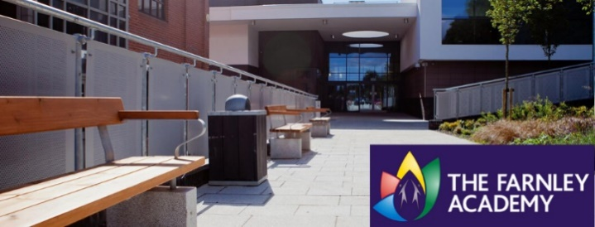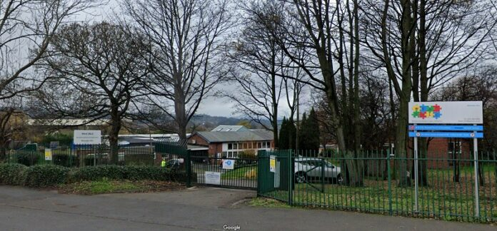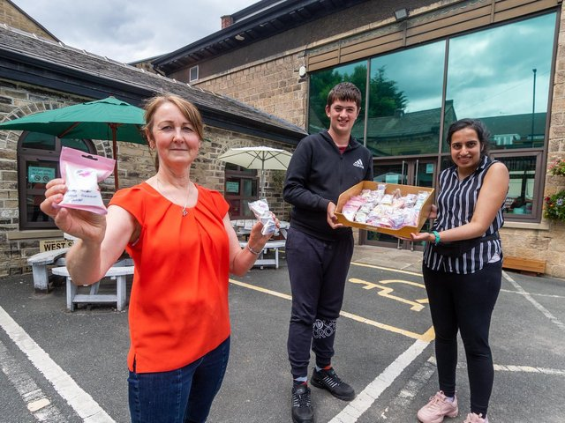

**Primary Partnership based at Hollybush Primary School, Bramley**

**Approx. 12 pupils**

**Personalised inclusion**

**Post 16 – MLD/SLD - The Powerhouse, Springfield Mills, Farsley including Studio and Hub as well as The Foundry at Sunnybank Mills, Farsley**

**Approx. 50 pupils**

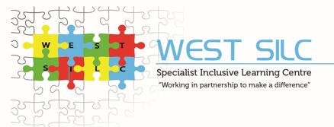

**Secondary Partnership based at Priesthorpe Coop Academy**

**Approx. 30 pupils**

**High levels of inclusion**

**All aged Partnership based at**

**The Farnley Academy**

**Approx. 40 pupils**

**Complex and Multiple Learning Needs (CMLN/PMLD) – complex physical and medical needs**

**Milestone site**

**Approx. 130 pupils**

**CCA—Complex Communication and Autism**

**Semi-formal**

**SEMH—Social Emotional and Mental Health**

**West 11 - 12 students at risk of permanent exclusion from West High Schools - key stage 3**

**West 14 - Up to 30 students at risk of permanent exclusion from West High Schools - key stage 4**