The St. Bart’s Academy Trust  Job Description | 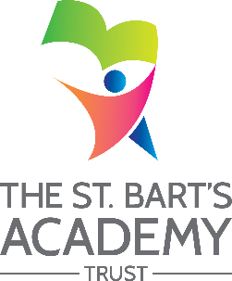

Job Title: | Travel Trainer
Grade: | Level 3

Job Purpose
Job Purpose:
To promote and support pupils and students with all aspects of Independent Travel, Personal Safety and Self Preservation Skills.

Key Responsibilities:
• Organise and plan travel timetables and journeys for individual pupils and small groups of pupils.
• Support pupils towards acquiring the skills required for independent travel.
• Complete Risk Assessments using the Evolve Risk Assessment programme
• Keep accurate records
• Complete and update travel logs.
• Provide an annual report of achievement for pupils

Person Specification:

• A good standard of education including GCSE Maths and English Level C or above
• Excellent communication skills both written and verbal
• The ability to establish good relationships with pupils and parents/carers
• The ability to deal with difficult and sensitive situations showing empathy and understanding
• The ability to form good relationships with both pupils and parents/carers.
• The ability to reassure and encourage confidence in both pupils and parents/carers
• Approachable disposition
• Enthusiastic with a good sense of humour, listening skills and lots of patience.
• The ability to work on own initiative

The St. Bart’s Academy Trust

Person Specification

Job Title: | Travel Trainer
Grade: | Level 3

Person Specification
Minimum Essential Requirements - Evidenced by: a: application form b: test c: interview
 | a | b | c
Working at NVQ level 2 in supporting teaching and learning or equivalent; may be working towards NVQ level 3 and/or national occupational standards.
Knowledge and compliance with policies and procedures relevant to child protection and health and safety.
An ability to fulfil all spoken aspects of the role with confidence through the medium of English

