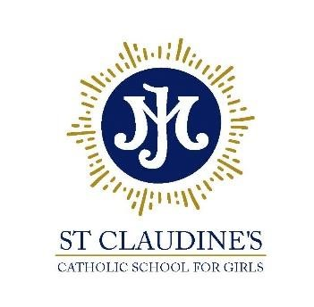
Diocese of Westminster

St Claudine’s Catholic School for Girls
Crownhill Road, London NW10 4EP
Tel: 020 8965 2986 | email: office@stclaudines.co.uk
Headteacher: Dr L McGowan, BMus (Hons) MA EdD NPQH FRSA

Championing excellence and equality in all-girls’ education

Teacher of English

M or U Scale, Full-time Permanent Contract

Required for: September 2024
Closing date: Friday 12th July 2024
Interviews: w/c 15th July 2024

*******

St Claudine’s Catholic School for Girls is a highly-successful Catholic girls’ comprehensive school (ages 11-19), where behaviour is outstanding and students are educated via a rich and diverse, holistic curriculum to become confident, articulate and independent young women.

Learning at St Claudine’s is rooted in the Gospel values in a warm, supportive and nurturing community. Even though we are a Catholic School, it is not a requirement to be Catholic and our international community welcomes staff and students of all faiths and none.

We require a qualified, skilled and enthusiastic teacher of English to join our happy and thriving school. Applicants must be able to demonstrate their high expectations and ambition for students' achievement and appreciate the joy of working in a school that celebrates an international, multi-cultural and multi-faith community where many languages are spoken. Our students are keen to learn and they appreciate and value their education in English Language and Literature. English is a very popular subject; English Language is taught to GCSE and Literature is taught up to A level.

This post is suitable for Early Career teachers as well as teachers that are more experienced

Further details of this post are available on our school website: http://www.stclaudines.co.uk/joiningus/vacancies/

St Claudine’s is committed to the safeguarding of young people and all staff are required to undergo a full Disclosure and Barring Service (DBS) check.

