 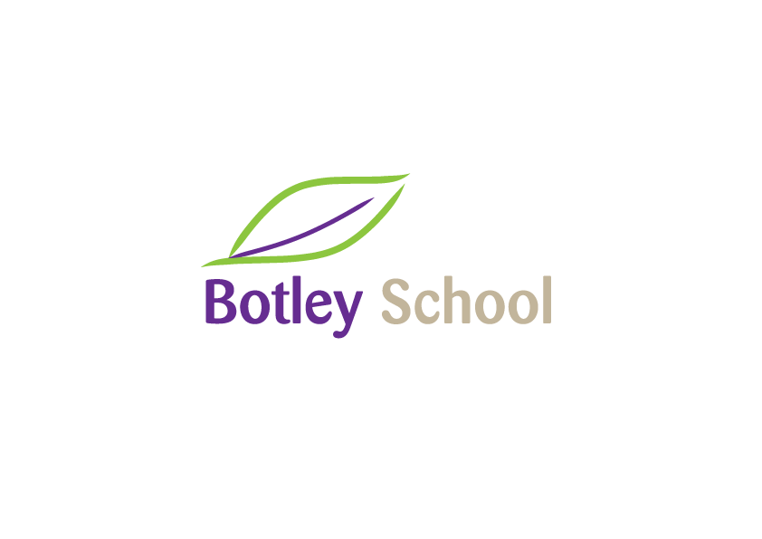

**Vacancy for Teaching Assistant at Botley School**

**To start work as soon as possible**

**Grade 4 (£12.65 to £12.85)**

**Temporary until 31st August 2025; term-time only**

Botley School is looking for additional Teaching Assistants to join our team and work with children to support their learning. The role may include working 1-1 supporting special needs in school as well as general classroom teaching assistant duties. Qualities we are looking for are patience, a friendly and outgoing disposition, and good organisational and communication skills. This would suit a person who has a genuine interest in the education of children and a passion for making a difference.

The role is 15 hours per week, Monday to Friday, 8:30am – 11:30m

**All candidates must be literate and numerate with a minimum of GCSE grade C (4), or equivalent, in English and Mathematics.**

Botley School is committed to safeguarding and promoting the welfare of children and young people, and expects all staff and volunteers to share this commitment. A full DBS check is required for this post prior to starting.

For the job description and person specification, see www.botleyschool.org.uk. Applications must be submitted on the Acer Trust support staff application form which is available from our website. Applications should be sent to office.2569@botley.oxon.sch.uk with the subject ‘FAO TA Recruitment Panel’.

**Closing date: Friday 10th January 2024**

**Interview date: Week commencing 13 January 2025**

We look forward to hearing from you.