



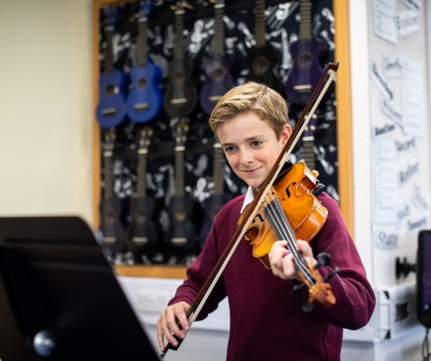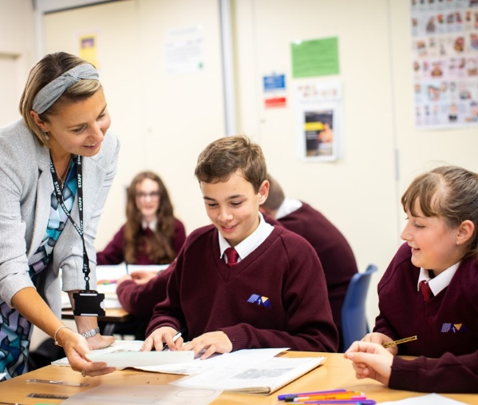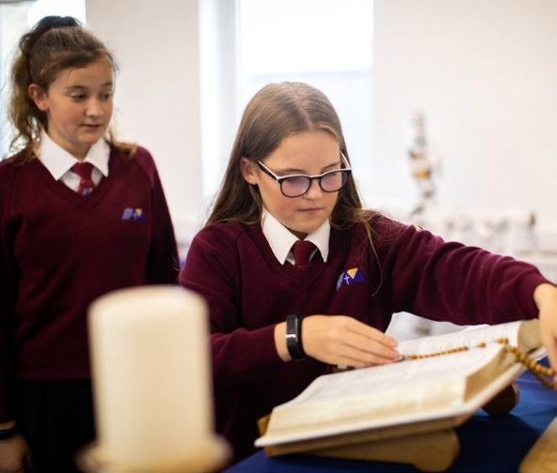

**Teaching Assistant (TA)**

Start Date: February 2025

Line-manager: SENDCo &Deputy Headteacher

Welcome

**The St Thomas More Mission:**

**We the St Thomas More family,** ‘aspire not to have more but be more’.

We aspire not to have the world but be more for the world.

**#BeMore**

am delighted to welcome you to St Thomas More Catholic Voluntary Academy.

I

We think that STM is a special place where every child is seen as an individual, and where nurturing the gifts and talents of our children is central to our mission. Our motto of ‘aspire not to have more but to be more’ summarises our ambition for our young people to #BeMore.

We achieve this by offering the highest quality of education possible, which includes a broad range of experiences aimed at developing the whole child and enabling all to grow in their faith in a safe and happy environment.

Our academic achievements and the standards of our pastoral care are excellent. We are very proud of the academic progress our students make and we are also very proud of the personal growth that they achieve during their time at St Thomas More.

If you choose to join the St Thomas More family, you will be joining a school which strives for excellence through our strong Catholic faith, our commitment to high standards of achievement, our high expectations of behaviour and respect for all, and a belief in developing a love of learning and healthy living.

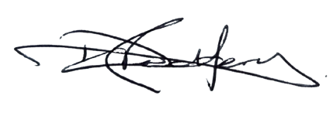

Mr D Redfern Headteacher

# About this post

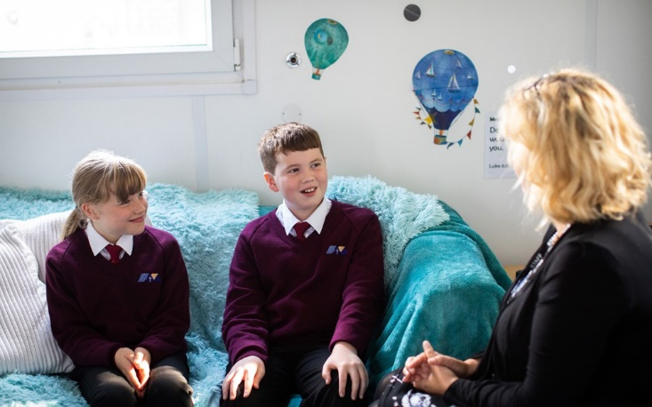

**The Role**

# The Post

We are looking to appoint a Teaching Assistant to work in the classroom with the teacher, to support pupils within the SEND department, to ensure that every child succeeds. Successful candidates will need to have expectations of all pupils’ attainment and behaviour, be enthusiastic about pupils’ learning, and be determined to get the best out of each pupil.

## We are looking for an enthusiastic, determined and committed Teaching Assistant to be part of our SEND Department from February 2025 at

## St Thomas More Catholic Voluntary Academy.

## This is an exciting time to join our SEND Department as we expand our team to support those pupils most in need.

**#BeMore**

*‘Aspire not to have more but to be more’*

Saint Oscar Romero

**St Ralph Sherwin Catholic Multi-Academy Trust**

**Job Description**

**Teaching Assistant (TA)**

St Thomas More Catholic Voluntary Academy is committed to creating a diverse workforce. We’ll consider all qualified applicants for employment without regard to sex, race, religion, belief, sexual orientation, gender reassignment, pregnancy, maternity, age, disability, marriage or civil partnership.

**Reporting to:** Deputy Headteacher and SENDCo

**Responsible for:** Pupils with SEND needs

**Liaising with:** Staff, HTLAs and Parents

**Grade/Salary:** 09-14

**Contract Type:** Fixed Term (Term Time Only)

**Hours:** 27.5 hours per week

**Location:** St Thomas More Catholic Voluntary Academy

**Person Specification**

|  |  |  |  |  |
| --- | --- | --- | --- | --- |
| Key: I = Interview A = Application Form | | **Essential** | **Desirable** | **How evidenced?** |
| **Qualifications and Experience** | Level 2 or 3 Certificate in Supporting Teaching and Learning in Schools, Level 3 Diploma in Childcare and Education, or other relevant qualification in primary work or childcare (or willingness to work towards a qualification if not already held) | ü |  | A |
| GCSEs or equivalent at grades 9 to 4 (A* to C) in English and maths | ü |  | A |
| Experience of working with children, primarily those of secondary age | ü |  | A |
| For TAs with a specialism in supporting pupils with SEND:   * Communication and interaction needs * Cognition and learning difficulties * Social, emotional and mental health difficulties * Sensory and/or communication needs |  | ü |  |
| **Skills and Knowledge** | Good literacy and numeracy skills | ü |  | A & I |
| Good organisational skills |  | ü | I |
| Ability to build effective working relationships with pupils and adults | ü |  | I |
| Skills and expertise in understanding the needs of all pupils |  | ü | I |
| Knowledge of how to help adapt and deliver support to meet individual needs |  | ü | I |
| Excellent verbal communication skills | ü |  | I |
| Subject and curriculum knowledge relevant to the role and ability to apply this effectively in supporting teachers and pupils |  | ü | I |
| Active listening skills | ü |  | I |
| Knowledge of guidance and requirements around safeguarding children | ü |  | I |
| Good ICT skills, particularly using ICT to support learning |  | ü | I |
| Understanding of roles and responsibilities within the classroom and wider school context |  | ü | I |
|  |  |  |  |
| **Personal Qualities** | Enjoyment of working with children | ü |  | I |
| Sensitivity and understanding, to help build good relationships with pupils | ü |  | I |
| A commitment to getting the best outcomes for pupils and promoting the Catholic ethos and values of the school | ü |  | I |
| A good sense of humour | ü |  | I |
| Commitment to maintaining confidentiality at all times | ü |  | I |
| Commitment to safeguarding and equality | ü |  | I |

**Job Description**

**Main purpose**

The Teaching Assistant will:

* Work with class teachers to raise the learning and attainment of pupils
* Promote pupils’ independence, self-esteem and social inclusion
* Give support to pupils, individually or in groups, so they can access the curriculum, take part in learning and experience a sense of achievement

**Duties and responsibilities**

**Supporting pupils**

* Build positive relationships with pupils, promoting high self-esteem and independence
* Adapt communication style to respond to pupils according to their individual needs
* Support pupils with their social, emotional and mental health needs, escalating concerns where appropriate
* Promote high standards of behaviour, responding to incidents in line with the school’s behaviour policy and guidelines on physical intervention
* Assist with the development and delivery of individual education and support plans (as appropriate)

**Teaching and learning**

* Demonstrate an informed and efficient approach to teaching and learning by adopting relevant strategies to support the work of the teacher and increase achievement of all pupils including, where appropriate, those with special educational needs and disabilities (SEND)
* Support the teaching of a broad and balanced curriculum aimed at pupils achieving their full potential in all areas of learning
* Promote, support and facilitate inclusion by encouraging participation of all pupils in learning and extracurricular activities
* Use effective behaviour management strategies consistently in line with the school’s policy and procedures
* Support class teachers with maintaining good order and discipline among pupils, managing behaviour effectively to ensure a good and safe learning environment
* Organise and manage teaching space and resources to help maintain a stimulating and safe learning environment
* Through observations, provide regular feedback to teachers on pupil progress, attainment and barriers to learning
* Supervise a class if the teacher is temporarily unavailable
* Use ICT skills to advance pupils’ learning
* Undertake any other relevant duties given by the class teacher

For TAs with a specialism in supporting pupils with SEND:

* Contribute to the planning of differentiated learning activities for individual or small groups of pupils with special educational needs (SEN), delivering activities inside or outside the classroom

**Planning & Assessment**

* Contribute to effective assessment and planning by supporting the monitoring, recording and reporting of pupil performance and progress as appropriate to the level of the role
* Read and understand lesson plans shared prior to lessons, if available
* Prepare the classroom for lessons

**Working with colleagues and other relevant professionals**

* Communicate effectively with other staff members and pupils, and with parents and carers under the direction of the class teacher
* Communicate their knowledge and understanding of pupils to other school staff and education, health and social care professionals, so that informed decision making can take place on intervention and provision
* With the class teacher, keep other professionals accurately informed of performance and progress or concerns they may have about the pupils they work with
* Collaborate and work with colleagues and other relevant professionals within and beyond the school
* Develop effective professional relationships with colleagues

**Whole-school organisation, strategy and development**

* Contribute to the development, implementation and evaluation of the school’s policies, practices and procedures, so as to support the school’s values and vision
* Make a positive contribution to the wider life and ethos of the school

**Health and safety and Safeguarding**

* Promote the safety and wellbeing of pupils, and help to safeguard pupils’ well-being by following the requirements of Keeping Children Safe in Education and our school’s child protection policy
* Look after children who are upset or have had accidents

**Professional development**

* Help keep their own knowledge and understanding relevant and up-to-date by reflecting on their own practice, liaising with Academy leaders, and identifying relevant professional development to improve personal effectiveness including research
* Take opportunities to build the appropriate skills, qualifications, and/or experience needed for the role, with support from the Academy and Trust
* Participate fully in the academy’s appraisal procedures

**Personal and professional conduct**

* Uphold public trust in the education profession and maintain high standards of ethics and behaviour, within and outside our academy
* Have proper and professional regard for the ethos, policies and practices of the academy, and maintain high standards of attendance and punctuality
* Demonstrate positive attitudes, values and behaviours to develop and sustain effective relationships with the school community
* Respect individual differences and cultural diversity

**Other areas of responsibility**

Desire to run extra curriculum / take responsibility for in school clubs and/or groups

The Teaching Assistant will be required to safeguard and promote the welfare of children and young people, and follow academy policies and the staff code of conduct.

Please note that this is illustrative of the general nature and level of responsibility of the role. It is not a comprehensive list of all tasks that the postholder will carry out. The postholder may be required to do other duties appropriate to the level of the role, as directed by the headteacher or line manager.

Any other duties which may arise during the course of work and are authorised by the Headteacher or member of the Senior Leadership Team. Such duties will be commensurate with the general level of this post and will be subject to the skills and abilities of the post holder.

**Headteacher/line manager’s signature:** _______________________________________

**Date:** _______________________________________

**Postholder’s signature:** _______________________________________

**Date:**  _______________________________________



*‘Aspire not to have more but to be more’*

Saint Oscar Romero

St Thomas More Catholic Voluntary Academy, Palace Fields,

Buxton, Derbyshire,

## SK17 6AF

[enquiries@stm.srscmat.co.uk](mailto:enquiries@stm.srscmat.co.uk)



01298 23167 scan the QR code to visit our website