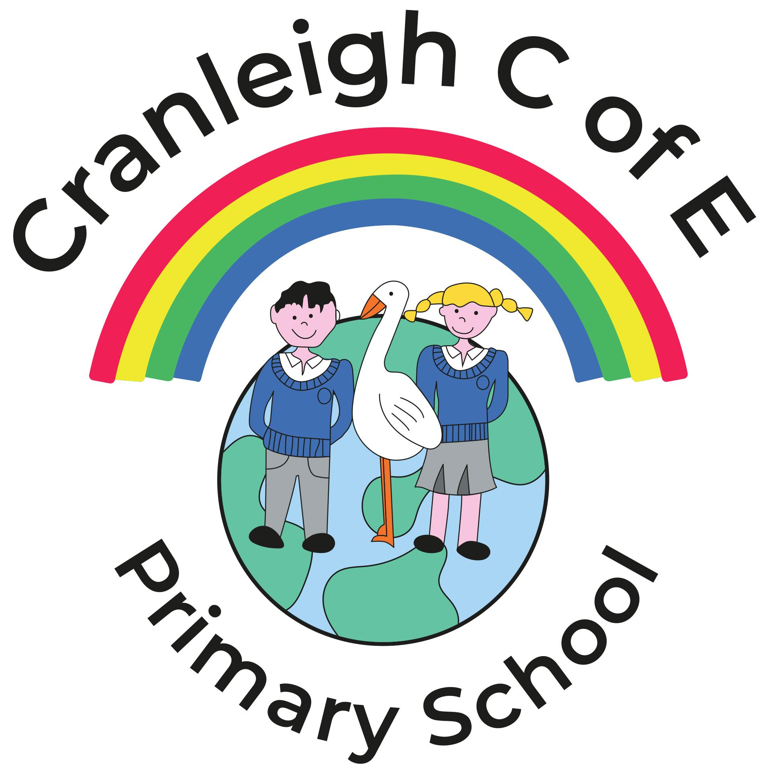
Cranleigh C of E Primary School
Job Description: Teaching Assistant

Cranleigh C of E Primary School is committed to creating a diverse workforce. We will consider all qualified applicants for employment without regard to sex, race, religion, belief, sexual orientation, gender reassignment, pregnancy, maternity, age, disability, marriage or civil partnership.
Job details
Job title: Teaching Assistant (TA)
Salary: £22,559 FTE (GST B1) Actual £17,294 p.a
Hours: 32.5 hours per week for 38.6 weeks p.a (to be agreed with the Headteacher). This will involve assisting with wrap-around care 2 days per week
Contract type: Full-time
Reporting to: Class Teacher

Main purpose
The TA will:
- Work with class teachers to raise the learning and attainment of pupils
- Promote pupils’ independence, self-esteem and social inclusion
- Give support to pupils, individually or in groups, so they can access the curriculum, take part in learning, and experience a sense of achievement

Duties and responsibilities
Teaching and learning
- Demonstrate an informed and efficient approach to teaching and learning by adopting relevant strategies to support the work of the teacher and increase achievement of all pupils including, where appropriate, those with special educational needs and disabilities (SEND)
- Promote, support and facilitate inclusion by encouraging participation of all pupils in learning and extracurricular activities
- Support the teaching of a broad and balanced curriculum aimed at pupils achieving their full potential in all areas of learning
- Use effective behaviour management strategies consistently in line with the school’s policy and procedures
- Support class teachers with maintaining good order and discipline among pupils, managing behaviour effectively to ensure a good and safe learning environment
- Organise and manage teaching space and resources to help maintain a stimulating and safe learning environment
- Observe pupil performance and pass observations on to the class teacher
- Supervise a class if the teacher is temporarily unavailable
- Use IT skills to advance pupils’ learning
- Undertake any other relevant duties given by the class teacher

Planning
- Contribute to effective assessment and planning by supporting the monitoring, recording and reporting of pupil performance and progress as appropriate to the level of the role
- Read and understand lesson plans shared prior to lessons, if available
- Prepare the classroom for lessons
- Use their area(s) of expertise to contribute to the planning and preparation of learning activities, and to plan their role in learning activities
- Use allocated time to devise clearly structured activities that interest and motivate learners and advance their learning
- Plan how they will support the inclusion of pupils in the learning activities

Working with staff, parents/carers and relevant professionals
- Communicate effectively with other staff members and pupils, and with parents and carers under the direction of the class teacher
- Communicate their knowledge and understanding of pupils to other school staff and education, health and social care professionals, so that informed decision making can take place on intervention and provision
- Contribute to meetings with parents and carers by providing feedback on pupil progress, attainment and barriers to learning, as directed by teachers
- With the class teacher, keep other professionals accurately informed of performance and progress, or concerns they may have about the pupils they work with
- Understand their role in order to be able to work collaboratively with classroom teachers and other colleagues, including specialist advisory teachers
- Collaborate and work with colleagues and other relevant professionals within and beyond the school
- Develop effective professional relationships with all colleagues

Health and safety
- Promote the safety and wellbeing of pupils, and help to safeguard pupils’ wellbeing by following the requirements of Keeping Children Safe in Education (KCSIE) and our school’s child protection policy
- Look after children who are upset or have had accidents

Professional development
- Help keep their own knowledge and understanding relevant and up-to-date by reflecting on their own practice, liaising with school leaders, and identifying relevant professional development to improve personal effectiveness
- Take opportunities to build the appropriate skills, qualifications, and/or experience needed for the role, with support from the school
- Take part in the school’s appraisal procedures
Other areas of responsibility
Wraparound provision
- Supervise and help run the breakfast club and after school club
- Responsible for ensuring the safe arrival of pupils and the safe delivery to parents/carers
- Plan, prepare and maintain a safe, engaging and caring environment including setting up activities
- Prepare and serve snacks/refreshments for pupils ensuring that hygiene, and health and safety measures are met
- Administer and record first aid as appropriate
- Use effective behaviour management strategies consistently in line with the school’s policy and procedures
- Responsible for tidying and cleaning the rooms and equipment once the clubs have fininshed
Safeguarding
- Work in line with statutory safeguarding guidance (e.g. Keeping Children Safe in Education, Prevent) and our safeguarding and child protection policies
- Promote the safeguarding of all pupils in the school

The TA will be required to follow school policies and the staff code of conduct.
Please note, this is illustrative of the general nature and level of responsibility of the role. It is not a comprehensive list of all tasks that the TA will carry out. The postholder may be required to do other duties appropriate to the level of the role, as directed by the Headteacher or line manager.

Person specification
CRITERIA | QUALITIES
Qualifications  and training | - GCSE or equivalent level, including at least a Grade 4 (previously Grade C) in English and Maths  - First-aid training, or willingness to complete
Experience | - Experience working with children / young people
Skills and knowledge | - Good literacy and numeracy skills  - Good organisational skills  - Ability to build effective working relationships with pupils and adults  - Skills and expertise in understanding the needs of all pupils  - Knowledge of how to help adapt and deliver support to meet individual needs  - Excellent verbal communication skills  - Active listening skills  - The ability to remain calm in stressful situations  - Knowledge of guidance and requirements around safeguarding children  - Good IT skills, particularly using IT to support learning  - Understanding of roles and responsibilities within the classroom and whole school context
Personal qualities | - Enjoyment of working with children  - Sensitivity, and understanding, to help build good relationships with all pupils  - A commitment to getting the best outcomes for all pupils, and promoting the ethos and values of the school  - A commitment to nurture pupils and support their holistic development  - Commitment to maintaining confidentiality at all times  - Commitment to safeguarding pupil’s wellbeing and equality  - Resilient, positive, forward-looking and enthusiastic about making a difference  - Capacity to inspire, motivate and challenge children and young people

This job description may be amended at any time in consultation with the postholder.

