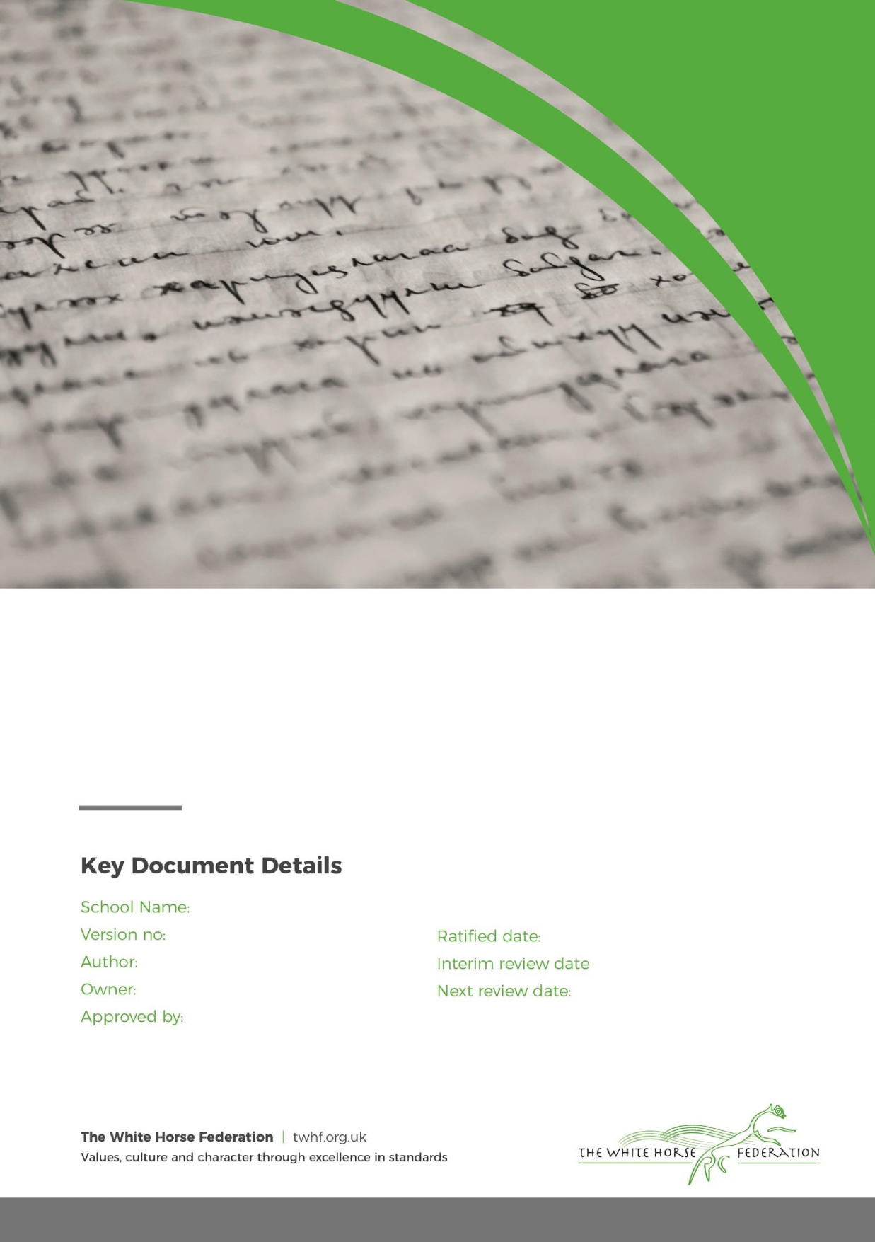

Behaviour Procedures
Our school Behaviour Procedures should be read in conjunction with the White Horse Federations’ Behaviour & Discipline Policy and the School Behaviour Curriculum.
Our belief in the value of kindness underpins our approach to managing behaviour. It is our aim that every member of our school community feels valued and respected and that each person is treated fairly and with kindness. Through this approach, we hope all our children will develop a strong sense of self-worth, responsibility and belonging.
Promoting Positive Behaviours
Praise and positive reinforcement are used as our primary strategy to uphold high expectations and maintain our daily routines (see Behaviour Curriculum). Children are praised in class and out for demonstrating our Christian school values (kindness, readiness & curiosity) and awarded Dojo points. Classes can set targets and rewards by consensus using Dojo.
Each week, a child from every class is nominated for a SMAS Fullness of Life Certificate which is presented in assembly and another receives a praise postcard through the post. Other forms of praise include stickers, badges, messages home and celebration posts on social media via the class or school Dojo pages.
Procedure for Managing Inappropriate Behaviour
As a school we ensure that all staff working directly with our pupils know and understand the impact of adversity and trauma on children’s mental and physical health, development and life chances.
We understand that children do sometimes use behaviour to communicate an unmet need and that this behaviour can be challenging and disruptive. All staff take care to ensure that children are shown respect and treated fairly when managing or sanctioning inappropriate behaviour using the following procedure:
Managing Behaviour Flow Chart | Reporting
 | Parents | SLT
Verbal reminder of expectations | - Teacher discretion
Verbal warning
Loss of break time (Punctuation Club in KS2) or work sent home  Use of therapeutic resolution / reflection sheet | - Record on Arbor  - Arbor monitors occurrences  - Parents informed of repeated occurrences | Behaviour Lead informed of repeated occurrences by Arbor
Time out of class / work completed in another location | - Record on Arbor  - Parents / Carers informed | Team Leader or Behaviour Lead informed as appropriate
Consider use of Individual Behaviour Plan | - In consultation between parents, Behaviour Lead, Class Teacher and SENCo if appropriate. | SLT informed
Exclusion  Internal or external at Principal’s discretion as per Inclusion & Exclusion Policy | - Record on Arbor  - Statutory paper work completed & sent to Brighter Futures  - Parents / Carers informed via written letter | Principal / Vice Principal
Permanent Exclusion | CEO discretion
Teaching appropriate behaviour
Appropriate and healthy social and interpersonal behaviours are taught like other learned behaviours such as learning to read, to write and to spell. These are taught through PSHE lessons, through Collective Worship and other personalised programmes such as ELSA or support from other professionals. As a school we ensure that all staff working directly with children have a knowledge and understanding of the impact of adversity and trauma on children’s mental and physical health, development and life chances. We understand that children can communicate an unmet need through their behaviour, whether this is challenging and disruptive or quiet and withdrawn
Exclusion
In cases where extreme negative, repeated or very dangerous behaviour is experienced at school, appropriate action will be taken. This may involve a Fixed Term Exclusion from school and in very extreme cases a Permanent Exclusion. Examples of extreme cases might include a child’s involvement in dangerous activity that compromises the safety of themselves and others or becoming involved in unlawful or criminal activity. All serious misdemeanours will be considered individually, based on the actions linked to the age and maturity of the child. Where children may pose a threat to their own safety or that of others, staff who are trained in physical intervention may use appropriate strategies. In the event of this taking place ALL incidents must be recorded in the school’s bound book and the DSL and Headteacher informed immediately. The person undertaking the intervention must also inform the child’s family.
Behaviour records
Incidents of inappropriate behaviour, including racism or bullying, are recorded in the behaviour log on Arbor and on CPOMS (safeguarding recording) if appropriate. These systems notify the Headteacher, Behaviour Lead and DSL team.
Class Expectations
At the start of the new academic year, all classes make their own Class Charters. These are displayed in each class room and show the rights and responsibilities of every child in the class. The rights come from the United Nations Convention on the Rights of the Child (UNCRC) and the responsibilities are created and agreed by the children. We are a Rights Respecting School, recognised by UNICEF, and currently Bronze certified. This means we put significant importance into respect for ourselves and others, as well as the local and global community. All expectations are discussed regularly during Picture News assemblies, Collective Worship, PSHE, in Pupil Leadership Team meetings and in other class time. Children aged 3-5 in our nursery follow the same behaviour procedures albeit with appropriate age-related variations.

