The St. Bart’s Academy Trust  Job Description | 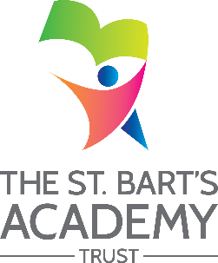

Job Title: | Senior Technician (Schools Generic)  (includes art and design, food, science technicians)
Grade: | Level 5 (Gauge Ref: N407)

Job Purpose
Job Purpose
To work with teachers as part of a professional team to support learning by providing technical assistance through working with pupils in the delivery / demonstration of practical learning activities and the preparation and maintenance of teaching areas and equipment for pupils.

Key Duties / Responsibilities

- Plan, prepare and set up specific resources / materials / equipment for lessons, under general direction of the class teacher
- Contribute to the development of lesson and work plans
- Implement structured and agreed practical learning activities for groups or on a one-to-one basis, as prepared by, and under the direction of, the class teacher
- Develop, prepare and maintain specialist resources as required
- Ensure the safe and secure storage of allocated resources / materials / equipment to prevent unauthorised access / misuse
- Clean and undertake maintenance of equipment as needed to ensure it is clean and in good working order
- Update records, including production of reports and analysis of information
- Contribute to planning and development of systems, policies and procedures for their technical area.
- Ensure the safe treatment and disposal of used materials, including hazardous substances, and respond to actual or potential hazards.
- Order and maintain resources within an agreed budget
- Demonstrate the use of equipment to technical and other staff
- Ensure the adherence to health and safety regulations by technical support staff within the school

The St. Bart’s Academy Trust

Person Specification

Job Title: | Senior Technician (Schools Generic)  (includes art and design, food, science technicians)
Grade: | Level 5 (Gauge Ref: N407)

Person Specification
Minimum Essential Requirements - Evidenced by: a: application form b: test c: interview
 | a | b | c
Working at or towards appropriate national occupational standards (NOS), for example laboratory and associated technical activities or supporting teaching and learning as appropriate to the type of technician role Level 3 equivalent experience in a specialist area.
Knowledge of appropriate use of specialist equipment and ability to communicate and demonstrate this knowledge effectively to staff and pupils

