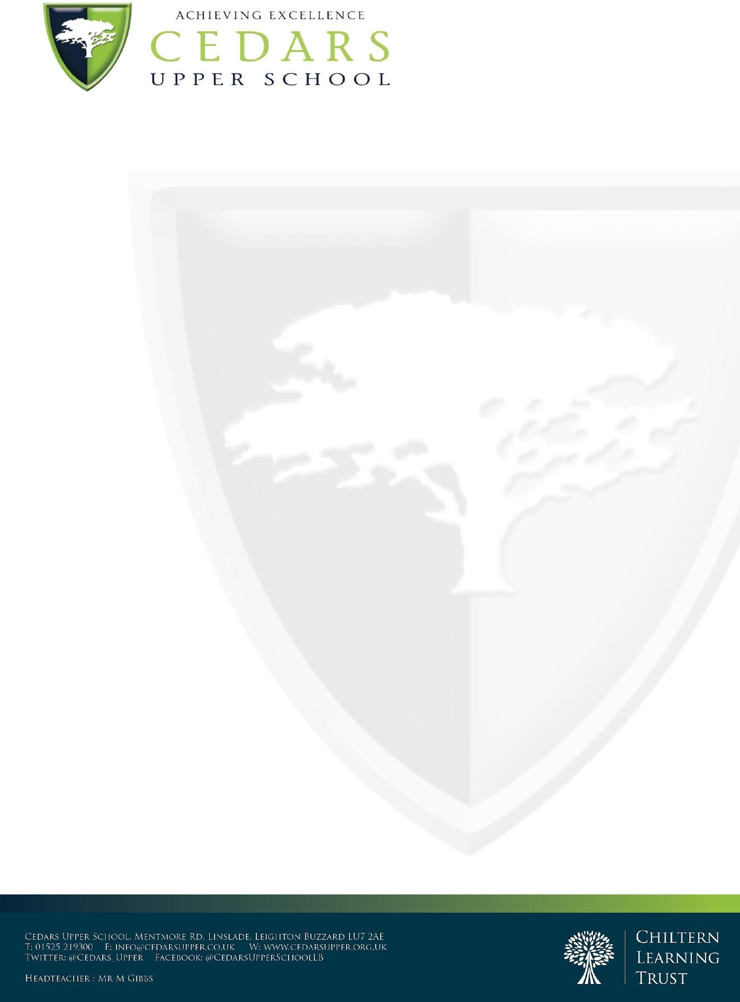

Senior Science Laboratory Technician- Required January 2025

Dear Candidate,

Thank you for your interest in Cedars Upper School. We are thrilled that you are considering becoming a part of our team and the Chiltern Learning Trust. The opportunity to take a leading role in our ongoing pursuit of excellence, as we strive towards an 'outstanding' rating from Ofsted in all areas, is perfectly suited for a dynamic and exceptional leader. Cedars Upper School, home to 1200 students, is a well-regarded institution with a thriving sixth form.

We are proud to announce that our Sixth Form has been graded as 'outstanding' by Ofsted, a testament to our unwavering commitment to educational excellence. This accomplishment reflects our relentless pursuit of high standards, especially in the sixth form, where they consistently achieve remarkable results. As noted by Ofsted 23, "Pupils at Cedars Upper School achieve well. They benefit from leaders’ high expectations of their learning. This is especially the case in the sixth form, where students make exceptional progress."

At Cedars Upper School, we foster an environment where positive relationships between students and staff thrive based on trust and mutual respect . Our commitment to maintaining a calm, respectful and orderly atmosphere throughout the school ensures that our students feel safe and enjoy their time here. We take great pride in creating a nurturing and secure environment where students feel enthusiastic about being at school. This sense of safety and belonging is integral to our educational philosophy.

We are now inviting applications from enthusiastic and dedicated leaders who can contribute to our exceptional leadership team. Joining us means becoming part of a passionate team committed to raising the bar in teaching and learning. Our dedication to curricular excellence ensures that our students receive the best possible education, setting them on a path to achieving their goals today and in the future.

At Cedars Upper School and as a Trust, we prioritise continuous professional development and offer outstanding in-house CPD opportunities. We foster a supportive and positive atmosphere, where our hard-working, polite, and eager-to-learn students deserve nothing less than outstanding educators, or educators who are actively striving for excellence.



The application deadline for this exciting opportunity is **12pm on Sunday 6th January 2025**. We hope you can envision your place in the Cedars Upper School journey and take this opportunity to apply for this pivotal role. If you have any questions or require further information, please feel free to reach out to Mark Gibbs, Headteacher, or Umara Qureshi, Head of School, at 01525 219300 or via [hr@cedarsupper.co.uk](mailto:hr@cedarsupper.co.uk).

To view our latest Ofsted report please click [here](https://www.cedarsupper.org.uk/Ofsted/)

Thank you once again for considering Cedars Upper School and CLT as your next career destination. We look forward to the possibility of welcoming you to our dedicated and ambitious team.

Yours sincerely,

Mark Gibbs Headteacher