
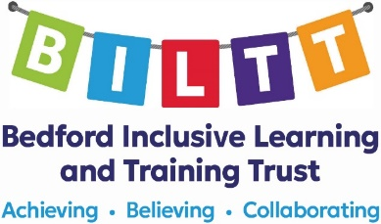

Greys Education Centre
Chestnut Avenue
Bromham
Bedford
MK43 8HP
01234 889320
greys.recruitment@biltt.org
https://biltt.org
https://www.greys.beds.sch.uk

Specialist Teaching Assistant

LEVEL 3BS points 7 – 11, £25,584 - £27,269
(Actual salary pa £21,257 - £22,657)
Term Time + 5 Training Days, Permanent contract
35 hours per week, start date – as soon as possible

Greys Education Centre is an Alternative Provision Academy providing full-time education for pupils permanently excluded from school, pupils on partnership programmes and pupils who are temporarily unable to attend school full time due to illness.
We require a Specialist Teaching Assistant based at our Primary Provision in Bromham to assist teachers working with pupils. This is a therapeutic provision for pupils with social, emotional, and behavioural difficulties. The role will be to work as part of a team re-engaging our pupils back in to learning and helping them to manage their behaviour in a way which allows them to better access the school curriculum and supports their successful return to a new school.
Greys Education Centre is part of the Bedford Inclusive Learning and Training Trust who are in the process of opening the new Rivertree Free School in Kempston.

What we offer:

- Membership of the Local Government Pension Scheme with employer contributions
- No evening, weekend or school holiday working
- A thorough induction programme
- Development opportunities within a growing Trust
- Employee Assistance Programme

Closing date: 9:00am on Monday, 6th January 2025. However, we reserve the right to interview and appoint on receipt of applications and withdraw the advert if a suitable candidate is found.

Interviews: Tuesday, 21st January 2025

To obtain an application pack or for further details for the above posts please visit https://biltt.org/job-vacancies or email greys.recruitment@billt.org

This post is subject to Enhanced DBS Clearance, satisfactory references, social media checks, health clearance, and a 24 week probationary period. This post is exempt from The Rehabilitation of Offenders Act 1974. It is an offence to apply for a role if you are barred from engaging in regulated activity relevant to children. Sorry CVs cannot be accepted.

BILTT is committed to safeguarding, Prevent, the welfare of pupils and ensuring equality of opportunity for all pupils, staff, parents and carers; irrespective of age, disability, gender reassignment, marriage & civil partnership, pregnancy & maternity, race, belief, sex or sexual orientation and expects staff to share that commitment.

