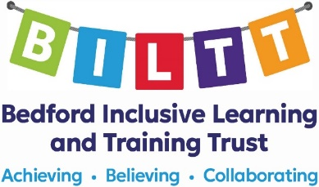

Greys Education Centre
Manor Drive
Kempston
Bedford
MK42 7AB
01234 408477
greys.recruitment@biltt.org
https://biltt.org
https://www.greys.beds.sch.uk

Specialist Teaching Assistant

LEVEL 3BS points 7 – 11, £18,586.40 - £19,986.46 actual salary pa
Term Time + 5 Training Days, Permanent contract
35 hours per week, start date – September 2024

Greys Education Centre is an Alternative Provision Academy providing full-time education for pupils permanently excluded from school, pupils on partnership programmes and pupils who are temporarily unable to attend school full time due to illness.
We require a Specialist Teaching Assistant based at our Secondary Provision in Kempston to assist teachers working with pupils. This is a therapeutic provision for pupils with social, emotional, and behavioural difficulties. The role will be to work as part of a team re-engaging our pupils back in to learning and helping them to manage their behaviour in a way which allows them to better access the school curriculum and supports their successful return to a new school.
Greys Education Centre is part of the Bedford Inclusive Learning and Training Trust who are in the process of opening the new Special Free School in Kempston in 2024.

Membership of the Local Government Pension Scheme and other employee benefits are offered.

Closing date: 9am 10th July 2024
Interviews: 17th July 2024

To obtain an application pack or for further details for the above posts please visit https://biltt.org/job-vacancies or email greys.recruitment@billt.org

This post is subject to Enhanced DBS Clearance, satisfactory references, social media checks, health clearance, and a 24 week probationary period. This post is exempt from The Rehabilitation of Offenders Act 1974. Sorry CVs cannot be accepted.

BILTT is committed to safeguarding, Prevent, the welfare of pupils and ensuring equality of opportunity for all pupils, staff, parents and carers; irrespective of age, disability, gender reassignment, marriage & civil partnership, pregnancy & maternity, race, belief, sex or sexual orientation and expects staff to share that commitment.

