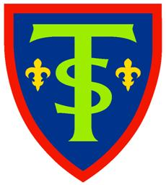**St. Teresa’s Catholic Primary School**Luckington Road, Monks Park, Bristol BS7 0UP

Tel: 0117 9030412   
E-mail: [school@stteresas.org.uk](mailto:school@stteresas.org.uk)  
Headteacher: Mrs Samantha Land

***‘Inspiring each other to excellence,***

***in the Light of Christ.’***

**School Meals Supervisory Assistant (SMSA)**

**Monday – Friday 12.05pm – 1.20pm**

**6 hours 15 mins TTO + 5 Inset Days)**

**Permanent Contract.**

**NJC 2 £23,656 full time and £3,494 actual salary**

**Required to start ASAP**

**Would you like to join our school family at St. Teresa’s Catholic Primary School Bristol?**

We are looking for an energetic, reliable & committed person who can join our team of SMSAs.

We are a school family at St. Teresa’s, where each member is proud to play their part. Our vibrant, one form entry, multi-cultural primary school, set in large grounds, is a place where every individual is valued, nurtured and respected so that they can flourish and live life to the full.

Duties will include supervising children during lunchtimes and most importantly, supporting pupils during play activities so that our children have an enjoyable and meaningful lunchtime experience.

Further details and an application pack are available from the school office on 0117 9030412 or by email [school@stteresas.org.uk](mailto:school@stteresas.org.uk). Applications MUST be completed on a CES application form.

‘We are committed to safeguarding the welfare of children and expect all staff to share this commitment. An enhanced DBS check is required for the successful applicant.’

**Start date: As soon as possible.**

**Closing date: Thursday 9th January 2025**

**Potential Interview Date: Monday 13th January 2025**