Design Technology and Food Technician
Recruitment Pack
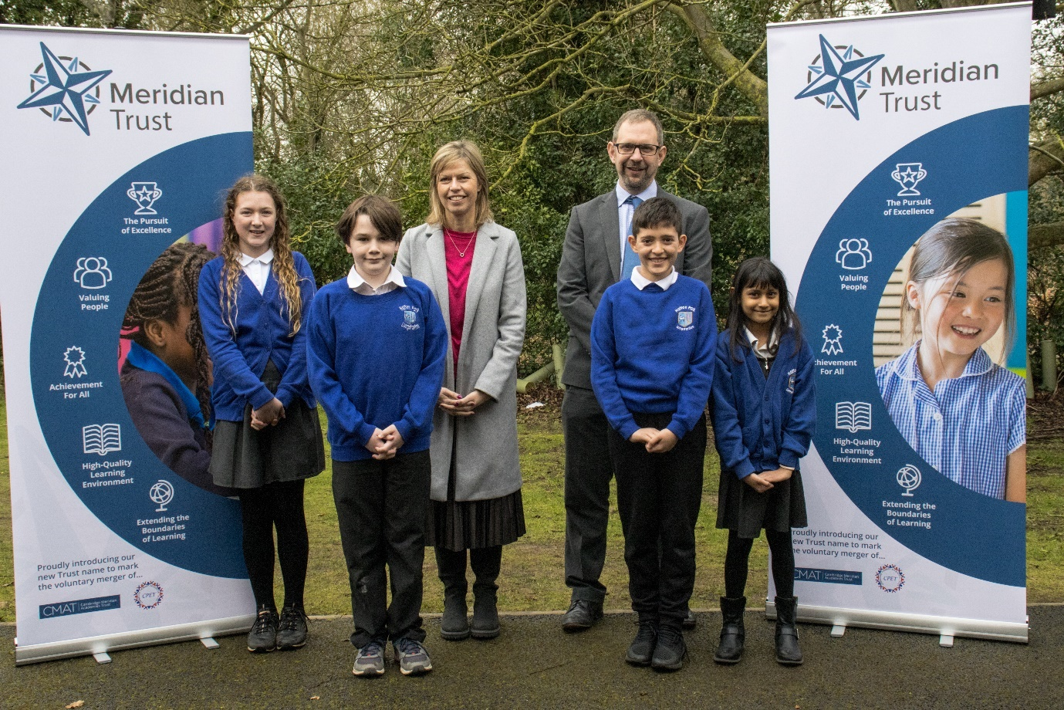

Content

Welcome from our Chief Executive Officer 3

A brief history of our Trust 4

Our Vison, Mission and Values 5

Why work for us 6

How to apply 6

Job description and Person Specification 7

About Lincroft Academy 12

Welcome from our CEO, Mark Woods

Thank you for your interest in joining the Meridian Trust family.
The success and growth of our Trust has been based on remaining focused on some critical principles:
- Every child is known, equally valued and supported to achieve their potential in all our academies. Every community we serve benefits from the facilities and services we provide.
- Our staff benefit from strong networks, excellent career opportunities and a human approach where they are equally valued and supported.
- We ensure that well-run schools retain and develop their distinct contextual identity, while sharing and contributing to our common values, practices, curriculum approaches and operational systems
Since 2011, thanks to the fantastic work of our staff, our Trust has grown from 1 to 28 academies whilst retaining our focus on working within an area that enables easy movement between our schools. From first developing an application in 2007 to open schools in the new town of Northstowe, we have been committed to the vision of being an all-through and all-inclusive Trust. Our Trust currently consists of 14 primary schools, 12 secondary schools and 2 special schools. We are also currently developing 3 free school projects within our region.
Meridian also plays a key role in the wider development of education in the region. We are the home to the Cambridge and Peterborough Teaching School Hub and operate a vibrant Initial Teaching Training provider that trains upwards of 100 teachers annually. In addition, our commitment to the local community as an extension of our village college ethos means that we host a range of activity in our schools, including providing leisure and educational opportunities.
If being part of a dynamic, compassionate and dedicated group who believe we can really improve young people’s life chances and opportunities by working together appeals to you, we very much look forward to receiving your application.

A Brief History
Meridian Trust, formerly known as Cambridge Meridian Academies Trust (CMAT), is a values-led Trust and has risen to be one of the highest performing academy groups in the country. Our Trust was first formed as an educational trust to create a federation of schools in 2006 with a desire to provide high quality and dynamic education for everyone, right in the heart of our community. Through various government policies, our commitment to collaboration has remained consistent.
Meridian Trust was formed in 2011 to deliver more widely on that clear vision to provide high quality and dynamic education for all at the heart of the communities we serve. Our steady growth since then reflects our commitment to the communities we serve and our track record of success. The period since 2018 has seen an increase in speed of growth as many long term projects matured and our relationship with Sharnbrook Academy Federation emerged.
We are currently a family of 28 academies (including 14 primary, 2 special and 12 secondary schools). The secondary schools include a University Technology College, an Upper School, four 11-16 schools and six 11-18 schools. We also have 2 new secondary free schools in development. All within 20 miles of Cambridge and Peterborough and the main communication routes between. We merged with Cambridge Primary Education Trust to become the Meridian Trust in April 2022. In addition to operating schools, we are the home of the Cambridgeshire and Peterborough Teaching School Hub, and train more than 150 new teachers each year through Meridian Trust ITT. We retain a strong commitment to growing and supporting staff throughout their training and career development. We have a proven track record of school improvement and transforming the lives of children and young people over the last 10 years.
Students thrive in Meridian Trust academies as a result of the implementation of our values, our successful and proven systems and our commitment to valuing people. We are among the highest performing multi-academy trusts in the country for student progress. Our academies are well-run and our staff benefit from excellent access to professional development.
Our commitment to the education system goes beyond just our own academies. We operate ’The Cambridge Partnership‘, one of the largest initial teacher training providers in the country which has recently merged with the SAF ITT, and ‘Leadership East’ these further strengthen our capacity and commitment to professional development. We also provide support through various SLAs to a number of other trusts and academies.
As a strong, regional multi-academy trust we currently operate schools across Bedfordshire, Cambridgeshire, Lincolnshire, Peterborough, and Northamptonshire. We are proud to have strong partnerships within all these communities.
Trust Vision, Mission and Values
Our values and who we are:
Meridian Trust is a successful multi-academy trust founded on its commitment to people and communities.
Our proven approach over more than a decade has elevated us to a respected and admired academy trust, a national leader in education and a source of great pride to the communities we serve.
Every child is known, equally valued and supported to achieve their potential in all our academies. Every community we serve benefits from the facilities and services we provide.
Our staff benefit from strong networks, excellent career opportunities and a human approach where they are equally valued and supported.
We ensure that well-run schools retain and develop their distinct contextual identity, while sharing and contributing to Meridian Trust values, practices, curriculum approaches and operational systems.
Our Vision:
High-quality educational provision for all at the heart of local communities.
Our Mission:
To deliver, promote and inspire high quality educational provision in schools at the heart of their local communities so that:
- Young people become successful learners and confident, empowered individuals;
- Young people are encouraged to think for themselves and act for others, equipping them with the values, attributes, knowledge and skills to make a rewarding contribution to society;
- Every school is a hub for community activities, a centre for extended services and a source of immense pride for students, their families, and other local stakeholders;
- Our staff benefit from strong networks, excellent career opportunities and a human approach where they are equally valued and supported;
- Well-run schools retain and develop their distinct contextual identity while sharing and contributing to the Meridian Trust values, practices, curriculum approaches and operational systems.
The enactment of our values for staff:
Engaged, developed, supported, and consulted.
Experts who strive for continual development. Collaborative networks, trusted to deliver.
Set ambitious goals and model what success looks like. Eager to improve.
Make connections, provide opportunities. Generous and sharing of knowledge and expertise.
Are accountable for the outcomes we contribute towards and strive for the very best.

Why work for us
Meridian Trust aims to be the employer of choice for the communities we serve. Since 2010 we have nurtured and developed the careers of many people. You can read about some of those journeys in the 'Meridian Trust People' section of this website. We are committed to making a difference to young people’s lives and the communities we serve. Help us make our mission a reality.
Benefits:
Working with us brings with it a range of attractive benefits, including;
- Generous employer contributions to Local Government or Teacher Pension Scheme
- Free on-site parking
- Eyecare vouchers
- Access to a free Employee Assistance Programme, offering mental health and wellbeing support to staff
- Cycle to work scheme
- Reduced staff membership to the facilities at Academy Leisure, Sawtry
- Free tea and coffee making facilities
- Generous sick pay and annual leave

How to apply
To apply please complete the online form on the TES. Your supporting statement should address and evidence the selection criteria detailed in the Person Specification.

Applying:
For any questions about the application process please contact:
hr@lincroft.academy

Meridian Trust is committed to safeguarding and promoting the welfare of children. All appointments will be subject to satisfactory pre-employment checks including enhanced DBS disclosure.
We are committed to diversity & inclusion and equality of opportunity for all staff and applications from individuals are encouraged regardless of age, disability, sex, gender reassignment, sexual orientation, race, religion or belief and marriage and civil partnerships.
Meridian Trust is committed to safer recruitment practice and pre-employment checks will be undertaken before any appointment is confirmed. This post is subject to an enhanced disclosure and barring service check. We expect all adults who work for the Trust to share our commitment to safeguarding and the health and wellbeing of our students.

About Lincroft Academy
Lincroft Academy has an excellent reputation locally and more widely across Bedfordshire and neighbouring counties. In the summer of 2022, we secured our first set of validated GCSE results, with a Progress 8 score of +0.4 and some of the best attainment in the area. In September 2021, we became part of the successful Meridian Trust and have been integrating into their proven networks and systems since joining. Our new Principal, Emma Appadoo, was appointed in June 2023. We have very high aspirations for the years ahead.
Lincroft is a growing school having transitioned from middle to secondary in 2017. We are highly ambitious and strive to achieve excellence in all areas.
We have high expectations of all our students and develop them to become successful, confident and responsible young people ready for further education or employment. In September 2023 we restructured our pastoral systems to implement a full House system, incorporating vertical tutoring and close academic mentoring. We believe that our task as teachers is to develop students’ full potential, both inside and outside of the classroom. We encourage them to work hard at their studies and join in the extensive range of extra-curricular opportunities provided by a dedicated staff. We aspire that every student is properly known, valued and supported.
Our staff are hardworking and supportive, we thrive on new challenges and we work closely together to ensure our students feel happy and safe; our experience tells us that young people work most successfully in a school community that is caring and friendly, yet firm and clear in its expectations and standards.

Principal’s Message
Ms Emma Appadoo
I am very proud to be Principal at Lincroft Academy. Within our vibrant learning community, we share a common goal; to continually strive for excellence. At Lincroft, we maintain exceptionally high expectations and standards in everything we do, ensuring that our students receive the best possible education. We commit to educating, inspiring and supporting our students so that they can become exceptional learners, confident and empowered to make a rewarding contribution to society.
Our curriculum is designed to seamlessly build upon the foundation laid in primary school, preparing our students for post-16 education. High-quality teaching enables our students to achieve very well. Lincroft Academy now has some of the highest performing GCSE outcomes in Bedford and are above the national average. While we take immense pride in our students’ achievements, we remain committed to continuous improvement.
Every child at Lincroft Academy is known, valued and supported to be the best they can be. Our foremost priority is to create a safe and nurturing environment where students thrive. We promote kindness, respect and good manners, just as families do at home, so that our students can become decent adult citizens. Students at Lincroft are well supported through our House System because they work with the same team of staff throughout their Lincroft journey. This system of support fosters belonging, ensures students are known well and strengthens relationships and communication with families. Our comprehensive Inclusion Hub allows us to provide tailored support to students, regardless of their background or needs. Working alongside each other, being supportive and caring is integral to who we are. Our partnership with parents and carers is highly valued and we know that this is an essential part of a positive educational experience for our students.
Our staff are absolutely committed to the education of our students; they are passionate, dedicated and many of them send their children here too. Some of our ex-students now teach here. This speaks volumes about the sense of community at Lincroft. The opportunities provided at Lincroft are broad and many and, even then, continue to grow; from sports to the arts, business and careers – our curriculum extends very much outside the classroom. Our students consistently excel in sports and the arts, enhancing our strong reputation in these areas.
We are proud to be part of Meridian Trust, who look after a total of 30 academies including many in Bedfordshire. We have access to extensive knowledge, expertise and resource, not just at Lincroft, but across the entire Meridian network. This broader community provides our students with additional opportunities and experiences alongside their peers from other academies. This has also opened up investment opportunities to help modernise the school building and facilities.
As a parent of two children myself, I am personally committed to ensuring that the education we deliver at Lincroft is nothing less than I would accept for my own children. Lincroft Academy is a place where every child has the opportunity to realise their potential. We warmly welcome you to our community.
For more detailed information about Lincroft Academy please visit our school website Lincroft Academy or contact us to make an appointment, we warmly welcome visits to the school, by appointment.

