 

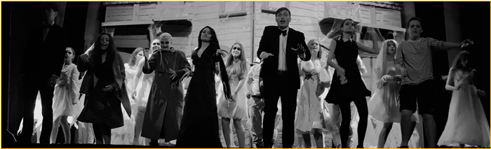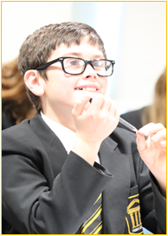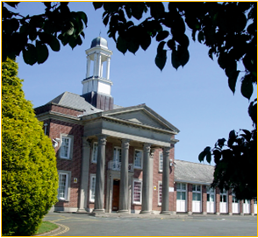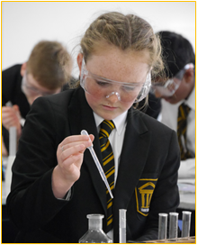

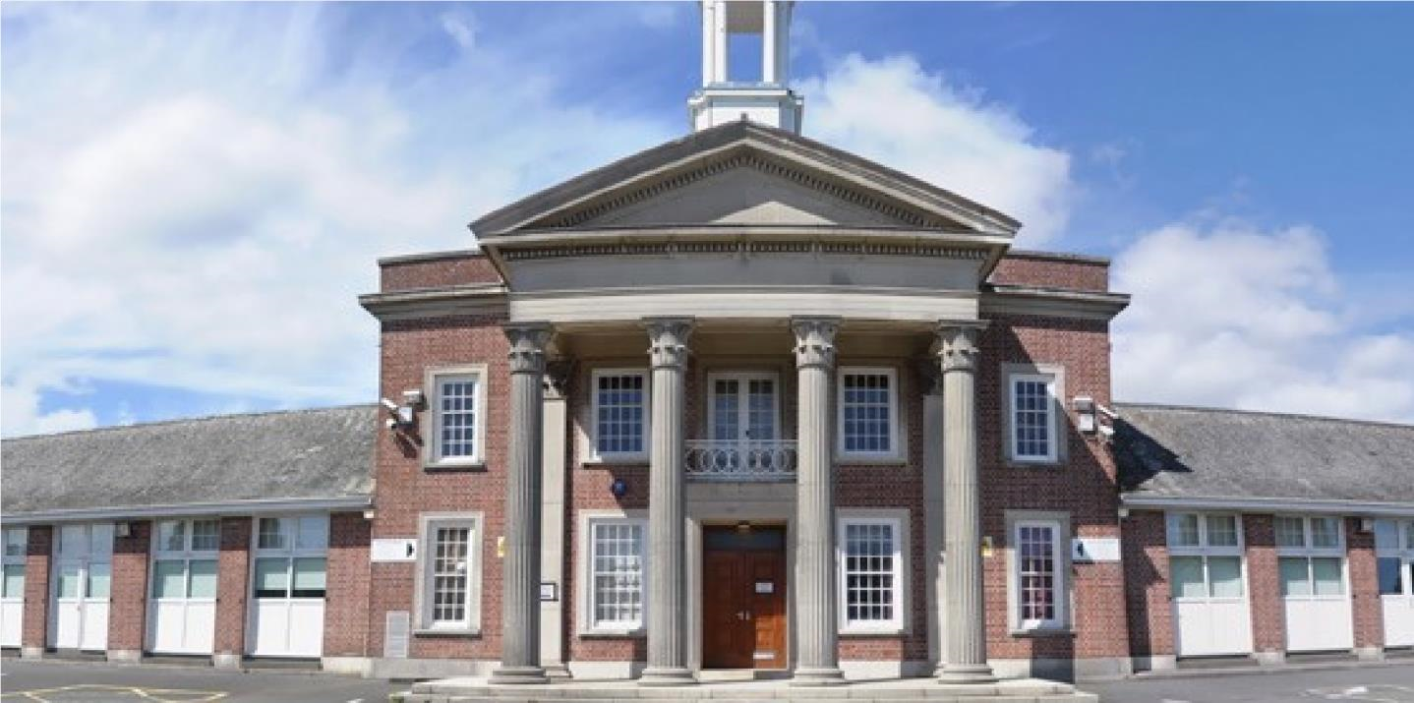

**Senior Science Technician**

**Candidate Pack**

*Seymour Road, Plympton, Plymouth, Devon PL7 4LT*

Phone: 01752 337193

C:\Users\Brooks\AppData\Local\Microsoft\Windows\INetCache\Content.MSO\2D2F1D58.tmpEmail:  heles.school@plymouth.gov.uk

Web: www.heles.plymouth.sch.ukd us on

Principal: Justine Mason

C:\Users\Brooks\AppData\Local\Microsoft\Windows\INetCache\Content.MSO\15FF6526.tmp

**Application Procedure**

 Senior Science Technician

Salary:  NJC Grade E (scp 15-20). Starting salary £29093 FTE, actual salary £23571

Hours:  35hrs per week x 39 weeks per annum

Required to start As soon as possible

This is an exciting opportunity to join Hele’s School and Westcountry Schools Trust. Hele’s is a supportive, friendly and oversubscribed learning community with a very good reputation. We wish to appoint an exceptional candidate, who possesses energy and creativity and can provide effective and efficient cover to support colleagues in our science department. If you are motivated by the prospect of being part of ‘Team Hele’s’ and by working alongside others who share a passion and determination to provide the very best opportunities of our young people, then we would very much welcome your application.

If you would like to join us and feel you could thrive in a collegiate and positive atmosphere, then we’d love to hear from you!

Please click the link to submit your application form. Please note – we do not accept CVs. Completed applications should be submitted prior to the closing date.

The closing date for applications is noon January 6th, 2025

Shortlisting will take place on January 6th, 2025.

Interviews will be held on Thursday 9th January 2025. If you have not heard from us by this date, you should assume that your application has been unsuccessful. Prospective candidates are welcome to telephone the school for additional clarification if they wish.

With 27- strong cross-phase MAT we are regularly looking for passionate people to join our teams. If there are no vacancies currently, but you would like to register your interest for future vacancies, please join our talent pool and we will be in touch as soon as we have a suitable position.

Equality Statement

Hele’s School affirms its opposition to unfair discrimination and commits itself to a comprehensive policy of equal opportunity.  At Hele’s we regard all members of our school as being of equal value and that each person has the right to equality of opportunity. We aim to create an atmosphere, which actively explores and counters myths, fears and prejudices that can work against equality of opportunity. No individual or group should be discriminated against on the grounds of their racial group, religion, sexual orientation, disability, ethnicity, nationality, age, gender, gender identity or political affiliation.  Bullying and harassment will not be tolerated. Sexual and racial harassment, including persecution on the grounds of sexual orientation (i.e. homophobic bullying), are disciplinary offences and relevant policies will be followed in such circumstances.

*Hele’s School is committed to safeguarding and promoting welfare of children and young people and expect all staff and volunteers to share this commitment; therefore, all posts will be subject to a satisfactory DBS Enhanced Disclosure.*



Welcome to Westcountry Schools Trust (WeST) and thank you for your interest in this exciting position at Hele’s School.

This post presents a fantastic opportunity to work in a dynamic, ambitious school and a tight-knit team of dedicated staff, governors and trustees committed to providing the very best experiences and support for the young people in our care.  The Pupil Admission Number at Hele’s increased from 210 to 240 students in September 2019, and each intake since has been over-subscribed at that number with a waiting list, such is the popularity of the school.

Beyond the boundaries of Hele’s School, you will have the opportunity to work and contribute to the development of a cross-phase family of twenty-seven schools.   We are passionate about our children benefiting from the blend of education in which we believe and know that we can only achieve this by creating the right climate for our staff to excel and feel professionally rewarded.  As such, you will work amongst a wide team of colleagues who are mutually supportive and value high quality professional development.

If you share our passion for children succeeding, regardless of their starting points, and believe you have the skills and energy to make a difference to the lives of our young people, we very much look forward to you joining our team.  We actively appoint people with a strong sense of moral purpose and a desire to help all students – we firmly believe that education can make a difference to the life chances of *all* young people.

Our promise to you as a colleague working in a Westcountry Schools Trust establishment is that you will be valued, empowered, invested in and grown in this role, supported to move on to the next stage in your career, whatever and wherever that may be.

Rob Haring

**Chief Executive Officer, WeST**





I take great pleasure in welcoming you to Hele’s School! We are a school with a tradition of academic excellence, high aspirations and a big heart. A school that students and staff are proud to attend. A school where we never compromise our insistence that everyone is valued, learns, enjoys and achieves. Expectations for staff and students are high, but very simple; *work hard both to do things right and to do the right thing…even when no one is looking!*

Our mission is to support and challenge everyone, adult or child, to be the best they can be. We have a ‘no excuses’ philosophy based on growth mindset principles, which reinforces our belief that all of us can always improve, and that nothing is impossible. Quite simply, it isn’t about being ‘the best’ at something but being better than we were yesterday or today. It is for this reason that recognising and celebrating endeavour, as well as achievement, is something we hold dear.

We work hard at providing an inclusive, calm, and purposeful learning environment, and aim to ensure all students have opportunities to enrich their learning, to discover new skills and interests, and to master others through providing a breadth of curricular and extra-curricular opportunities to excite and engage young people, wherever their interests or aspirations may lie.

I am extremely proud to lead a dedicated and enthusiastic team of staff who are passionate about working with young people and are committed to ensuring that those entrusted in our care get the best life chances possible. Everything we do is shaped by our determination to ensure that each and every child has a positive and memorable experience of school; that they thrive, flourish and, crucially, are happy. We focus on opportunities to develop teaching and learning at every turn and, importantly, teachers at Hele’s have a resolve to be the best they can be in the classroom; our core purpose being to remove barriers to learning so that young people can be inspired, can aspire and can achieve. In return we expect a buy in to our belief that we all have an active role to play in making our school a great place to be, which manifests itself in every child displaying the highest standards of commitment to learning, pride and care.

Hele’s is a community committed to personal and professional growth of all, with dedicated staff and governance, supportive families and committed students.  I have no doubt that the right candidate will be happy, supported and fulfilled being part of Team Hele’s, and will take great pride in what we can achieve together for our community and for each other.  I do hope you are inspired to apply for this post and I look forward to reading your application.

Thank you in advance for the time and emotional investment that I know you will commit to this process.

With very best wishes.

Justine Mason

**Principal**

About Hele’s School

Hele’s School is a larger than average 11-18 comprehensive school in Plympton, Plymouth.  Plympton sits at the northeastern edge of the city, bordering the South Hams area of outstanding natural beauty.

The school makes use of the closeness of Devon’s countryside and moors and Plymouth’s waterfront with a thriving Cadet Corps and Duke of Edinburgh Scheme.  Our Combined Cadet Force (CCF), incorporating Army, Royal Navy and Royal Air Force corps, is one of our unique selling points, providing a visible presence both in the school and the wider community and opening countless opportunities for our students around leadership, teamwork and personal presentation, outdoor pursuits, to name just a few.

In recent years, the Pupil Admission Number has increased to 240 in each year group and a period of capital investment to meet this growth is being planned. There are 1350 students in the school, which includes a thriving Sixth Form of 210, based in specialist accommodation.

Hele’s has a proud and long history as a caring school with a strong reputation for excellence and providing opportunity. It enjoys the support of an active parent body, who share our determination to provide the highest quality of education and pastoral care for their children.  Students’ attitudes to learning are good; they are well behaved, and attendance and punctuality are excellent.  In short, the young people entrusted to our care want to learn and are delightful to teach.

Our pastoral system is organised around year groups with an 8-form entry and leadership from a teaching Head of Year and a non-teaching Pastoral Support Manager for each year group.   There is a 30-minute tutor period each morning with a Guided Reading Programme and a strong programme of Personal Development in this time, supported by weekly assemblies.  The pastoral leadership team and tutors remain with the tutor group and take them through from Year 8 to Year 11 so that the relationship between tutor and students is deep and sustained, and family connections with school become trusted and embedded.   Year 7 remains as a separate year team of specialist tutors and Head of Year so that we can ensure an exceptional start to secondary school for every child.

Post-16 has a mix of Year 12 and Year 13 students in each Tutor group.  We use every opportunity to harness the expertise and interest of our post-16 learners to act as leaders and mentors to younger students in all manner of ways, including having a visible Junior Leadership Team (JLT) to act as an important conduit for student voice and school improvement.

An excellent professional body of teachers and a hardworking and effective team of associate staff is a hallmark of the school and Hele’s is fully staffed in all areas with specialist teachers.   Middle Leaders form an active and effective Joint Leadership Group (JLG) with Senior Leaders, and the JLG is the driving force behind school improvement.

The curriculum structure is currently based around a 2-year KS4, with GCSE options ordinarily taken in the spring term of Year 9.  We operate a 2-week timetable with 50 lessons a fortnight, each of 1-hour duration. The school day runs from 8.40am to 3.10pm, allowing plenty of time for the well-developed and rich extra-curricular provision, which includes a mix of academic, sporting, performance and personal development opportunities, as well as a newly implemented Guided Reading Programme that runs for all year groups (except for Year 11 and Year, which have an intervention programme) in Tutor time.

Hele’s plays its part fully in the Westcountry Schools Trust, in Plymouth and beyond; the principal has a passion and commitment for Hele’s to be outward-facing, and the school and trust regularly contribute to national, regional and city-wide initiatives on a range of fronts, maintaining a strong relationship with the Local Authority, the Regional Directors, and other organisations across the country.

History of Hele’s School

Elize Hele was born in Brixton in about 1560 and although he lived most of his life at Fardell, Cornwood, on the outskirts of Plympton, his final resting place is in St Andrew’s Chapel in Exeter Cathedral.  Having no heirs, Elize left his wealth to be used for “pious uses”.  A number of schools in the Southwest were founded out of his estate by his trustees, including the grammar school at Plympton, which was, until its temporary closure at the end of last century, known as Hele’s School, Plympton.

The old grammar school building, which still stands in Plympton St. Maurice, was completed in 1671.  Next to it stood the Schoolmaster’s house in which Sir Joshua Reynolds was born.  It is a surprising fact that the old grammar school produced four distinguished artists:  Sir Joshua Reynolds, the first President of the Royal Academy; James Northcote; Benjamin Haydon and Sir Charles Eastlake, President of the Royal Academy and the first Director of the National Gallery.

The school faced many difficulties in the latter part of the nineteenth century and was eventually forced to close in 1903, before it was reconstituted by Devon County Council as a co-educational grammar school in 1921 called Plympton Grammar.  The school grew and prospered and moved to its present site on Seymour Road in 1937.

New extensions were opened from 1970, and in 1983 refurbishment took place in preparation for reorganisation into an 11 – 18 mixed comprehensive school and it reverted to its old name of Hele’s School.

In the decade from 2000, Hele’s benefited from three specialisms - Languages, Maths & Computing and Applied Learning - and enjoyed national acclaim as a Language College.  This strength continues, despite the change to national policy and the subsequent removal of funding, and international links and internationalism remain important.

The school became a Converter Academy in April 2011 and operated as a Stand-Alone Academy Trust for the following 7 years.   In September 2018, Hele’s joined a Multi Academy Trust, the Westcountry Schools Trust (WeST), which it played a key part in co-constructing.

Stronger Together

A now 31- strong cross-phase MAT of 23 Primaries, 8 Secondaries, plus an Adult Training Provider, the Westcountry Schools Trust is geographically tight but spans Devon, Plymouth and Cornwall.  With the strength of collaboration and ambition, the capacity for shared school improvement, leadership development and collaboration is limitless.  The WeST aspiration of *‘Every child in a great school’*sits well with the Hele’s vision (and vice-versa) and the strap line *‘Stronger together’* articulates our shared ambition to ensure that this aspiration becomes a reality.

There remains a strong commitment, professionalism and moral imperative amongst the Hele’s staff and Local Governing Body to ensure we provide the young people in our care with an educational and pastoral support experience that is first class in every aspect. This is very much supported by the WeST Trust Board and strategic direction of the MAT.  We have a burning ambition and determination to put Hele’s firmly on the map locally, regionally and nationally and to be recognised as an outward-facing, aspirational and collegiate centre of excellence, which remains committed to continuous improvement.

Hele’s School Ambition

*Our school’s purpose:*

*To warm hearts and to light fires in minds.  Our ambition is to inspire confident learners who will thrive in a changing world, never fearful of taking risks and learning from mistakes made as part of their growth. We hold dear the belief that ‘people matter’, and the quality of personal relationships at all levels is central to ensuring a safe, happy, caring, inclusive environment.*

*Vision:*

*We pride ourselves on being an outward-facing school community that delivers outstanding academic and personal outcomes for all.*

*Mission:*

*We instil a passion for learning - for child and adult alike.*

*We allow everyone a chance to shine.*

*We provide a safe, happy community, where we are all supported and challenged to be the best we can be.*

*We believe there is no ceiling to aspiration.*

*We ensure a growth mindset culture pervades all we do.*

*We celebrate endeavour at every opportunity.*

*We grow ‘future fit’ young people.*

*We are a school in the heart of the community and with the community in our heart.*

*We develop and maintain a reputation for excellence - locally, regionally and nationally.*

*We remain restless for continuous improvement, always striving to be better.*

*Values:*

*We dream big, aim high and work hard.*

*We have pride in all we do and all we are.*

*We respect each other, our environment, and ourselves.*

*We ensure outstanding learning is at the core of our provision.*

*We do things right, and we do the right things.*

*We have high expectations of and for every person.*

*We strive to be better each day – as adults and as young people.*

*There are no excuses – all can achieve no matter their starting point.*

*We ’walk the talk’ and all play our part in ensuring Hele’s is a great school to be part of.*

Meet the Science Team

|  |  |  |
| --- | --- | --- |
|  | Mr R Ramage | Head of Science |
|  | Ms K Horvath-Nimmo | Deputy Head of Science |
|  | Dr A Parker (part time) | Science, Subject Leader Biology |
|  | Mr C Lethardy | Science, Subject Lead Chemistry |
|  | Mr M Reynolds | Science, Subject Leader Physics |
|  | Mrs S Greenway | Teacher of Science |
|  | Mr D Lovell | Teacher of Science |
|  | Ms L McCarthy | Teacher of Science |
|  | Mrs A Moore (part time) | Teacher of Science |
|  | Miss C Rutley | Teacher of Science |
|  | Mrs G Stewart | Teacher of Science, Head of Year |
|  | Miss L Warner (part time) | Teacher of Science |
|  | Vacancy | Senior Science Technician |

**

**WESTCOUNTRY SCHOOLS TRUST**

**JOB DESCRIPTION**

**Job Title:** Senior Science Technician

**Location:** Hele’s School

**Grade/Salary**: NJC Grade E (Scp 15-20)

**Hours:** 35 hours a week, 39 weeks per year

**Reports to:** Head of Science Department

**Job Purpose**

To contribute to the achievement of the School’s Mission and strategic objectives by working as a member of the Science Team, providing effective, flexible and efficient practical support to the Science Department.

**Duties and Responsibilities**

**Main Duties**

1. To lead a team of science laboratory technicians to ensure the provision of good quality technical support.
   * Supervise, manage and direct science technicians to provide a good level of technical support for staff and students working in the science department.
   * Organise deployment of the science technician team and delegate workload.
   * Be integral to the induction of new technician staff.
   * Identify and address any laboratory-specific training of staff to develop expertise.
   * Ensure that technical knowledge is kept up to date through training and familiarisation with CLEAPPS guidance.
   * Meet regularly with the team.
2. To be responsible for setting up and monitoring systems used in the management and control of practical resources.
   * Organise and monitor stock control procedures to maintain practical resources in the department at a sensible level.
   * Ensuring health and safety COSHH and CLEAPSS procedures are followed for the safe storage and maintenance of hazardous chemicals — working alongside the school's Health and Safety Manager, as required.
   * Working alongside the Head of Physics to assist with the maintenance and safe storage of the radioactive sources, and ensuring paperwork is current and correctly kept.
   * Oversee the inventory for equipment within Science: keep the inventory up-to-date by adding and removing items as appropriate and identifying where equipment is coming to the end of life or needs replacing.
   * Oversight of ordering: check off and put away resources across Biology, Chemistry and Physics and keep appropriate records.
   * Ensure the availability of suitable materials and liaise with suppliers where necessary.
3. To support the Science teaching staff in meeting the needs of the curriculum.
   * Be responsible for the accurate and punctual preparation of equipment and materials.
   * Ensure the technical team performs practical duties safely and to a good standard.
   * Make sure all members of the team - including teaching staff and trainee teachers - are updated with developments in practical science.
   * Work with the science department PGCE lead to develop practical skills of trainee teachers.  Carry out risk assessments for technical work and provide relevant technical information for teaching staff.
   * Take overall responsibility for the preparation of definitive equipment for internal and external tests and examinations.
   * Ensure that personal technical knowledge is kept up to date.
   * Monitoring and acting on regular CLEAPSS bulletins that impact on short term and mediumterm practical activities.
   * Assist the Head of Science/relevant TLR holder with the management of the Science internal cover process in the event of staff absence, including assistance with ensuring all paperwork (know your class, cover sheets, 'explain' work, textbooks, etc.) are in packs for each cover lesson for the cover teacher, and to assist the cover teacher if questions arise.
   * Assist the second in department with ordering and distribution of Pupil Premium and student revision books, workbooks and revision cards.
4. To be accountable for the maintenance of a safe and healthy working environment.
   * Ensure the directions for preparation, storage, transportation and disposal of resources are followed safely by the technician team.
   * Organise the programme of safety checks in the department and where applicable carry out safety checks.
   * Introduce and maintain safe working procedures as recommended by CLEAPSS.  Hold a First Aid Certificate or be willing to undertake First Aid training.
5. Take a lead role in the provision of design, development and maintenance of specialist resources and projects within the department.
   * Organise the construction and modification of apparatus in consultation with colleagues.
   * Contribute to the development of new/revised practical lessons.
   * Oversee the trialling of new/adapted science experiments.
   * Work with colleagues to adapt and introduce equipment to contribute to successful and safe practical lessons.
6. To have responsibility for supporting the teaching of science qualifications.
   * Prepare appropriate apparatus, biological, chemical and physics materials to support science teaching.
   * Maintain correct storage of chemicals, cultures and other biological substances.
   * Dispose safely of used materials including hazardous substances.
   * Use specialist knowledge to advise teaching staff on best practice when introducing new schemes of work for practical lessons and experiments.
   * Work with the Head of Department to evaluate the new courses needs for practical sessions and be willing to take on research to support new developments.
   * Responsible for the appraisal of other Science technicians in the department: set clear objectives, monitor performance, and ensure training needs are identified and met.

**Demands:**

The position requires manual handling. The post holder will be required to carry or move Science equipment between laboratories and will need to be able to bend under desks to plug leads in and assist with Exhibitions, demonstrations and displays.

Some cleaning duties are required of the post holder

Concentration and attention to detail are required whilst assisting students in class with experiments and practical work.

**Working Conditions:**

Exposure to smells, noise, dust and differing temperatures

Contact with hazardous substances and chemicals, microorganisms and radioactive materials.

PPE is required and provided: Lab coat, gloves, goggles etc… appropriate to the task

**General**

* To act in accordance with, and actively promote, all Trust policies, including Safeguarding, Health and Safety and Equality & Diversity.
* To participate in Continuing Professional Development (CPD relevant to the role and to engage in Performance Development Reviews (PDRs).
* Preparing and contributing to Trust wide development by sharing best practice and delivering/receiving professional feedback.
* To retain confidentiality and maintain data and/or files in accordance with Trust policies for data governance, as appropriate for the role.

This job description provides a general reflection of the main duties and responsibilities of the post at the date of production. You may be expected to take on other reasonable activities deemed to be within the character of the post to assist in efficient service delivery. The duties may change over time as requirements and circumstances evolve without changing the general character of the post or level of responsibility.

**PERSON SPECIFICATION**

E = Essential, D = Desirable

|  |  |  |  |
| --- | --- | --- | --- |
| **Method of Assessment**  The table indicates the possible method/s by which the skills/knowledge/level of competence in each area will be assessed. | **Essential or Desirable** | **Application Form** | **Interview (or other selection activity)** |
| **Qualifications:** | | | |
| Higher grade GCSE passes or equivalent including Maths, English and Science | E | ✓ |  |
| NVQ 3 or equivalent qualification, and/or willing to train | D | ✓ |  |
| Leadership Experience | D | ✓ | ✓ |
| **Experience:** | | | |
| Awareness of health and safety within a Science department | E | ✓ | ✓ |
| Experience of working successfully in a team | E | ✓ | ✓ |
| Working to tight deadlines | E | ✓ | ✓ |
| Experience of working in a school Science department | D | ✓ | ✓ |
| Use of Excel or similar programmes | D | ✓ | ✓ |
| Chemistry specialism or professional experience | D | ✓ | ✓ |
| **Knowledge, Skills and Abilities:** | | | |
| Literate | E | ✓ | ✓ |
| Good organisation and time management skills | E | ✓ | ✓ |
| Ability to form positive relationships with students and staff | E | ✓ | ✓ |
| Ability to manage resources effectively | E | ✓ | ✓ |
| Confident in the use of ICT | D | ✓ | ✓ |
| Experience of stock taking / record keeping | D | ✓ | ✓ |
| Ability to remain calm under pressure | E | ✓ | ✓ |
| Ability to work with young people in a lively flexible environment | E | ✓ | ✓ |
| Flexible approach to work | E | ✓ | ✓ |
| Ability to work independently and use own initiative within departmental policy guidelines | D | ✓ | ✓ |
| **Further Requirements:** | | | |
| Work effectively as part of the School Team while also having the ability to work independently | E | ✓ | ✓ |
| Ability to identify and engage in training/CPD opportunities for role requirements | D | ✓ | ✓ |
| **VALUES-BASED BEHAVIOURS:** | | | |
| **Compassion:** | | | |
| Recognising need in others and acting with positive intention to promote wellbeing and improve outcomes | E |  | ✓ |
| **Aspiration:** | | | |
| Working to high expectations, modelling the delivery of high quality outcomes | E |  | ✓ |
| Showing passion, persistence and resilience in seeking creative solutions to strive for continuous improvement and excellence | E |  | ✓ |
| **Integrity:** | | | |
| Acting always in the interests of children and young people | E |  | ✓ |
| Acting with a consistent and uncompromising adherence to strong moral and ethical principles | E |  | ✓ |
| Communicating with transparency and respect, creating a working environment based on trust and honesty | E |  | ✓ |
| **Collaboration:** | | | |
| Creating a shared vision and working effectively across boundaries in an equitable and inclusive way to skillfully influence and engage others | E |  | ✓ |