

**Recruitment Pack**

|  |  |
| --- | --- |
|  | |
| Croyland Nursery School | Parklands Nursery School |

Contents

Welcome from our Executive Principal Lindsay Lambert 2

# A Brief History 4

Why work for us 5

# 

# **Welcome from our Executive Principal Lindsay Lambert**



Thank you for your interest in joining the Foundation for Schools Nursery Federation.

Foundations for Children Nursery Schools Federation comprises of four maintained nursery schools: Camrose Early Years Centre for Children & Families and Parklands Nursery School in Northampton; and Croyland Nursery School & Day Nursery and Highfield Nursery School in Wellingborough. We have over 80 years' experience providing high quality early education for children aged 0-5.

Working collaboratively across our nursery schools we provide responsive, high quality early education, for all children in our communities. Our ambition for children's lifelong learning and success drives our commitment to strengthen our sustainable model of Nursery Schools, as we support the growing and diverse learning community.

Our mission underpins our values aiming to inspire and nurture foundations for lifelong learning, to foster strong family partnerships, and to optimise the life chances of all children.

In addition to our core values,

Every child is known, equally valued and supported to achieve their potential in all our nurseries. Every community we serve benefits from the facilities and services we provide.

We ensure that well-run nurseries retain and develop their distinct contextual identity, while sharing and contributing to our common values, practices, curriculum approaches and operational systems

Our staff benefit from strong networks, excellent career opportunities and a human approach where they are equally valued and supported.

Being part of a family community who are compassionate and dedicated, who believe can really improve young people’s life chances and opportunities by working together. If this appeals to you, we very much look forward to receiving your application.

# **A Brief History**

The Federation was formed in December 2021 comprising of Croyland Nursery School, Highfield Nursery School, Parklands Nursery School and Camrose Early Years Centre.

Our schools have a long history of providing early years education to the families of Wellingborough and Northampton - embedded into our local communities. We are proud to be working together so closely to continue the provision of high quality, extended services in our areas, in addition to training and support for our colleagues in the Early Years sector across Northamptonshire.

**Federation Vision, Mission and Values**

**Our values and who we are:**

Every child is known, equally valued and supported to achieve their potential in all our nurseries. Every community we serve benefits from the facilities and services we provide.

We ensure that well-run nurseries retain and develop their distinct contextual identity, while sharing and contributing to our values, practices, curriculum approaches and operational systems.

**Our Values;**

**Nurture and Compassion**

Harnessing a nurturing environment where compassion and kindness are at the heart of everything we do.

**Challenging**

Testing boundaries and not accepting the status quo

**Accountability**

Colleagues strive for excellence, taking responsibility for their actions and results.

**Equitable and inclusive**

Always fostering respect and a culture of inclusion, diversity, tolerance, and fairness

**Sense of belonging**

Child centred, encouraging curiosity, independence, participation, and encouragement towards skills for the future.

**Integrity**

Doing the right thing, always. This means being honest and open even when it is difficult.

High-quality educational provision for all at the heart of local communities.

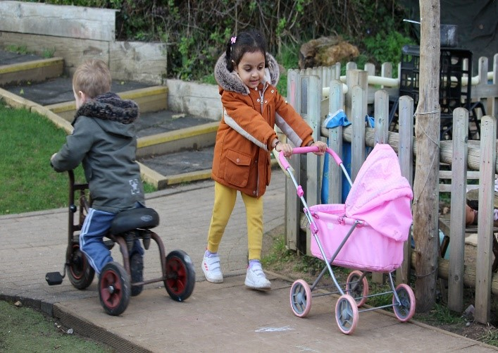

**Our Vision:**

Our vision is to provide warm, stimulating, welcoming environments which give us a secure foundation for all children and their families to become happy, confident, caring individuals who achieve personal success and develop a lifelong love of learning. We are proud of our school nurseries and welcome all visitors.

# **Why work for us**

**Benefits:**

As a collaborated Federation of 4 nursery schools, we can provide a wide network of opportunities for collaboration and career development for both teaching and support staff.

In addition, we also offer:

* Access to CPD via virtual college and development programme.
* Access to a free Employee Assistance Programme, offering mental health and wellbeing support
* Opportunity for progression and CPD within the Federation and wider maintained nursery school network.
* Access to the Local Government pension scheme
* Access to discounted fees for your children that attend one of our schools.

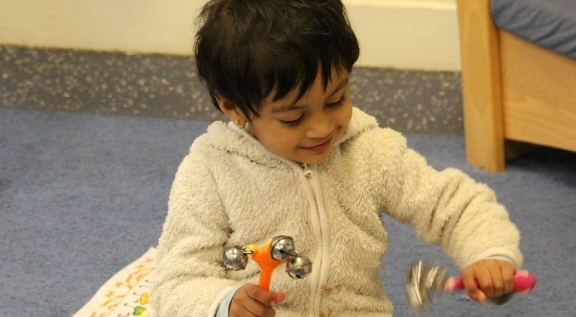  
  
**How to apply**

To apply please complete the online form on MyNewTerm. Your supporting statement should address and evidence the selection criteria detailed in the Person Specification.

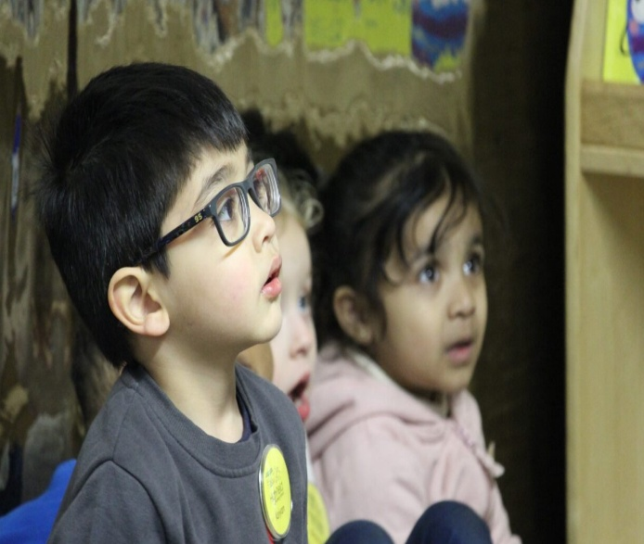

**Closing Date:**

**08th January 2025**

**Interviews: Week commencing 13th January 2025**

**Applying:**

For any questions about the application process please contact: Michelle Page HR Manager

**Email:**  [MPage@ffcnschools.com](mailto:MPage@ffcnschools.com)

We are committed to diversity & inclusion and equality of opportunity for all staff and applications from individuals are encouraged regardless of age, disability, sex, gender reassignment, sexual orientation, race, religion or belief and marriage and civil partnerships.

Foundations for Children Nursery School Federation is committed to safer recruitment practice and pre-employment checks will be undertaken before any appointment is confirmed. This post is subject to an enhanced disclosure and barring service check. We expect all adults who work for FFCN to share our commitment to safeguarding and the health and wellbeing of our children.

*JOB DESCRIPTION AND PERSON SPECIFICATION*

|  |  |
| --- | --- |
| Job Title: | Early Years Educator |
| JD Reference: | JD - 006 |
| Nursery/School: | Parklands Nursery School |
| Weeks: | 39.00 weeks |
| Hours of work: | 37.00 Full time |
| Salary: | Grade D SCP 3-4 (£24,027 - £24,404 FTE) Actual £20,723.29 per annum |
| Responsible to: | Deputy Manager/ EY Officer |

|  |  |
| --- | --- |
| Role: | Support and work as part of the Nursery team |
| Purpose of job: | To provide safe, high quality EYFS education and care for children aged 0-5 years, which meets the individual needs of children attending the setting. Liaise with the Deputy Manager, room leaders and EYFS Officers regarding the provision, progress, and model good, competent practice. |

**Responsibilities and Accountabilities:**

* To provide a high quality of education and learning within the Early Years framework and offer appropriate stimulation and support to children attending the setting.
* To be involved with planning for provision which meets the requirements of the EYFS curriculum.
* To assist in planning and evaluation of activities with the Early Years Officer, providing feedback children’s progress and behaviour.
* To implement the daily routine in the nursery, including the daily timetable, planning, observations, and assessments.
* To facilitate, supervise, participate in, observe, and assess activities to engage and teach the children, following each area of the Early Years curriculum.
* To record and evidence observations of children in alignment with EYFS framework.
* To contribute towards the school's Inclusive practice positively, by promoting anti discriminatory practice and valuing individual identity, culture, heritage and belief.
* To supervise the children and be responsible for their physical, emotional, social, and intellectual well-being.
* Take on the role of key worker for a designated group of children.
* To help to create a welcoming and family friendly environment.
* To accompany and support with home visits promoting ‘working together’ and encouraging parental involvement in children’s learning.
* To assist in setting up and clearing away, ensuring the daily provision follows the planning and is inviting and engaging for children.
* To support with feeding, washing, and changing children, and generally tending to their physical needs as appropriate to their level of development.
* To support and participate in mealtimes within the setting (snack and lunch).
* Be involved in induction and settling in for new children.
* To promote the inclusion and acceptance of children with special needs ensuring access to activities through appropriate clarification, explanation, and resources.
* Promoting positive values, attitudes, and behaviour, dealing promptly with conflict and incidents in line with established policy and encouraging children to take responsibility for their own behaviour.
* To assist with the display and presentation of work.
* To assist with escorting children on any educational visits.
* To keep completely confidential any information regarding the children, their families, or other staff, which is acquired as part of the job.
* To assist with the preparation, maintenance, and control of stocks of materials and resources.
* To liaise with the SENDCO as needed

**Key Worker Responsibilities:**

* To build a positive, professional relationship with the family of each child.
* To share information about the child’s progress, development and pastoral needs as required by the preschool.
* To liaise closely with parents/carers, informing them about the preschool and its curriculum, exchanging information about children’s progress and encouraging parents’ involvement.

**Support for Nursery/ Federation /Place of work:**

* The post holder will adhere to the Federation values and vision; abiding by the agreed policies and procedures to ensure provision is of the highest quality.
* The post holder will interact on a professional level with all colleagues and establish and maintain good working relationships which will promote the development and effective delivery of the EYFS curriculum and maximise children’ achievement.
* The post holder will be responsible for the pastoral care and safeguarding of the children within their session, class, or groups, ensuring that children’s safety, wellbeing, and welfare are at the forefront of all they do.

**Data security:**

* Act in accordance with legal provisions regulating confidentiality and security of data and information in accordance with GDPR regulations.
* Ensure records are properly maintained, e.g., daily attendance register, accident, and incident book in line with Federation policy.

**Health and Safety:**

* To help ensure records are properly maintained and updated, e.g. daily attendance register, accident, and incident book etc.
* To ensure that the welfare and safety of children is promoted within the setting and that any child protection/ safeguarding concerns are always appropriately and immediately acted upon in accordance with the school’s policies and procedures.
* Maintain the highest level of cleanliness and hygiene in all nursery areas.
* Take shared responsibility for the care, maintenance and security of all equipment and toys within the nursery.
* To contribute to and to help implement all preschool policies and procedures, e.g., register and signing out procedures, child protection, health and safety, confidentiality, food safety, setting hygiene etc.
* To help ensure that the preschool is a safe environment for children, staff, and others, that equipment is safe, standards of hygiene are high, and safety procedures are always implemented.

**Continuing Professional Development:**

* In conjunction with the line manager, take responsibility for personal professional development, keeping up to date with research and developments related to nursery/place of work efficiency, which may lead to improvements in the day-to-day running of the nursery.
* Undertake any necessary and identified professional development taking full advantage of any relevant training and development available, particularly when related to the use of ICT, for data management and record keeping.
* Maintain a professional portfolio of evidence to support the Performance Management process – evaluating and improving own practice.

**Child Protection and Safeguarding:**

* The post holder will have a shared responsibility for the safeguarding of all children and young people. The post holder also has an implicit duty to promote the welfare of all children and young people.
* Inform the Safeguarding leads of any issues relating to the safety and well-being of children.
* Promote and safeguard the welfare of children and young people, implementing safeguarding and child protection procedures including taking on the role of Designated Person.

***The Foundation is committed to safeguarding and promoting the welfare of children and young people and expects all staff and volunteers to share in this commitment.***

***All staff will be subject to an enhanced check with the Disclosure & Barring Service.***

|  |  |  |  |  |
| --- | --- | --- | --- | --- |
| **Person Specification – Pre School-Leader** | | Assessment Key:  A = Application Form  I = Interview | | |
|  |  |  | | |
| **Education and Qualification** | | **Essential** | **Desirable** | **Assessment** |
| 1 | English and Maths GCSE at grades A* - C (9-4) or equivalent | ✓ |  | A |
| 2 | NNEB, CACHE Level 3, NVQ Level 3 or equivalent | ✓ |  | A |
| **Experience** | | **Essential** | **Desirable** | **Assessment** |
| 3 | 2-3 years' post-qualification experience | ✓ |  | A/I |
| 4 | Good working knowledge of child development and learning processes, relevant legislations | ✓ |  | A/I |
| 5 | Knowledge of Early Years Foundation Stage curriculum and framework | ✓ |  | A/I |
| 6 | Experience of working as a key worker for a group of children and their families | ✓ |  | A/I |
| 7 | Implementation of the policies of inclusion and equal opportunities | ✓ |  | A/I |
| 8 | Knowledge of procedures related to  the safeguarding of children’s welfare | ✓ |  | A/I |
| **Knowledge and understanding** | | **Essential** | **Desirable** | **Assessment** |
| 9 | Understanding of how children learn and relate well | ✓ |  | A/I |
| 10 | Excellent working knowledge of the Early Years Foundation Stage and Ofsted statutory guidance | ✓ |  | I |
| 11 | A sound grasp of the concept of inclusive practice | ✓ |  | I |
| 12 | Knowledge of the concept of confidentiality and to maintain throughout the role | ✓ |  | I |
| 13 | Knowledge and experience of working in an integrated care and education setting with a 0-5 years’ provision or Early Years setting | ✓ |  | A/I |
| 14 | First aid certificate and Food Hygiene Training |  | ✓ | A |
| 15 | Ability to act as a positive role model and to inspire pupils as individuals | ✓ |  | I |
| 16 | Able to use school ICT systems and undertake a range or administrative tasks including numeracy and literacy skills | ✓ |  | I |
| **Skills and abilities** | | **Essential** | **Desirable** | **Assessment** |
| 17 | Skilled at making and sustaining positive relationships with children | ✓ |  | I |
| 18 | Skilled at developing children’s self-esteem and motivation so that they become resilient, independent learners | ✓ |  | I |
| 19 | Ability to use language and other communication skills that parents, and pupils and staff members can understand and relate to | ✓ |  | I |
| 20 | Excellent written and oral communication skills | ✓ |  | I |
| 21 | Work constructively as part of a team, understanding the roles, responsibilities and own position within these | ✓ |  | I |
| 22 | Able to deliver EYFS educational programmes evaluate and implement strategies to enhance learning | ✓ |  | I |
| 23 | Take responsibility with minimum supervision, for delivering planned activities over an extended period to groups of children including those with special educational needs | ✓ |  | I |
| 24 | Ability to observe, assess and report and child’s behaviour | ✓ |  | A/I |
| 25 | Ability to write detailed reports and clear accurate records | ✓ |  | A/I |
| **Personal Qualities** | | **Essential** | **Desirable** | **Assessment** |
| 26 | Willingness to undergo further training and development |  | ✓ | I |
| 27 | Positive and enthusiastic approach towards work | ✓ |  | I |
| 28 | High Level initiative and creativity | ✓ |  | I |
| 29 | Kindness and empathy towards students and colleagues | ✓ |  | I |
| 30 | Ability to work as part of a team effectively | ✓ |  | I |
| 31 | Ability to self-evaluate learning needs and actively seek learning opportunities | ✓ |  | I |
| **Child Protection** | | **Essential** | **Desirable** | **Assessment** |
| 32 | Support the Federation policies on safeguarding and child protection | ✓ |  | A/I |
| 33 | A solid understanding of Child protection / Safeguarding concerns and protocol | ✓ |  | A/I |
| **Other** | | **Essential** | **Desirable** | **Assessment** |
| 34 | Flexibility of working hours |  | ✓ | A/I |
| 35 | Experience of supporting children with Special Educational Needs and Disabilities (SEND) |  | ✓ | A/I |