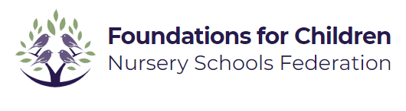

**Recruitment Pack**

|  |  |
| --- | --- |
|  | |
| Croyland Nursery School | Parklands Nursery School |

Contents

Welcome from our Executive Principal Lindsay Lambert 2

# A Brief History 4

Why work for us 5

# 

# **Welcome from our Executive Principal Lindsay Lambert**

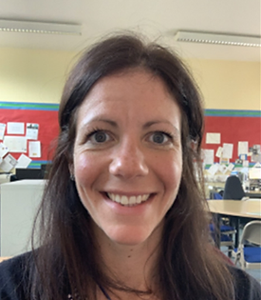

Thank you for your interest in joining the Foundation for Schools Nursery Federation.

Foundations for Children Nursery Schools Federation comprises of four maintained nursery schools: Camrose Early Years Centre for Children & Families and Parklands Nursery School in Northampton; and Croyland Nursery School & Day Nursery and Highfield Nursery School in Wellingborough. We have over 80 years' experience providing high quality early education for children aged 0-5.

Working collaboratively across our nursery schools we provide responsive, high quality early education, for all children in our communities. Our ambition for children's lifelong learning and success drives our commitment to strengthen our sustainable model of Nursery Schools, as we support the growing and diverse learning community.

Our mission underpins our values aiming to inspire and nurture foundations for lifelong learning, to foster strong family partnerships, and to optimise the life chances of all children.

In addition to our core values,

Every child is known, equally valued and supported to achieve their potential in all our nurseries. Every community we serve benefits from the facilities and services we provide.

We ensure that well-run nurseries retain and develop their distinct contextual identity, while sharing and contributing to our common values, practices, curriculum approaches and operational systems

Our staff benefit from strong networks, excellent career opportunities and a human approach where they are equally valued and supported.

Being part of a family community who are compassionate and dedicated, who believe can really improve young people’s life chances and opportunities by working together. If this appeals to you, we very much look forward to receiving your application.

# **A Brief History**

The Federation was formed in December 2021 comprising of Croyland Nursery School, Highfield Nursery School, Parklands Nursery School and Camrose Early Years Centre.

Our schools have a long history of providing early years education to the families of Wellingborough and Northampton - embedded into our local communities. We are proud to be working together so closely to continue the provision of high quality, extended services in our areas, in addition to training and support for our colleagues in the Early Years sector across Northamptonshire.

**Federation Vision, Mission and Values**

**Our values and who we are:**

Every child is known, equally valued and supported to achieve their potential in all our nurseries. Every community we serve benefits from the facilities and services we provide.

We ensure that well-run nurseries retain and develop their distinct contextual identity, while sharing and contributing to our values, practices, curriculum approaches and operational systems.

**Our Values;**

**Nurture and Compassion**

Harnessing a nurturing environment where compassion and kindness are at the heart of everything we do.

**Challenging**

Testing boundaries and not accepting the status quo

**Accountability**

Colleagues strive for excellence, taking responsibility for their actions and results.

**Equitable and inclusive**

Always fostering respect and a culture of inclusion, diversity, tolerance, and fairness

**Sense of belonging**

Child centred, encouraging curiosity, independence, participation, and encouragement towards skills for the future.

**Integrity**

Doing the right thing, always. This means being honest and open even when it is difficult.

High-quality educational provision for all at the heart of local communities.

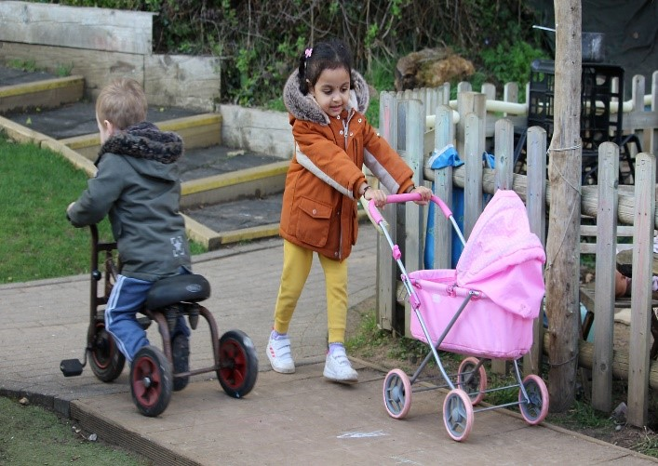

**Our Vision:**

Our vision is to provide warm, stimulating, welcoming environments which give us a secure foundation for all children and their families to become happy, confident, caring individuals who achieve personal success and develop a lifelong love of learning. We are proud of our school nurseries and welcome all visitors.

# **Why work for us**

**Benefits:**

As a collaborated Federation of 4 nursery schools, we can provide a wide network of opportunities for collaboration and career development for both teaching and support staff.

In addition, we also offer:

* Access to CPD via virtual college and development programme.
* Access to a free Employee Assistance Programme, offering mental health and wellbeing support
* Opportunity for progression and CPD within the Federation and wider maintained nursery school network.
* Access to the Local Government pension scheme
* Access to discounted fees for your children that attend one of our schools.

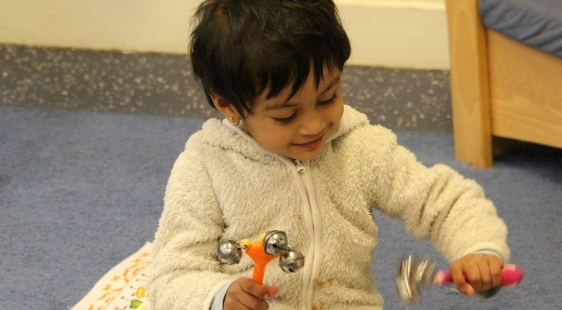  
  
**How to apply**

To apply please complete the online form on MyNewTerm. Your supporting statement should address and evidence the selection criteria detailed in the Person Specification.

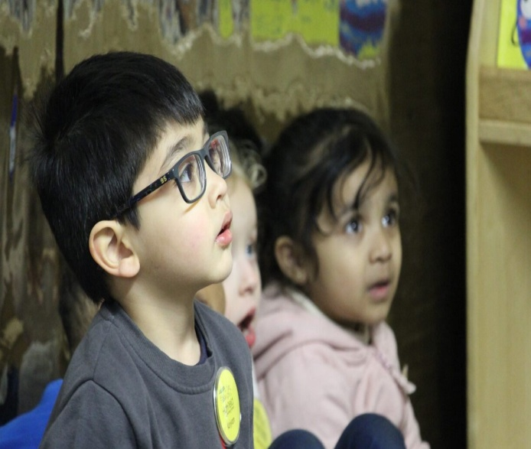

**Closing Date:**

**16th December 2024 at 8.00 am**

**Interviews: Week commencing 16th December 2024**

**Applying:**

For any questions about the application process please contact: Michelle Page HR Manager

**Email:**  [MPage@ffcnschools.com](mailto:MPage@ffcnschools.com)

We are committed to diversity & inclusion and equality of opportunity for all staff and applications from individuals are encouraged regardless of age, disability, sex, gender reassignment, sexual orientation, race, religion or belief and marriage and civil partnerships.

Foundations for Children Nursery School Federation is committed to safer recruitment practice and pre-employment checks will be undertaken before any appointment is confirmed. This post is subject to an enhanced disclosure and barring service check. We expect all adults who work for FFCN to share our commitment to safeguarding and the health and wellbeing of our children.