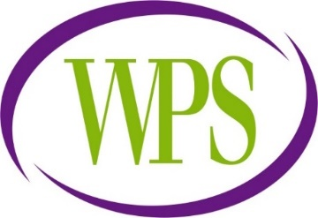

**Wyndcliffe Primary School, Little Green Lane, Birmingham, B9 5BG**

**Tel: 0121 464 4241**

**RECEPTIONIST/ADMIN**

**GRADE 2**

Wyndcliffe Primary School is seeking to appoint a Receptionist/Administrator to join our committed, enthusiastic and supportive team.

Hours – Fulltime 36.5 hours per week – Term Time Only

Start Date – September 2024

Status – Permanent/Fixed Term (2 posts)

Are you a well organised and enthusiastic Receptionist and Administrator looking for a friendly school to develop your skills? Wyndcliffe Primary School has an exciting opportunity for a Receptionist/Administrator to join our amazing team.

We pride ourselves on being a happy, warm and welcoming school with children at the heart of everything we do. We have high expectations and a culture of learning built on trust and support.

**Our Vision and values**

Our vision is to develop a community where children can enjoy a welcoming, secure, happy and healthy environment, all members can develop self-confidence, self-esteem, self-motivation, independence, compassion, tolerance and understanding.

As part of the Leigh Trust family of schools, we are **“The TEAM that CARES.”**

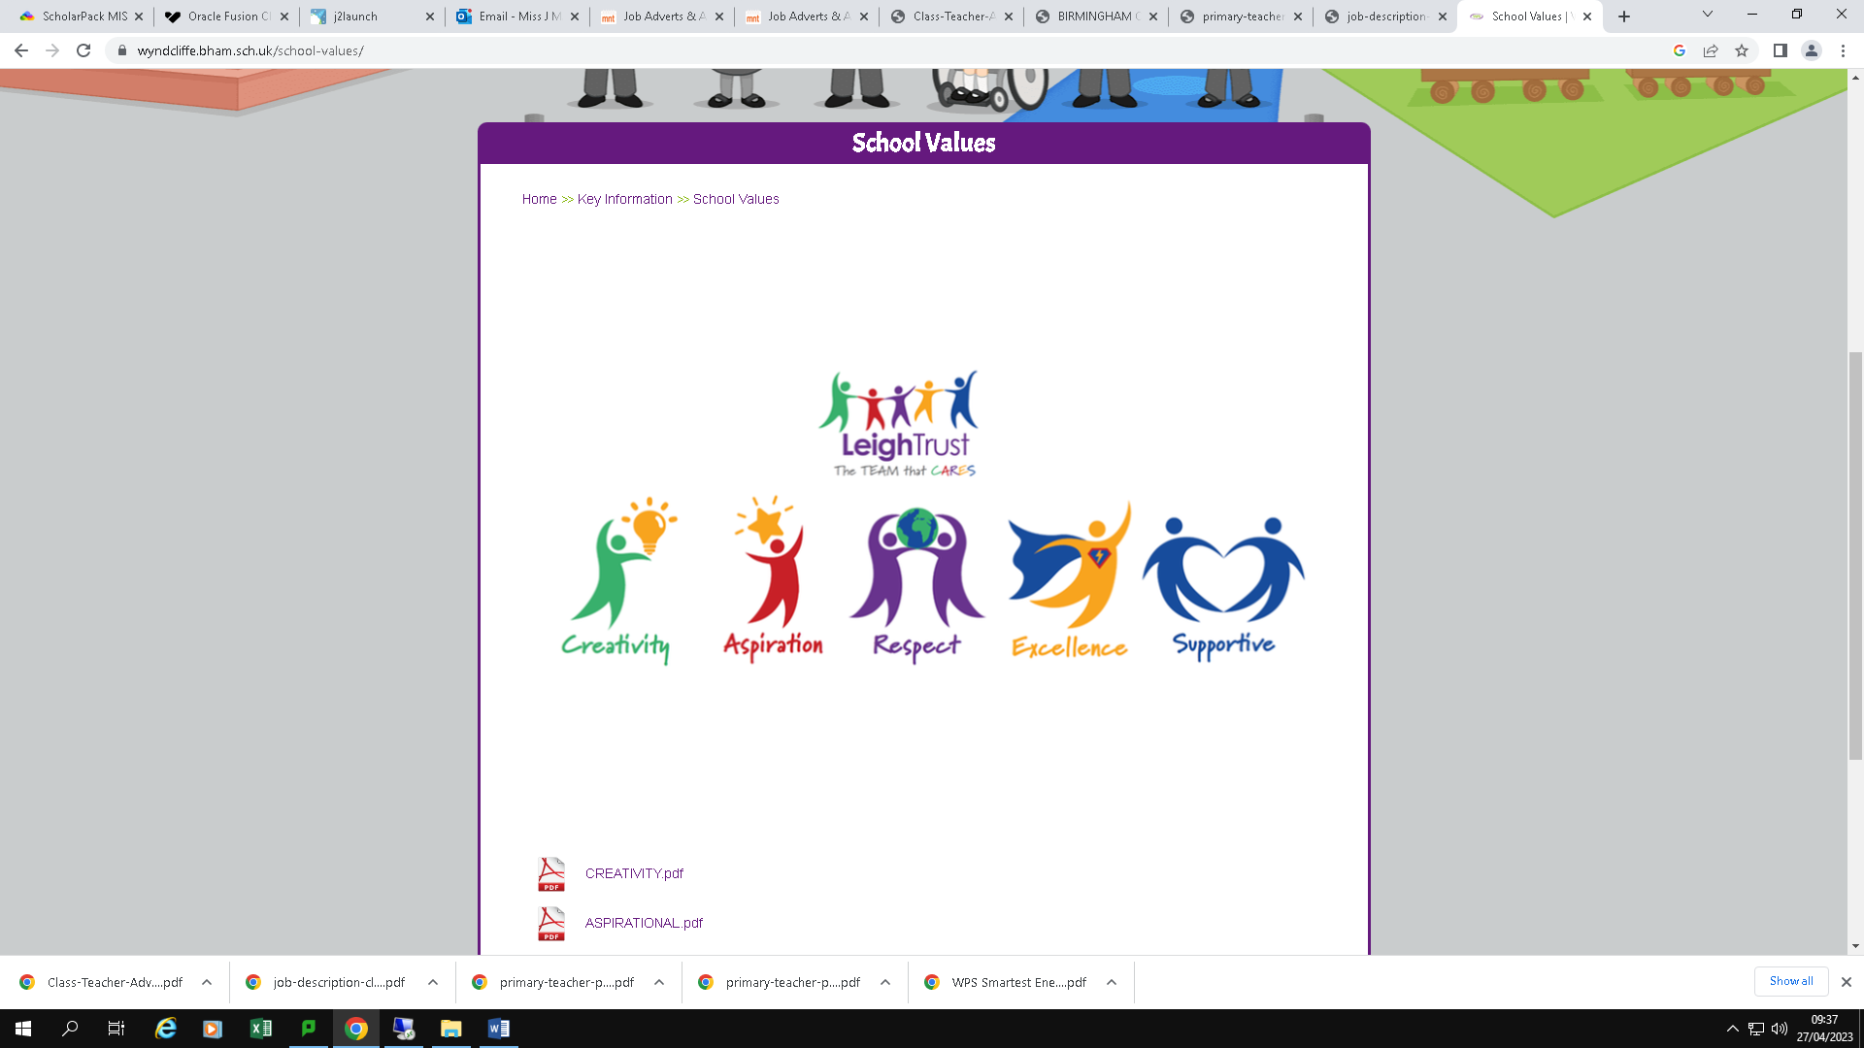

**We can offer you:**

* The opportunity to work in a truly inclusive and forward thinking school.
* A positive and enthusiastic staff, committed to achieving the best for all pupils.
* Happy, motivated, keen to learn children
* Commitment to support you in your continued professional development.
* Support of a caring and motivated Senior Leadership Team.
* The opportunity to collaborate with and benefit from the mutual support of schools within Leigh Trust.

**We are looking for applicants that:**

* Have a positive, optimistic outlook
* Have the ability to prioritise their own work load.
* Show initiative and work collaboratively with a team.
* Great communication skills with the ability to build trust and confidence with parents, children and colleagues.

If you have the skills required and are interested in joining our successful team, we would love to hear from you.

Closing date: Thursday 4th July 2024 at 9.00 am

Interviews: Week commencing 8th July 2024

**How to apply:**

To apply for the post, please complete the application form via mynewterm portal using the link on our website:

<https://www.wyndcliffe.bham.sch.uk/vacancies/>

Only applications submitted via mynewterm will be accepted.

This school is committed to safeguarding and promoting the welfare of children and expect all staff to share this commitment. The successful candidate will be subject to all necessary pre-employment checks, including:

Enhanced DBS; Prohibition check; Childcare Disqualification (where applicable); qualifications (where applicable); medical fitness; identity and right to work.

All applicants will be required to provide two suitable references.

An online search will also be carried out as part of due diligence on all short-listed candidates.

This post is exempt from the Rehabilitation of Offenders Act 1974 and the amendments to the Exceptions Order 1975, 2013 and 2020. This means that when applying for certain jobs and activities certain spent convictions and cautions are ‘protected’, so they do not need to be disclosed to employers, and if they are disclosed, employers cannot take them into account.