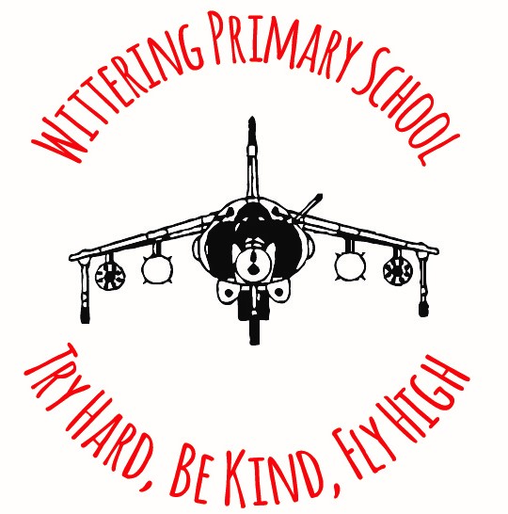

WITTERING PRIMARY SCHOOL AND FAMILIES CENTRE
Try Hard, Be Kind, Fly High
JOB DESCRIPTION
Wittering Primary School is committed to safeguarding and promoting the welfare of children and young people and expects all staff to share this commitment.
POST TITLE: BEFORE/AFTER SCHOOL CLUB PLAY WORKER
SCALE: GRADE 3
HOURS: 19 hours per week term time only (38 weeks of the year) covering both before and after the school day
RESPONSIBLE TO: Before/After School Club Leader, Operations Manager, Headteacher

Job Purpose

To provide support for the Before and After School Club provision and assist the Before and After School Club Leader

Main responsibilities

To assist in the day-to-day running of the Before and After School Club by:

- Promote a safe and welcoming atmosphere, where children feel valued and respected.
- Implement activities that foster creativity, physical activity and social development.
- Supervising children for fair behaviour during play, dealing with any minor injuries.
- Foster positive relationships with parents, carers and the community.
- Ensure cleanliness and organisation of play areas and equipment.
- Collaborate with fellow Play Workers.
- Ensure health and safety protocols are followed and maintain accurate records.

