Pastoral Support Assistant
Permanent Contract 30 hrs/week
Grade 3 SCP 7 - 11

Required 1st September 2024

Term time only + 5 INSET days
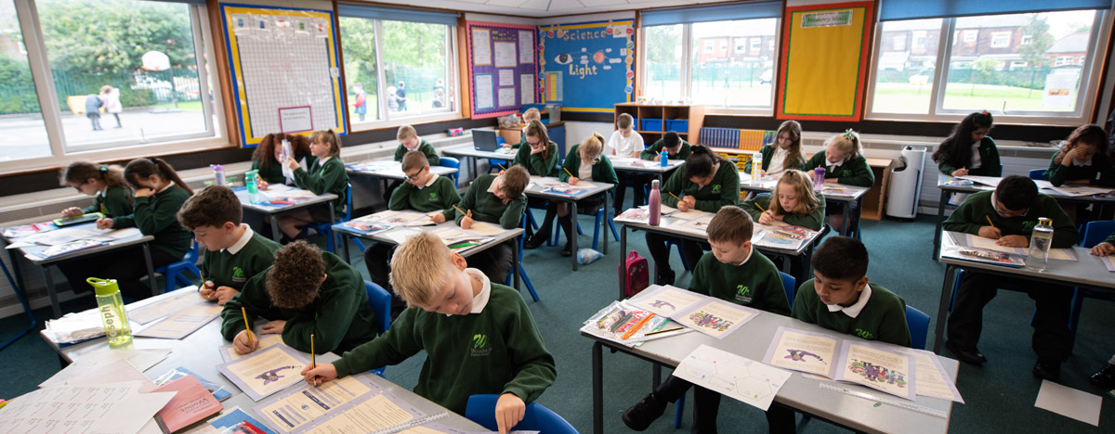
Required September 2024

Contents Page

Foreword from Academy Principal, Mrs Sharpe | Page 3
Woodlands Primary Academy Vision and Aims | Pages 4
South Pennine Academies Vision, Aims and Partnerships | Page 5-6
Selection Process | Pages 7
Job Description and Person Specification | Pages 8-11

Woodlands Primary Academy

Dear Potential Colleague,

Firstly, thank you for your interest in working at Woodlands Primary Academy, a proud member of the highly regarded Trust, South Pennine Academies. If you’re impressed by our exciting work, understand our vision, and want to be part of our journey, then we are keen to hear from you.

Woodlands Primary Academy was last inspected in January 2020 and it was identified that leaders have developed a strong sense of teamwork across the school. Staff morale is high. Leaders help teachers to improve their teaching and leadership skills through effective training and support. This work has contributed to the improved quality of education that pupils now receive.

Our motivation is to provide a nurturing school community, where children excel in their achievements and are inspired to continue learning in the future. We inspire children to become independent learners by fostering a willingness to take risks and persevere, celebrate individual strengths and promoting respectful attitudes. We believe in the holistic development of the child including teaching character such as respect, kindness and honesty as well as learner attributes such as responsibility, resilience and emotional well-being all of which underpin our vision of Enjoy, Thrive, Aspire.

We are looking for an enthusiastic, dedicated and inspirational candidate with a strong sense of character and someone who is committed to providing the best for children with complex needs. Most importantly we are keen to hear from candidates that are excellent at building good working relationships with children, parents, staff and other professionals from external agencies who will help our children to achieve their full potential.

If this is a position that appeals to you, and you have the passion to make a positive impact on the life chance of our students, then we would very much like to hear from you.

If you wish to discuss any of the opportunities we have on offer, please contact Leanne Allen, Office Manager, at lallen@woodlandsprimaryacademy.org or call 0161 359 5698. We also invite you to visit our website www.woodlandsprimaryacademy.org and our social media pages to learn more about Woodlands Primary Academy and the Trust.

Yours sincerely,

Catherine Sharpe
Principal

Our Vision and Values at Woodlands
Enjoy, Thrive, Aspire

At Woodlands Primary Academy we aim to create a nurturing school community, where children excel in their achievements and are inspired to continue learning in the future
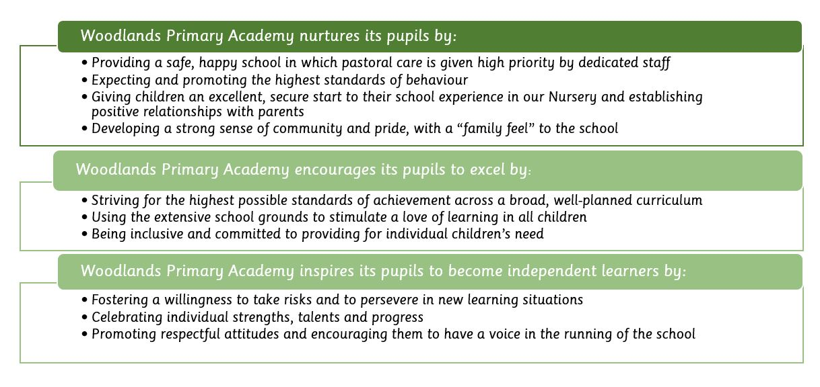

South Pennine Academies

Woodlands Primary Academy is a proud member of South Pennine Academies.
South Pennine Academies help us to reach our aims and objectives through tailored support. The vision, values and key priorities of the Trust are outlined below.

Vision
- To develop a group of closely partnered academies
- To ensure all academies are world class Centres of Excellence for Teaching and Learning
- To ensure the Trust plays a pivotal role in improving the life chances of students
- To develop local solutions and partnerships to meet local needs
- To promote school improvement with inclusion and diversity at its core
South Pennine Academies believes in school improvement through a partnership model.
This brings drive, expertise and capacity to the school improvement agenda. We recognise and encourage each academy’s unique characteristics and ethos, reinforcing their individual identities within their respective communities.
Working within a multi academy trust allows school to school support to flourish. Becoming part of our partnership will allow you to become a leader not a follower and be involved in shaping the partnership rather than having it shaped for you. Pes
- Strong and Effective Leadership
- High Performing Staff
- Successful Students
- Engaged Community

South Pennine Academies Partners
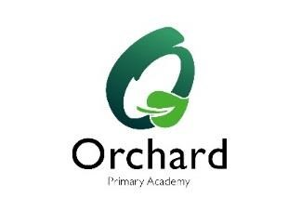

THE SELECTION PROCESS
How to Apply

Thank you for taking time to read and digest our information. If you wish to apply for the post of Pastoral Support Assistant, then you should:
- Follow the link to complete the electronic My New Term application form from the academy website at www.woodlandsprimaryacademy.org or by logging onto My New Term at www.mynewterm.com

- Complete the application form fully, ensuring all details are accurate and all declarations are signed. Please ensure you enclose two professional referees with one being your current employer (with email addresses if possible). Do not enclose additional CVs.

- Ensure you fully complete the relevant skills and experience section of the form, addressing the key characteristics and experiences outlined in the person / employee specification and the unique contribution that you could make to the future success of the Academy.

- Submit your application as soon as possible via MyNewTerm

Time table for the selection process:
- Closing date for applications: Friday 5th July @ 9.00am
- Interview Notifications by: Friday 5th July by 5.00pm
- Interview day: Wednesday 10th July

Successful applicants will be required to undertake a Criminal Record Check via the DBS. Woodlands Primary Academy is committed to safeguarding and promoting the welfare of children and young people and expects all staff and volunteers to share this commitment.

Job Description

Pastoral Support Assistant
(30 hours p/w, TERM TIME ONLY PLUS 5 DAYS TRAINING)

Job Title Pastoral Support Assistant

Salary Scale Grade 3 SCP 7 - 11

Responsible to Learning Mentor and SENCO

Required for 1st September 2024

Academies: Woodlands Primary Academy

JOB PURPOSE:
The Pastoral Support Assistant (PSA) plays a key role in supporting the work of the senior leadership and pastoral team, under the guidance of the Inclusion Leader. To take a lead role in providing high quality and effective safeguarding, SEMH and pastoral support across the school, maintaining accurate records and working with staff, pupils, parents and external agencies to ensure appropriate plans and strategies are in place to support pupils and their families. To lead peer to peer mentoring and deliver small group interventions to meet the needs of pupils. This job description may be amended at any time, following consultation between the Principal and member of staff and will be reviewed annually.
MAIN DUTIES AND RESPONSIBILITIES:
Act as a deputy safeguarding lead across the school:
• Working with the schools safeguarding leads to implement actions related to safeguarding concerns and matters.
• Under the direction of the DSL, liaise with social workers and other relevant support agencies to ensure that all families, vulnerable children and young people receive the care and protection they require.
• To lead on idenitified universal cases as directed by the learning mentor and, where required, cover the DSL in attendance at multi agency meetings.
• To meet regularly with the designated line manager to report on progress of identified pupils.
• Advise school staff on safeguarding matters.

Pastoral:
• Meet with pupils and parents as necessary to address pastoral concerns.
• To develop, agree and implement time bound action plans with groups or individuals linked to the needs of vulnerable pupils and to maintain accurate records of work for each identified pupil.
• To liaise closely with school staff to ensure that everyone understands and supports the strategies being used by the Pastoral Team to develop pupils’ skills for learning and learning behaviour.
• To work alongside the SENCO to contribute to the identification of barriers to learning for individual children and provide them with a range of strategies for overcoming barriers.
• To lead peer to peer mentoring programme across the school, focused on social interactions during play and lunchtimes.
• To work alongside SLT and the Office Administrator/Attendance Officer to improve attendance of vulnerable pupils.
• Take a joint lead to develop pastoral care of pupils, providing CPD as necessary.
• Lead workshops and arrange external talks to educate parents in pastoral trends and issues facing pupils.

Pupil Wellbeing:
• Take a lead role in developing and implementing practices which reflect the school’s commitment to positive behaviour and emotional well-being.
• Contribute to school’s positive behaviour policy.
• Work with the PSHE lead to enhance the delivery of the curriculum in this area, reflecting the schools own issues.
• To deliver interventions to groups or individuals, to meet their needs.

Admissions and Transition:
• To support the pastoral transition of vulnerable pupils, particularly from PVI to Nursery, Nursery to Reception and Year 6 to Year 7.

Management and General:
• To be a point of contact with parents/carers in relation to pastoral care and behaviour matters, liaising with teaching staff and senior leaders.
• Follow up all correspondence from parents/carers to ensure enquiries have been dealt with.
• Meet parents as required.
• Attend Pastoral Team or staff meetings as required.
• To keep up to date with the range of activities, courses and opportunities, organisations and individuals that could be drawn upon to provide support to pupils and build up a detailed knowledge of support available.
• To attend training and professional development sessions.
- To undertake other duties, appropriate to the post, as may be required from time to time.

Person specification

 | Essential | Desirable
Education and Qualifications | • Level 3 qualification  • GCSE English & Maths (A –C grade equivalent)  - Working knowledge of policies and procedures relating to child protection. | - First Aid Qualification  - ELSA qualification or be willing to train as an ELSA
Knowledge and Experience | - Experience of working with children or young people and their families.  - Experience of managing a caseload and maintaining accurate records. | - Experience of working in a school environment.  - Experience of dealing with safeguarding cases.  - Experience of contributing to or delivering training.  - Ability to contribute to policy development  - Knowledge and experience of working with a wide range of support agencies and services.
Skills | - Ability to evaluate the risk of abuse and assess the need for intervention.  - Ability to facilitate children and young people’s learning and development through mentoring, promoting and maximising educational achievement.  - Good listening skills and the ability to communicate effectively both orally and in writing, especially with children.  - Excellent organisation and time management skills.  - Problem solving skills  - Ability to record information concisely and present reports.  - Able to work exercise initiative, work independently and also deal with a number of problems at the same time, being able to prioritise.  - Good ICT skills  - An ability to work constructively as part of a team.  - A customer service ethos.  - Ability to work flexibly.
Knowledge | - Sound working knowledge of safeguarding  - Understand how external agencies work, what they do and when it would beneficial to use them.
Personal competences and qualities | - Enthusiasm and commitment to working with children and their families.  - Ability to respect confidentiality  - An open, honest and transparent approach | - Be a strong, reliable dependable person, consistent in approach but maintaining a sense of humour.

Thank you for taking the time to read and digest the information about our school. If you wish to apply for the post of Pastoral Support Assistant at Woodlands Primary Academy, then you should;
If you would like more information about Woodlands Primary Academy, or would like to visit the school, please contact Leanne Allen – Office Manager at lallen@woodlandsprimaryacademy.org or telephone
0161 3595698

South Pennine Academies is committed to safeguarding and promoting the welfare of children and young people. Therefore, we expect all workers, volunteers and employees to share this commitment. All appointments are subject to satisfactory pre-employment checks, including a satisfactory Enhanced criminal records with Barred List check through the Disclosure and Barring Service (DBS). CV’s will not be accepted.
Links to both the safer recruitment policy and Safeguarding and Child Protection Policy can be found on our website www.woodlandsprimaryacademy.org or by clicking the links below.
https://www.woodlandsprimaryacademy.org/docs/policies/Safer_Recruitment_Policy_.pdf
https://www.woodlandsprimaryacademy.org/docs/policies/Safeguarding_and_Child_Protection_Policy_.pdf

Please make sure that you demonstrate your ability to meet the requirements of the job by giving clear, concise examples of how you meet each criteria on your application form. References must be from your current or last employer in a senior role and from different places of work. The letters A, B and C in the "Rank" column refer to the importance we will give your answers when we read your applications. You must have all the A's on day one to be able to do the job, you need to have all the B's to do the job, but they could be learnt during the induction, and if you have C criteria this would be an additional bonus. We recognise and welcome our responsibility to remove any barriers in our Recruitment and Selection process for disabled people. We have tried to do this, but if you have a disability and identify any barriers in the job description or employee specification, please tell us of these in your application. We are committed to making reasonable adjustments to the job wherever possible and it would help us to know your needs in order to do this.

Where criteria are to be identified through the "Selection Process", this may involve written exercises, group discussions, presentations, interview etc.

Please note this role is subject to an Enhanced DBS Certificate

