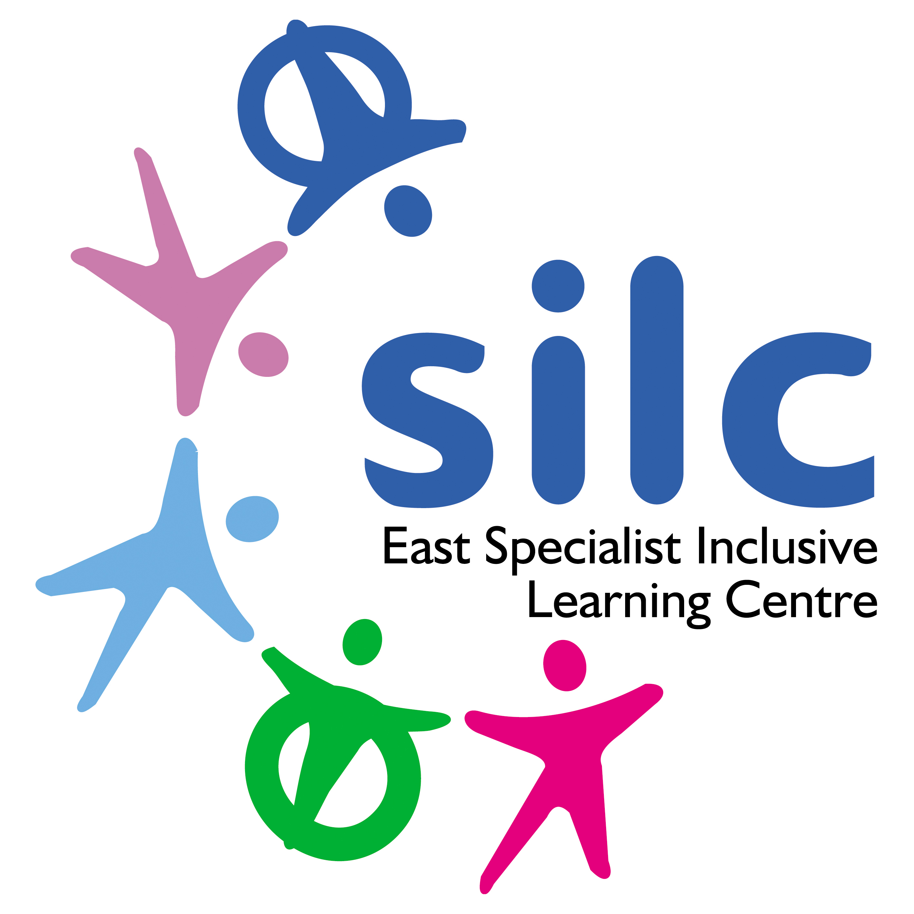
East Specialist Inclusive Learning Centre (SILC)
John Jamieson School

Job Description

Job Title: | Minibus Driver/ Level 1 Teaching Assistant
Pay Band: | B1
Responsible to: | Heads of School
Hours of Work: | 35 hours- Term Time Only

Values, Aims and Ethos
Our ethos and values are at the core of everything we do.

Aims
We aim to enhance educational, physical, personal and spiritual development and well-being, by taking into account the individual needs of all learners in the school environment. By working together as a multi-disciplinary team, the school aims to provide a holistic approach to learning.
Mission Statement/ Ethos
Personalised pathways to successful learning and continuous achievement.
Core Values
At the East SILC we believe that ‘Every Day is a Chance to SUCCEED’. We provide a bespoke system that underpins and runs throughout our core values for staff, learners and all stakeholders.
S | Support | – | Support and provide opportunities for all learners and staff members to maximise their potential.
U | Understanding | – | Understand the individual needs of all our learners.
C | Compassion | – | Awareness, kindness and providing positivity for self-worth.
C | Commitment | – | Commitment to the learning and growth of all staff through Professional Development and delivering a personalised learning experience for all learners.
E | Empathy | – | To understand or feel what another person is experiencing.
E | Enjoyment | – | Exciting and meaningful learning and enthusiasm for work.
D | Dignity | – | Respecting feelings, cultures and values and treat each other as individuals. We promote the right to feel valued and respected.

Proposed Role:

To assist in the provision of an effective and efficient transport service for pupils at East SILC as and when required. To support groups when out of school on educational visits and not driving.

Main Duties:
- To undertake the safe transportation of passengers and/or equipment to various locations in the school minibus, adhering to all traffic laws at all times.
- Responsible for the health and safety, comfort and welfare of learners and staff.
- To carry out regular vehicle safety checks, fueling and basic maintenance and cleaning duties accordingly.
- To report any vehicle defects, faults, incidents, accidents or near misses immediately to the Site Managers.
- To ensure the minibus is in a clean and roadworthy condition before and after use.
- To ensure all mileage logs and other paperwork relating to the minibus is kept up to date and accurate.
- To maintain the school’s image; appropriate working attire should be worn at all times and kept in a clean and tidy condition.
- To work within health and safety guidelines and other guidelines that may be issued from time to time.
- To attend any relevant training courses as identified and agreed.
- To undertake such duties appropriate to the post as may from time to time be required to ensure the smooth and efficient running of the school.
- To support learners on educational visits in a teaching assistant capacity and as directed by the visit lead.
- Providing support to learners who need assistance with personal care, such as feminine hygiene, changing nappies etc. for incontinent pupils and assisting learners to use the toilet if they are unable to use the toilet unaided.
- Feeding learners and assisting them with drinking, in-house training given.
- Supporting learners who because of their physical needs may need to be lifted and carried and/or in transported in wheelchairs, training will be provided.
- The post holder may be required to restrain learners who may harm themselves or others. Some learners may bite, kick, nip and punch etc. themselves staff and or other learners. Training will be provided on how to restrain learners appropriately.
- To supervise and support learners ensuring their safety and access to learning.
- To establish good relationships with learners, acting as a role model, being aware of, and responding appropriately to individual needs.
- To promote the inclusion and acceptance of all learners.
- To encourage learners to interact with others and engage in activities led by the teacher.

- To encourage learners to act independently as appropriate.
- To be aware of learner’s problems/progress/achievements and report to the teacher as agreed.
- To support learners to understand instructions.
- To support learners in respect of local and national learning strategies - literacy, numeracy, appropriate key stages, early years, as directed by the teacher.
- To be aware of and comply with policies and procedures relating to child protection, health, safety and security, confidentiality and data protection/GDPR regulations, reporting all concerns to an appropriate person.
- To be aware of, support difference, and ensure all learners have equal access to opportunities to learn and develop.
- To contribute to the overall ethos/work/aims of the school.
- To appreciate and support the role of other professionals.
- To attend relevant meetings as required.
- To participate in training and other learning activities and performance development as required.

Special Conditions of Service:
- A full clean UK driving license with D1 is essential.
- Term time working.
- The school and grounds have a no smoking policy.
- Requirement to occasionally work out of school hours and off school premises as required by the school.
- Working across the East SILC.

Safeguarding:
- The East SILC is committed to safeguarding and promoting the welfare of children and young people and expects all staff and volunteers to share this commitment. Appointments are made subject to a satisfactory Disclosure and Barring Service check (DBS formally CRB) and medical clearance from Leeds City Council’s Occupational Health Service.

- It is illegal to apply if you are on the children’s barred list.

The East SILC promotes diversity and wants a workforce which reflects the population of Leeds.

