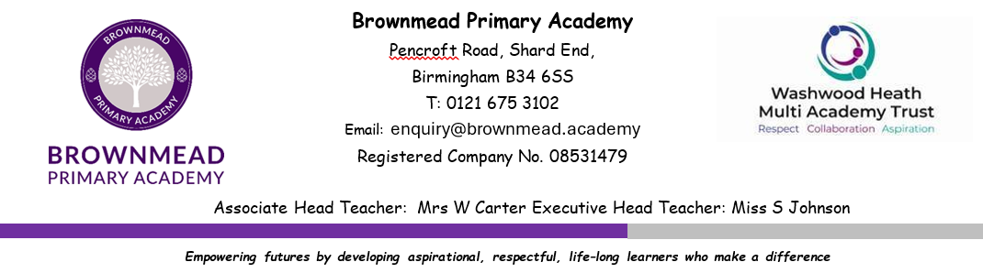

JOB DESCRIPTION

At Brownmead Academy we use our guiding values of ‘Achieve, Inspire and Motivate’ to empower our children to develop the skills and experiences to enable them to be confident, independent and active learners who will experience success in life.

We are a thriving school and we embrace our whole community and admit any child living in our area regardless of gender, social, ethnic, religious background or disability.

You are required to undertake an appropriate share of the duties attached to teachers generally within the school as set out in paragraphs 37-40 (inclusive) of the School Teachers Pay and Conditions Document, under the reasonable direction of the Headteacher and/or the Executive Headteacher.

Job Purpose:
In addition, you are required to undertake the following responsibilities which may or may not be included above.
 | Job Title: |  | Experienced Key Stage Two - Teaching Assistant
 | Grade: |  | GR3
 | 1.0 | JOB PURPOSE:
 |  | 1.1 | This level is applicable to experienced teaching assistants whose working role calls for competency across a varied range of responsibilities.
 |  | 1.2 | To support teaching staff in the development and education of pupils including the provision of specialist skills as appropriate.
 | 2.0 | DUTIES AND RESPONSIBILITIES:
 |  | Support for pupils (either individually or in groups)
 |  | 2.1 | Support the activities of individuals or groups
 |  | 2.2 | Establish and maintain relationships with individual pupils and groups.
 |  | 2.3 | Contribute to individual Education Plans as appropriate.
 |  | 2.4 | Support pupils during learning activities.
 |  | 2.5 | Promote pupils’ social and emotional development.
 |  | 2.6 | Contribute to the health and well-being of pupils.
 |  | 2.7 | Provide support for bilingual/ multilingual pupils (where appropriate to the focus of the role).
 |  | 2.8 | Support children with specific needs (where appropriate to the focus of the role), for example, sensory and/ or physical impairment, cognitive or learning difficulties, behavioural, emotional and social development needs, communication and interaction difficulties.
 |  | 2.9 | Support pupils with English (including Phonic skills) and maths skills
 |  | 2.10 | Support pupils to access the curriculum. Including adaptations to support pupil progress.
 |  | 2.11 | Dealing with the personal care needs of children, where appropriate, in line with the guidance of the Multi-Academy Trust.
 |  | Support for the teacher (s)
 |  | 2.12 | Observe and report on pupil performance
 |  | 2.13 | Contribute to the planning and evaluation of learning activities.
 |  | 2.14 | Assist in preparing and maintaining the learning environment.
 |  | 2.15 | Contribute to the management of pupils’ behaviour.
 |  | 2.16 | Contribute to maintaining pupils’ records
 |  | 2.17 | Support the maintenance of pupils’ safety and security. (Working with a Safeguarding ethos).
 |  | 2.18 | Supervise the whole class for a short time in an emergency (normally for a period less than a whole lesson until the teacher returns or alternative arrangements are made) or for a period of planned absence.
 |  | 2.19 | Undertake routine marking in line with school policy
 |  | 2.20 | Provide general administrative support, for example, administer coursework, produce worksheets, populate displays etc.
 |  | 2.21 | Undertake joint home visits as appropriate and in line with LEA policy
 |  | Support for the school
 |  | 2.22 | Support the development and effectiveness of teamwork within the school environment
 |  | 2.23 | Develop and maintain working relationships with other professionals
 |  | 2.24 | Liaise with parents as appropriate
 |  | 2.25 | Review and develop own professional practice
 |  | 2.26 | Work as required across the curriculum and in all Key Stages within the school in accordance with the job
 |  | Support for the curriculum
 |  | 2.27 | Support the use of information and communication technology in the classroom
 |  | 2.28 | Individuals have a responsibility for promoting and safeguarding the welfare of children and young people he/she is responsible for or comes into contact with.
 |  | 2.29 | To ensure their tasks are carried out with due regard to Health and Safety
 |  | 2.30 | To participate in appropriate professional development including adhering to the principle of performance management.
 |  | 2.31 | To adhere to the ethos of the school
 |  |  | 2.31.1 | To promote the agreed vision and aims of the school
 |  |  | 2.31.2 | To set an example of personal integrity and professionalism
 |  |  | 2.31.3 | Attendance at appropriate staff meetings and parents evenings
 |  | 2.32 | Any other duties as commensurate within the grade in order to ensure the smooth running of the school.
 | 3.0 | SUPERVISION RECEIVED:
 |  | 3.1 | Supervising Officer’s Job Title: |  | Phase leader
 |  | 3.2 | LEVEL OF SUPERVISION
 |  |  | Left to work within established guidelines subject to scrutiny by supervisor.
 | 5.0 | SPECIAL CONDITIONS:
 |  | 5.1 | See the Education (Specified Work and Registration) (England) Regulations 2003 and Guidance for Schools on Cover Supervision
 | Within the grade and job description of each level the exact focus of the role will be decided at school level and will take into account the needs of the school as well as the experience and development needs of the member of staff.

 | PERSON SPECIFICATION
Job Title: |  | EYFS Teaching Assistant Level 3
Grade: |  | GR3
Method of Assessment (M.O.A.)
A.F. = Application Form; I = Interview; T = Test or Exercise;
P = Presentation

CRITERIA | ESSENTIAL | M.O.A.
EXPERIENCE  (Relevant work and other experience) | Experience of supporting children in a classroom environment, including those with special educational needs  Experience of using Information Technology to support pupils in the classroom | AF/I  AF/I
SKILLS AND ABILITIES  (Eg Written communication skills, dealing with the public) | A good standard of education particularly in English and Mathematics  Knowledge of the legal and organisational requirements for maintaining the health, safety and security of yourself and others in the learning environment  Knowledge of SEN Code of Practice  Knowledge of strategies to recognise and reward efforts and achievements towards self-reliance that are appropriate to the age and development stage of the pupils  Ability to provide classroom cover – with agreed parameters – in the absence of the class teacher  Ability to consistently and effectively implement agreed behaviour management strategies  Ability to use language and other communication skills that pupils can understand and relate to  Ability to establish positive relationships with pupils and empathise with their needs  Ability to demonstrate active listening skills  Ability to provide levels of individual attention, reassurance and help with learning tasks as appropriate to pupils’ needs, encouraging the pupils to stay on task  Ability to monitor the pupils’ response to the learning activities and, where appropriate, modify or adapt the activities as agreed with the teacher to achieve the intended learning outcomes  Ability to carry out and report on systemic observations of pupils’ knowledge understanding and skills  Ability to assist in the recording of lessons and assessment as required by the teacher  Ability to offer constructive feedback to pupils to reinforce self-esteem  Ability to work effectively and supportively as a member of the school team  Ability to work within and apply all school policies e.g. behaviour management, child protection, Health and Safety, Equal Opportunities | AF/I  AF/I  AF/I  AF/I  AF/I  AF/I  AF/I  AF/I  AF/I  AF/I  AF/I  AF/I  AF/I  AF/I  AF/I  AF/I
TRAINING | Willingness to participate in further training and developmental opportunities offered by the school and county, to further knowledge | AF/I
EDUCATION/  QUALIFICATIONS  NB Full regard must be paid to overseas qualifications | NVQ Level 3 for Teaching Assistants or equivalent | AF/I
OTHER | Willingness to maintain confidentiality on all school matters | AF/I

OBSERVANCE OF THE MULTI-ACADEMY TRUST’S
EQUAL OPPORTUNITIES POLICY WILL BE REQUIRED

Signed: __________________________________ (Head Teacher)

Signed: __________________________________ (Post-holder)

Date: __________________________________

