Dear Applicant

School Meals Supervisory Assistant (SMSA)
Monday – Friday 12.05pm – 1.20pm
6 hours 15 mins TTO + 5 Inset Days)
Permanent Contract.
NJC 2 £23,656 full time and £3,494 actual salary
Required to start ASAP

We invite you to apply for this SMSA position to become part of our school family. This is an exciting opportunity to contribute to the vision of our school.

We are a school family at St. Teresa’s, where each member is proud to play their part. Our vibrant, one form entry, multi-cultural primary school, set in large grounds, is a place where every individual is valued, nurtured and respected so that they can flourish and live life to the full.

Duties will include supervising children during lunchtimes and most importantly, supporting pupils during play activities so that our children have an enjoyable and meaningful lunchtime experience.

If you think this is you then we would love to hear from you! To apply, please submit a completed CES application form.

Start date: As soon as possible.
Closing date: Thursday 9th January 2025
Potential Interview Date: Monday 13th January 2025

I look forward to receiving your application by the closing date.

Yours sincerely,
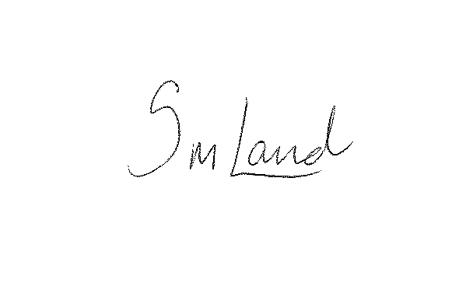

Mrs Samantha Land
Headteacher

