Behaviour & Learning Mentor
This role will also take a lead in organising after school clubs
Grade 8
Required September 2024
£25,997 actual salary – FTE £29,777

Term Time Only
37 hours plus 5 days

Job Description

Closing date: | 14th June 2024
Interview date: | Week commencing 17th June 2024

Contents

Page | Item
Page 3 | Safeguarding Notice /  Statement of intent
Pages 4 and 5 | A word from the Principal of Beaumont Primary Academy
Pages 6 and 7 | Information about South Pennine Academies Trust
Page 9 | The Selection Process
Pages 10,11 and 12 | Job Description
Pages 13 and 14 | Person Specification

Important Safeguarding notice / Statement of Intent

As part of your wider duties and responsibilities you are required to promote and actively support the Trusts ‘responsibilities towards safeguarding. Safeguarding is about keeping people safe and protecting people from harm, neglect, abuse and injury. It is about creating safe places, being vigilant and doing something about any concerns you might have. It isn’t just about the very old and the very young, it is about everyone who may be vulnerable.

2. Statement of Intent

2.1 South Pennine Academies is committed to ensuring a culture of safer recruitment and as part of that implement recruitment procedures that deter, reject or identify people who might abuse children. All Academies across the Trust adopt a consistent and rigorous approach in the recruitment and selection processes, with the aim of ensuring that those recruited are suitable for such an important and responsible role. The purpose of safer recruitment is ultimately to:

- Deter: From the beginning of the recruitment process, it is important to send the right message – that the organisation has a rigorous recruitment process and does not tolerate any form of abuse. Wording in adverts and recruitment information must aim to deter potential abusers.

- Identify and Reject: It will not always be possible to deter potential abusers. Therefore, careful planning for the interview and selection stage, in terms of asking the right questions, setting appropriate tasks and obtaining the right information can assist in finding out who is suitable for the role and who is not.

- Induct: Induction is an essential part of our recruitment process, we ensure that comprehensive induction processes are in place, together with appropriate policies and procedures, raising awareness through staff training and generally developing and maintaining a safe culture within the organisation will all help to prevent abuse or identify potential abusers.

2.2 The intention of this policy is to ensure that all stages of the recruitment process contain measures to deter, identify, prevent and reject unsuitable people from gaining access to pupils within the organisation. The policy and the practical implementation of recruitment and selection processes also aim to meet all legislative requirements, any statutory or other guidance that may from time to time be issued in order to keep children safe and safer recruitment in education, as well as principles of general good practice.

Beaumont Primary Academy
Background and Vision
‘’Adventures in Learning’’

Beaumont is a larger than average primary school with nearly 700 children from nursery to Year 6. Nursery has a small group of 2 year olds, a larger group of 3 and 4 year olds and then Reception to Year 6 has 90 children in each year group.

At Beaumont a highly skilled and experienced team of staff are all committed to providing a safe environment and a high quality education for our students. Our expectations are high and we work relentlessly to realise them. Our belief is that all children whatever their background and starting points, can achieve highly. We know that children only get one chance at their education and we have a duty to ensure that at the end of each stage of their education, children are ready and prepared for moving on to the next stage.

We are committed and proud of our offer for pupils with additional needs across school and in September 2023, we opened an additionally resourced provision for pupils with Social, Emotional, Mental Health Needs (SEMH ARP) This is a Kirklees partnership and will meet the needs of pupils with an EHCP (Education, Health Care Plan)

Alongside the strong focus on progress and attainment, a planned programme of opportunities is in place which enriches experiences, allowing students to develop their interests, social skills and embrace the community around them, in many areas of learning. Pupil voice is central to our work and we have a Gold Rights Respecting award in recognition of the work we do in respecting the rights of the child as well as a Gold Mental Health evidencing our commitment to the well being of everyone.

We want our children to be truly involved and excited by their education and as such we provide active, engaging and interactive learning experiences, both onsite and beyond as a classroom and this is an essential part of the role. The classroom environment is a fundamental part of the learning experience where children have a sense of ownership and are able to develop as purposeful, focussed and independent learners. To work at Beaumont, you must enjoy being outside whatever the weather.

We have well established relationships with our families and the local community and expect all staff to commit to this way of working. Beaumont is a very happy, calm, purposeful learning environment where children and adults thrive. It is a special place to work with low staff turnover – staff morale is high and staff relationships are exceptional. We face challenges with a genuine ‘can do’ approach and look for solutions – we are unapologetic and uncompromising in our vison for what is possible.

Beaumont Primary Academy serves a fabulous vibrant academy community from a diverse cultural and religious background. We want all of our students and families to be proud of themselves and who they are, whilst having the highest standards of respect and understanding for each other.
Beaumont Primary Academy has the advantage of sharing a site with Moor End Academy and we work closely together.

We are looking for people who have a proven track record of excellence, a strong commitment to their own professional development and wanting to continually improve our offer for our children through open, honest and reflective team work.

We can offer you a well- established team of highly professional and dedicated staff who work as one team in the best interests of our children.

We are uncompromising and relentless in our drive for the very best for every single child and their unique circumstances. If you think you are the right person to join our team, please do find out more:

- on our website www.beaumontprimary.org.uk or
- telephone and a member of SLT will be able to answer any further questions you may have.

We encourage visits to the school.

Debbie Kelly,
Principal

South Pennine Academies

Sponsorship

South Pennine Academies is the sponsor and works in partnership to raise levels of attainment and aspirations of all students. As sponsor, South Pennine Academies is very well placed to create a unique institution characterised by high achievement and success. The Trust has a national reputation for excellence and has a solid track record of partnership working with employers, universities and local academies.
The benefits that South Pennine Academies brings are immense, adding their expertise and ideas as well as opening up life-enhancing opportunities to all academies in the Trust including Beaumont Primary Academy.
The key to the Academies success will be the development of a shared vision, effective and transformational leadership and management, robust partnership arrangements, high quality and focused teaching which guarantees students learning and success. This all needs to be achieved amongst a strong and cohesive staff body.
Students will show good manners, work hard and be honest at all times. They will learn, share and succeed, together.
At Beaumont, we are proud to be part of the SPA team. Staff have fantastic opportunities to work with colleagues across the Trust and build upon good networks to support professional development. The Trust offer an excellent professional development calendar for staff across the academy.

The Vision:
- To develop a group of closely partnered academies.
- To ensure all academies are world class centres of excellence for teaching, learning and progress.
- To ensure the trust plays a pivotal role in improving the life chances of students.
- To ensure that local solutions and partnerships meet local needs.
- To focus on academy improvement with inclusion and diversity at the core.

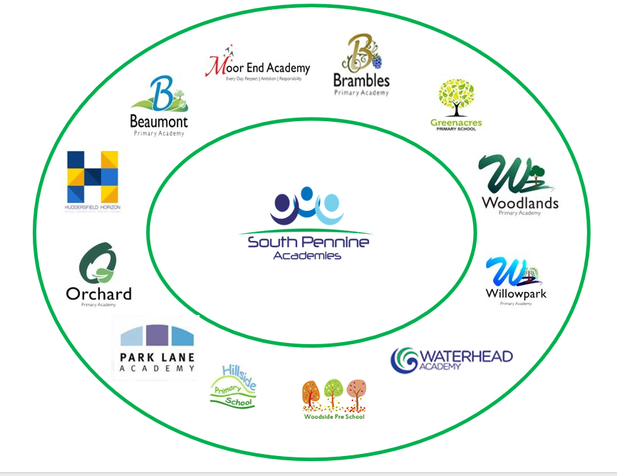
THE SELECTION PROCESS

How to Apply

Thank you for taking time to read and digest our information. If you wish to apply for the post of Behaviour & Learning Mentor you should;

- Apply via the My New Term website only. Late applications will not be considered. If you have any questions please telephone the school office on 01484 503111 to speak to a member of staff.

- Please do not complete a Kirklees Application form as they cannot be accepted. If you require a handwritten form to complete, please contact the academy office on 01484 503111.

- Complete the application form fully, ensuring all details are accurate and all declarations are signed. Please ensure you enclose two professional referees with one being your current employer (with email addresses if possible). Do not enclose additional CVs.

- Ensure you fully complete the relevant skills and experience section of the form, addressing the key characteristics and experiences outlined in the person / employee specification and the unique contribution that you could make to the future success of the Academy.

- Please ensure that your personal statement is no more than 2 A4 sides.

Beaumont Primary Academy, Dryclough Road Campus, Dryclough Road, Crosland Moor, Huddersfield, HD4 5JA.

Time table for the selection process – please see front cover

Successful applicants will be required to undertake a Criminal Record Check via the DBS.
Beaumont Primary Academy is committed to safeguarding and promoting the welfare of children and young people and expects all staff and volunteers to share this commitment.

Job Description
______________________________________

JOB DESCRIPTION – Behaviour & Learning Mentor

JOB PURPOSE:

A behaviour and learning mentor plays a key role in providing a supportive service to all pupils and their families in school whose difficulties are providing significant barriers to learning. Learning Mentors provide a complimentary service to both staff in school and external agencies.
The Learning Mentor role may include using strategies to:
· Improve learning and raise attainment.
· Work both in and out of the classroom on a 1:1 or small group basis.
· Work closely with the DSL, SENDco and Disadvantaged leads.
· Raise standards of behaviour.
· Provide both learning and nurture activities and support.
· Be very visible during unstructured times
· Lead and coordinate the extended schools offer for after school clubs
The Behaviour and Learning Mentor will work directly with identified individual or groups of pupils to help overcome barriers to learning, improve behaviour and raise achievement.
Main Duties / Responsibilities:
Learning:
· To work under the guidance of the class teacher/line manager to plan and monitor pupils learning. Ensuring the progress is clearly recorded in the relevant systems and relates to the learning objectives/goals for pupils.
· Assess the needs of pupils and use knowledge and specialist skills to support pupils’ learning by helping them to overcome barriers to learning both inside and outside the classroom in order to achieve their full potential, and enable the school to raise standards of achievement and behaviour.
· Establish productive mentoring relationship with identified pupils acting as a role model and setting high expectations.
· Promote the inclusion and acceptance of all pupils within the classroom.
· Support pupils consistently while recognising and responding to their individual needs.
· Encourage pupils to interact and work co-operatively with others and engage all pupils in activities.
· Promote independence and employ strategies to recognise and reward achievement and self-reliance.
· Provide feedback to pupils in relation to progress and achievement.
· Promote good behaviour, dealing promptly with conflict and incidents in line with the academy policy and encourage pupils to take responsibility for their own behaviour.
· Support pupils with their Social and Emotional development, providing strategies that they can use to enable them to be ready to learn.
Nurture and support:
· Organise and manage an appropriate learning environment and resources both in an out of the classroom.
· Organise learning activities when required.
· Within an agreed system of supervision, plan challenging teaching and learning objectives to evaluate and adjust lesson/work/plans as appropriate.
· Work with teachers to target children to get back on track with learning when required to.
· Monitor and evaluate pupil responses to learning activities through a range of assessment and monitoring strategies against pre-determined learning objectives.
· Provide objective and accurate feedback and reports as required on pupil achievement, progress and other matters, ensuring the availability of evidence.
· Record progress and achievement in lessons/activities systematically, and provide evidence.
· Work within an established discipline policy to anticipate and manage behaviour constructively, promoting self-control and independence.
· Secure positive family support and involvement through regular contact.
· Support the role of parents in pupils’ learning and contribute to/lead meetings with parents to provide constructive feedback on progress and achievement.
· Deliver high-quality SEMH and academic interventions both indoors and outdoors through bespoke, creative and active means.
Other duties:
· Liaise with school staff, the DSL, SENDco, Disadvantaged Lead and other agencies to support pupils to overcome barriers to learning.
· Share best practice and co-ordinate work to meet the needs in a focused and integrated way.
· Maintain a data base of children’s behaviour including records of incidents and action.
· Any other role required and agreed with the Principal and SENDco within the skills and role remit.
· Coordinate with external providers and school staff re after school club provision. Oversee all admin and organisation/allocation /communication for clubs
· Promote and actively support the Academy’s responsibilities towards safeguarding. Safeguarding is about keeping people safe and protecting people from harm, neglect, abuse and injury. It is about creating safe places, being vigilant and doing something about any concerns you might have. It isn’t just about the very old and the very young, it is about everyone who may be vulnerable.

Responsible for: None

Responsible to: Assistant Principal for Inclusion

