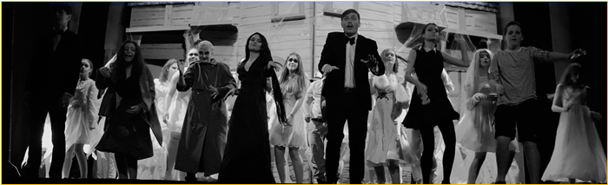
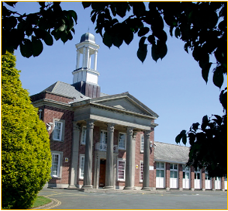
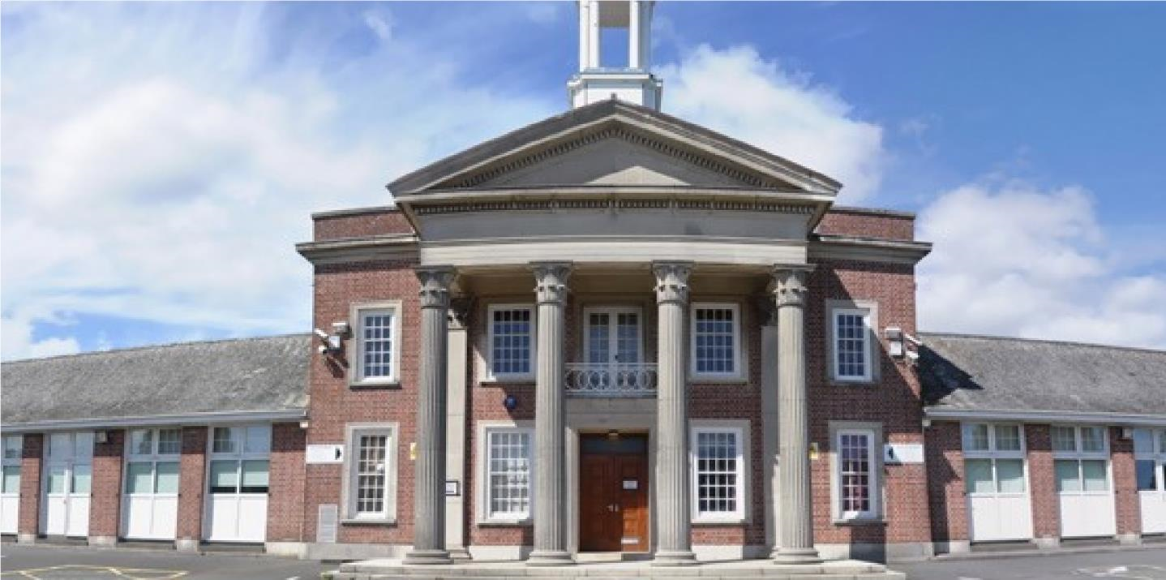

Learning Support Assistant
Candidate Pack

Seymour Road, Plympton, Plymouth, Devon PL7 4LT
Phone: 01752 337193
Email: heles.school@plymouth.gov.uk
Web: www.heles.plymouth.sch.ukd us on
Principal: Justine Mason

Application Procedure
Learning Support Assistant
Salary: NJC Grade B (scp 3-4). Starting salary £22,737 FTE, actual salary £14,130
Hours: 27 hrs 30 mins per week x 38 weeks per annum
Required to start 3rd September 2024

This is an exciting opportunity to join Hele’s School and Westcountry Schools Trust. Hele’s is a supportive, friendly and oversubscribed learning community with a very good reputation. We wish to appoint dynamic and ambitious team players with the capacity and commitment to provide high quality experiences and support for our whole school community. If you are motivated by the prospect of being part of ‘Team Hele’s’ and by working alongside others who share a passion and determination to provide the very best opportunities of our young people, then we would very much welcome your application.

If you would like to join us and feel you could thrive in a collegiate and positive atmosphere, then we’d love to hear from you!
Please click the link to submit your application form. Please note – we do not accept CVs. Completed applications should be submitted prior to the closing date.

The closing date for this application is 9am on Monday 1st July 2024.
Shortlisting will take place on Tuesday 2nd July 2024.
Interviews will be held Wednesday 10th July 2024. If you have not heard from us by this date, you should assume that your application has been unsuccessful. Prospective candidates are welcome to telephone the school for additional clarification if they wish.

With 27- strong cross-phase MAT we are regularly looking for passionate people to join our teams. If there are no vacancies currently, but you would like to register your interest for future vacancies, please join our talent pool and we will be in touch as soon as we have a suitable position.

Equality Statement
Hele’s School affirms its opposition to unfair discrimination and commits itself to a comprehensive policy of equal opportunity. At Hele’s we regard all members of our school as being of equal value and that each person has the right to equality of opportunity. We aim to create an atmosphere, which actively explores and counters myths, fears and prejudices that can work against equality of opportunity. No individual or group should be discriminated against on the grounds of their racial group, religion, sexual orientation, disability, ethnicity, nationality, age, gender, gender identity or political affiliation. Bullying and harassment will not be tolerated. Sexual and racial harassment, including persecution on the grounds of sexual orientation (i.e. homophobic bullying), are disciplinary offences and relevant policies will be followed in such circumstances.

Hele’s School is committed to safeguarding and promoting welfare of children and young people and expect all staff and volunteers to share this commitment; therefore, all posts will be subject to a satisfactory DBS Enhanced Disclosure.

Welcome to Westcountry Schools Trust (WeST), and thank you for your interest in this exciting position at Hele’s School.

This post presents a fantastic opportunity to work in a dynamic, ambitious school and a tight-knit team of dedicated staff, governors and trustees committed to providing the very best experiences and support for the young people in our care. The Pupil Admission Number at Hele’s increased from 210 to 240 students in September 2019, and each intake since has been over-subscribed at that number with a waiting list, such is the popularity of the school.

Beyond the boundaries of Hele’s School you will have the opportunity to work and contribute to the development of a cross-phase family of twenty-seven schools. We are passionate about our children benefiting from the blend of education in which we believe, and know that we can only achieve this by creating the right climate for our staff to excel and feel professionally rewarded. As such, you will work amongst a wide team of colleagues who are mutually supportive and value high quality professional development.

If you share our passion for children succeeding, regardless of their starting points, and believe you have the skills and energy to make a difference to the lives of our young people, we very much look forward to you joining our team. We actively appoint people with a strong sense of moral purpose and a desire to help all students – we firmly believe that education can make a difference to the life chances of all young people.

Our promise to you as a colleague working in a Westcountry Schools Trust establishment is that you will be valued, empowered, invested in and grown in this role, supported to move on to the next stage in your career, whatever and wherever that may be.

Rob Haring
Chief Executive Officer, WeST

I take great pleasure in welcoming you to Hele’s School! We are a school with a tradition of academic excellence, high aspirations and a big heart. A school that students and staff are proud to attend. A school where we never compromise our insistence that everyone is valued, learns, enjoys and achieves. Expectations for staff and students are high, but very simple; work hard both to do things right and to do the right thing…even when no one is looking!

Our mission is to support and challenge each individual, adult or child, to be the best they can be. We have a ‘no excuses’ philosophy based on growth mindset principles, which reinforces our belief that all of us can always improve, and that nothing is impossible. Quite simply, it isn’t about being ‘the best’ at something but being better than we were yesterday or today. It is for this reason that recognising and celebrating endeavour, as well as achievement, is something we hold dear.

We work hard at providing an inclusive, calm, and purposeful learning environment, and aim to ensure all students have opportunities to enrich their learning, to discover new skills and interests, and to master others through providing a breadth of curricular and extra-curricular opportunities to excite and engage young people, wherever their interests or aspirations may lie.

I am extremely proud to lead a dedicated and enthusiastic team of staff who are passionate about working with young people and are committed to ensuring that those entrusted in our care get the best life chances possible. Everything we do is shaped by our determination to ensure that each and every child has a positive and memorable experience of school; that they thrive, flourish and, crucially, are happy. We focus on opportunities to develop teaching and learning at every turn and, importantly, teachers at Hele’s have a resolve to be the best they can be in the classroom; our core purpose being to remove barriers to learning so that young people can be inspired, can aspire and can achieve. In return we expect a buy in to our belief that we all have an active role to play in making our school a great place to be, which manifests itself in every child displaying the highest standards of commitment to learning, pride and care.

Hele’s is a community committed to personal and professional growth of all, with dedicated staff and governance, supportive families and committed students. I have no doubt that the right candidate will be happy, supported and fulfilled being part of Team Hele’s, and will take great pride in what we can achieve together for our community and for each other. I do hope you are inspired to apply for this post and I look forward to reading your application.

Thank you in advance for the time and emotional investment that I know you will commit to this process.
With very best wishes.

Justine Mason
Principal

About Hele’s School

Hele’s School is a larger than average 11-18 comprehensive school in Plympton, Plymouth. Plympton sits at the north eastern edge of the city, bordering the South Hams area of outstanding natural beauty.

The school makes use of the closeness of Devon’s countryside and moors and Plymouth’s waterfront with a thriving Cadet Corps and Duke of Edinburgh Scheme. Our Combined Cadet Force (CCF), incorporating Army, Royal Navy and Royal Air Force corps, is one of our unique selling points, providing a visible presence both in the school and the wider community and opening up countless opportunities for our students around leadership, teamwork and personal presentation, outdoor pursuits, to name just a few.

In recent years, the Pupil Admission Number has increased to 240 in each year group and a period of capital investment to meet this growth is being planned. There are 1350 students in the school, which includes a thriving Sixth Form of 210, based in specialist accommodation.

Hele’s has a proud and long history as a caring school with a strong reputation for excellence and providing opportunity. It enjoys the support of an active parent body, who share our determination to provide the highest quality of education and pastoral care for their children. Students’ attitudes to learning are good; they are well behaved and attendance and punctuality are excellent. In short, the young people entrusted to our care want to learn and are delightful to teach.

Our pastoral system is organised around year groups with an 8-form entry and leadership from a teaching Head of Year and a non-teaching Pastoral Support Manager for each year group. There is a 30-minute tutor period each morning with a Guided Reading Programme and a strong programme of Personal Development in this time, supported by weekly assemblies. The pastoral leadership team and tutors remain with the tutor group and take them through from Year 8 to Year 11 so that the relationship between tutor and students is deep and sustained, and family connections with school become trusted and embedded. Year 7 remains as a separate year team of specialist tutors and Head of Year so that we can ensure an exceptional start to secondary school for every child.

Post-16 has a mix of Year 12 and Year 13 students in each Tutor group. We use every opportunity to harness the expertise and interest of our Post-16 learners to act as leaders and mentors to younger students in all manner of ways, including having a visible Junior Leadership Team (JLT) to act as an important conduit for student voice and school improvement.

An excellent professional body of teachers and a hardworking and effective team of associate staff is a hallmark of the school and Hele’s is fully staffed in all areas with specialist teachers. Middle Leaders form an active and effective Joint Leadership Group (JLG) with Senior Leaders, and the JLG is the driving force behind school improvement.

The curriculum structure is currently based around a 2-year KS4, with GCSE options ordinarily taken in the spring term of Year 9. We operate a 2-week timetable with 50 lessons a fortnight, each of 1-hour duration. The school day runs from 8.40am to 3.10pm, allowing plenty of time for the well-developed and rich extra-curricular provision, which includes a mix of academic, sporting, performance and personal development opportunities, as well as a newly-implemented Guided Reading Programme that runs for all year groups (except for Year 11 and Year, which have an intervention programme) in Tutor time.

Hele’s plays its part fully in the Westcountry Schools Trust, in Plymouth and beyond; the Principal has a passion and commitment for Hele’s to be outward-facing, and the school and trust regularly contribute to national, regional and city-wide initiatives on a range of fronts, maintaining a strong relationship with the Local Authority, the Regional Directors, and other organisations across the country.

History of Hele’s School

Elize Hele was born in Brixton in about 1560 and although he lived most of his life at Fardell, Cornwood, on the outskirts of Plympton, his final resting place is in St Andrew’s Chapel in Exeter Cathedral. Having no heirs, Elize left his wealth to be used for “pious uses”. A number of schools in the South West were founded out of his estate by his trustees, including the grammar school at Plympton, which was, until its temporary closure at the end of last century, known as Hele’s School, Plympton.

The old grammar school building, which still stands in Plympton St. Maurice, was completed in 1671. Next to it stood the Schoolmaster’s house in which Sir Joshua Reynolds was born. It is a surprising fact that the old grammar school produced four distinguished artists: Sir Joshua Reynolds, the first President of the Royal Academy; James Northcote; Benjamin Haydon and Sir Charles Eastlake, President of the Royal Academy and the first Director of the National Gallery.

The school faced many difficulties in the latter part of the nineteenth century and was eventually forced to close in 1903, before it was reconstituted by Devon County Council as a co-educational grammar school in 1921 called Plympton Grammar. The school grew and prospered and moved to its present site on Seymour Road in 1937.

New extensions were opened from 1970, and in 1983 refurbishment took place in preparation for reorganisation into an 11 – 18 mixed comprehensive school and it reverted to its old name of Hele’s School.

In the decade from 2000, Hele’s benefited from three specialisms - Languages, Maths & Computing and Applied Learning - and enjoyed national acclaim as a Language College. This strength continues, despite the change to national policy and the subsequent removal of funding, and international links and internationalism remain important.

The school became a Converter Academy in April 2011 and operated as a Stand Alone Academy Trust for the following 7 years. In September 2018, Hele’s joined a Multi Academy Trust, the Westcountry Schools Trust (WeST), which it played a key part in co-constructing.

Stronger Together

A now 27- strong cross-phase MAT of 19 Primaries, 7 Secondaries, plus an Adult Training Provider, the Westcountry Schools Trust is geographically tight but spans Devon, Plymouth and Cornwall. With the strength of collaboration and ambition, the capacity for shared school improvement, leadership development and collaboration is limitless. The WeST aspiration of ‘Every child in a great school’ sits well with the Hele’s vision (and vice-versa) and the strap line ‘Stronger together’ articulates our shared ambition to ensure that this aspiration becomes a reality.

There remains a strong commitment, professionalism and moral imperative amongst the Hele’s staff and Local Governing Body to ensure we provide the young people in our care with an educational and pastoral support experience that is first class in every aspect. This is very much supported by the WeST Trust Board and strategic direction of the MAT. We have a burning ambition and determination to put Hele’s firmly on the map locally, regionally and nationally and to be recognised as an outward-facing, aspirational and collegiate centre of excellence, which remains committed to continuous improvement.

Hele’s School Ambition

Our school’s purpose:
To warm hearts and to light fires in minds. Our ambition is to inspire confident learners who will thrive in a changing world, never fearful of taking risks and learning from mistakes made as part of their growth. We hold dear the belief that ‘people matter’, and the quality of personal relationships at all levels is central to ensuring a safe, happy, caring, inclusive environment.

Vision:
We pride ourselves on being an outward-facing school community that delivers outstanding academic and personal outcomes for all.

Mission:
We instil a passion for learning - for child and adult alike.
We allow everyone a chance to shine.
We provide a safe, happy community, where we are all supported and challenged to be the best we can be.
We believe there is no ceiling to aspiration.
We ensure a growth mindset culture pervades all we do.
We celebrate endeavour at every opportunity.
We grow ‘future fit’ young people.
We are a school in the heart of the community and with the community in our heart.
We develop and maintain a reputation for excellence - locally, regionally and nationally.
We remain restless for continuous improvement, always striving to be better.

Values:
We dream big, aim high and work hard.
We have pride in all we do and all we are.
We respect each other, our environment, and ourselves.
We ensure outstanding learning is at the core of our provision.
We do things right, and we do the right things.
We have high expectations of and for every person.
We strive to be better each day – as adults and as young people.
There are no excuses – all can achieve no matter their starting point.
We ’walk the talk’ and all play our part in ensuring Hele’s is a great school to be part of.

WESTCOUNTRY SCHOOLS TRUST

JOB DESCRIPTION

Job Title: Learning Support Assistant

Location: Across the Trust (based at Hele’s School currently)
Grade: Scale B (scp 3-4)
Hours: 27 hrs 30 mins/38 weeks per year (term-time only)
Reports to: SENDCO, Deputy SENDCO & Deputy Principal (Support)

Job Purpose
To work under the direct instruction of teaching/senior staff, usually in the classroom with the teacher, to support access to learning for students and provide general support to the teacher in the management of students and the classroom. Work might occasionally, but not regularly, take place outside the main teaching area.

Responsibilities

To work under direct supervision/instruction to support access to learning by:
- Attending to the welfare and personal care of students including those with special educational needs
- Working with small groups or one to one
- Undertaking general clerical/organisational support for the teacher

Duties

Support the teacher by:
- Scaffolding and differentiating work as advised
- Supervise and provide support in the classroom for students with special educational needs, ensuring their safety and access to learning activities
- Being aware of pupil problems/progress/achievements and reporting these to the teacher as agreed
- Sharing pupil feedback as requested
- Being aware of/working within planned learning activities
- Occasional contribution to planning e.g. for individual students, general literacy/numeracy
- Working with the teacher in managing pupil behaviour and reporting difficulties as appropriate
- Gathering/reporting information from/to parents/carers as directed
- Invigilating/administering routine tests/exams
- Have high expectations for all students that you support and wherever possible, assist in breaking down barriers to learning
Supporting students by:
- Supervising and providing support for students, including those with special needs, ensuring their safety and access to learning
- Attending to the student’s personal needs, and implementing related personal programmes, including social, health, physical, hygiene, first aid and welfare matters
- Establishing good relationships with students, acting as a role model and being aware of and responding appropriately to individual needs
- Promoting the inclusion and acceptance of all students
- Encouraging students to interact with others and to engage in activities led by the teacher
- Encouraging students to act independently as appropriate
Support the curriculum by:
- Supporting students to understand and follow instructions
- Supporting students in respect of local and national learning strategies
- Supporting students using ICT as directed
- Preparing and maintaining equipment/resources as directed by the teacher and assisting students in their use
Support the school by:
- Being aware of and complying with policies and procedures relating to child protection, health, safety and security, confidentiality and data protection, and reporting all concerns to an appropriate person
- Being aware of and supporting difference and ensuring all students have equal access to opportunities to learn and develop
- Contributing to the overall ethos/work/aims of the school
- Appreciating and supporting the role of other professionals
- Attending relevant meetings as required
- Participating in training and other learning activities and performance development as required
- Assisting with the supervision of students out of lesson times, including before and after school and at lunchtimes as required
- Accompanying teaching staff and students on visits, trips and out of school activities as required.
General
- Preparing and contributing to Trust wide development by sharing best practice and professional feedback.
- To assist with the production and analysis of regular reports on activity for use at management meetings and feedback, as appropriate for the role.
- To maintain designated databases / files in accordance with Trust policies for data governance, as appropriate for the role.
- To comply with and promote all Trust policies, including Safeguarding, Health and Safety, and Equality & Diversity.

This is not an exhaustive list and additional duties may be added as appropriate and commensurate to the pay grade.

PERSON SPECIFICATION

E = Essential, D = Desirable

Method of Assessment  The table indicates the possible method/s by which the skills/knowledge/level of competence in each area will be assessed. | Essential or Desirable | Application Form | Interview (or other selection activity)
Qualifications:
GCSE English and Maths grade C or above | E | ✓
Knowledge of ICT systems | E | ✓
Experience of working in a school environment | D | ✓
A recognised First Aid qualification or training will be provided. | D | ✓
Experience:
Experience of working in a busy environment | E | ✓ | ✓
Experience of working with children/young adults | E | ✓ | ✓
First Aid experience | D | ✓ | ✓
Knowledge, Skills and Abilities:
Interest in and enjoyment of working with children | E | ✓ | ✓
Excellent communication skills | E | ✓ | ✓
Compassionate and caring | E | ✓ | ✓
Punctual and reliable | E | ✓ | ✓
Confidentiality of information | E | ✓ | ✓
High levels of commitment and enthusiasm | E | ✓ | ✓
Initiative, flexibility and ability to work independently | E | ✓ | ✓
Commitment to equal opportunities Commitment to Safeguarding | E | ✓ | ✓
Calm under pressure | E | ✓ | ✓
Reflect on and develop professional practice | E | ✓ | ✓
To have a ‘can do’ philosophy | E | ✓ | ✓
Good relationships with students | E | ✓ | ✓
Good organisation skills | E | ✓ | ✓
Good motivation skills | E | ✓ | ✓
Effective communication and interpersonal skills | E | ✓ | ✓
Ability to work as part of a team | E | ✓ | ✓
Willingness to undertake further training as required | E | ✓ | ✓

