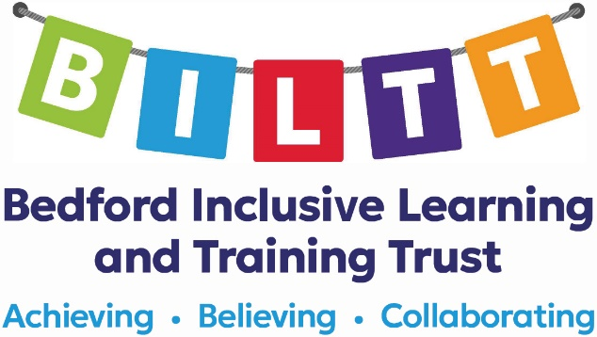

JOB DESCRIPTION

JOB TITLE: | Learning Support Assistant Level 3
GRADE/SALARY: | 3 AS point 6 - 9
DATE PREPARED:  REPORTS TO: | September 2024  Class Teacher/Assistant Headteacher

It is expected that SLSAs will fulfil all the expectations of the role of Learning Support Assistant. In addition, the role will also require the following:

MAIN DUTIES AND RESPONSIBILITIES: Learning Support Assistant

- Work under the direct guidance and advice of the class teacher with all aspects of planning, class organisation, staff support and delegation of duties.
- Provide professional support to teachers in agreed aspects of planning, implementing and evaluating teaching and learning and supporting pupils with complex learning needs to access curriculum and make progress against individual and generic targets.
- Be conversant with lessons and able to plan and deliver structured activities with guidance, without the direct supervision, of the teacher to cover.
- Under the direction of the teacher, direct, advise and support other LSAs in classroom management, working with pupils, assessing and recording, pupil care and pupil programmes.
- Select, adapt and prepare appropriate resources/methods to facilitate agreed learning activities under the direction of the teacher.
- Prepare work and make resources.
- With direction from the teacher, offer support for families – liaise with parents/carers via the home school diary, telephone calls and electronic communication methods.
- Support with parent/carer consultations.
- Mentor new staff as directed.
- Any other duties of similar nature or level as required.

Also:

MAIN DUTIES AND RESPONSIBILITIES: Learning Support Assistant

- Support pupils with all learning opportunities as directed by the class teacher.
- Under direct or indirect supervision deliver prepared work to small group of pupils or provide one-to-one support to a pupil.
- Ensure supervision of pupils at all times including play/break times, transport etc.

- Access relevant training in addition to induction in order to develop skills for use in the classroom.
- Undertake whole school duties as directed by class teachers or SLG.
- Work with both individual pupils and groups of pupils to support learning and promote access to learning activities.
- Implement behaviour support plans with pupils, as directed.
- Implement communication programmes with pupils, as directed.
- Support the personal and social aspects of teaching, for example, working with pupils on eating programmes and toilet training.
- Contribute towards the physical education of pupils, for example, swimming and PE.
- Assist in aspects of recording pupil progress as directed by the class teacher and in line with school policy.
- Assist in creating educational resources including classroom and whole school displays.
- Accompany pupils on educational visits and journeys including sports events and community access.
- Attend regular after school staff meetings as directed by SLG.
- Respect confidentiality of information on all pupils and their families.
- Any other duties of similar nature or level as required.

EQUALITY AND DIVERSITY STATEMENT:

The Trust will seek to ensure that all existing and potential employees and students are given equal opportunities for employment and education. It is committed to the elimination of unlawful or unfair discrimination on the grounds of any of the protected characteristics (as defined by the Equality Act 2010). The Trust will seek to ensure that no applicant for employment or education is disadvantaged by conditions or requirements which cannot be justified. The Trust provides an open, welcoming and safe environment for all its students, employees and visitors.

PREVENT STATEMENT:

All employees are required to uphold the values of democracy, rule of law, individual liberty and tolerance and have mutual respect for those with different faiths and beliefs.

BILTT is committed to Safeguarding, Prevent, the welfare of pupils and ensuring equality of opportunity for all pupils, staff, parents and carers; irrespective of age, disability, gender reassignment, marriage & civil partnership, pregnancy & maternity, race, belief, sex or sexual orientation and expects staff to share that commitment. The post is subject to satisfactory references, social media checks, enhanced DBS & health clearance.

