Level 1 Play Leader and Teaching Assistant
Grade 1 SCP 1 - 4
(30 hours p/w, term time only plus 5 days training)

Required September 2024

Contents Page

Foreword from Academy Principal, Mrs Sharpe | Page 3
Woodlands Primary Academy Vision and Aims | Pages 4
South Pennine Academies Vision, Aims and Partnerships | Page 5-6
Selection Process | Pages 7
Job Description and Person Specification | Pages 8-11

Woodlands Primary Academy
Dear Potential Colleague,

Firstly, thank you for your interest in working at Woodlands Primary Academy, a proud member of the highly regarded Trust, South Pennine Academies. If you’re impressed by our exciting work, understand our vision, and want to be part of our journey, then we are keen to hear from you.

Woodlands Primary Academy was last inspected in January 2020 and it was identified that leaders have developed a strong sense of teamwork across the school. Staff morale is high. Leaders help teachers to improve their teaching and leadership skills through effective training and support. This work has contributed to the improved quality of education that pupils now receive.

Our motivation is to provide a nurturing school community, where children excel in their achievements and are inspired to continue learning in the future. We inspire children to become independent learners by fostering a willingness to take risks and persevere, celebrate individual strengths and promoting respectful attitudes. We believe in the holistic development of the child including teaching character such as respect, kindness and honesty as well as learner attributes such as responsibility, resilience and emotional well-being all of which underpin our vision of Enjoy, Thrive, Aspire.

We are looking for an enthusiastic, dedicated and inspirational candidate with a strong sense of character and someone who is committed to providing the best for children with complex needs. Most importantly we are keen to hear from candidates that are excellent at building good working relationships with children, parents, staff and other professionals from external agencies who will help our children to achieve their full potential.

If this is a position that appeals to you, and you have the passion to make a positive impact on the life chance of our students, then we would very much like to hear from you.

If you wish to discuss any of the opportunities we have on offer, please contact Leanne Allen, Office Manager, at lallen@woodlandsprimaryacademy.org or call 0161 359 5698. We also invite you to visit our website www.woodlandsprimaryacademy.org and our social media pages to learn more about Woodlands Primary Academy and the Trust.

Yours sincerely,

Catherine Sharpe
Principal

Our Vision and Values at Woodlands
Enjoy, Thrive, Aspire

At Woodlands Primary Academy we aim to create a nurturing school community, where children excel in their achievements and are inspired to continue learning in the future
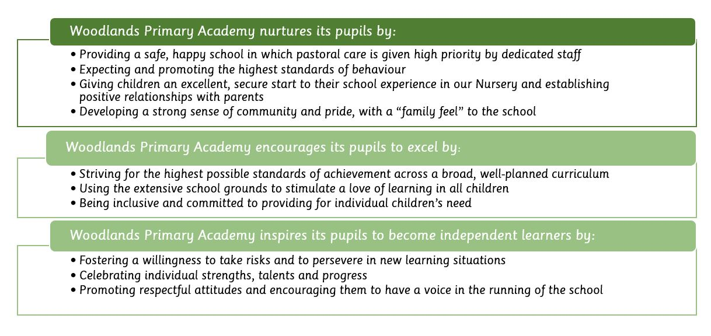

South Pennine Academies

Woodlands Primary Academy is a proud member of South Pennine Academies.
South Pennine Academies help us to reach our aims and objectives through tailored support. The vision, values and key priorities of the Trust are outlined below.

Vision
- To develop a group of closely partnered academies
- To ensure all academies are world class Centres of Excellence for Teaching and Learning
- To ensure the Trust plays a pivotal role in improving the life chances of students
- To develop local solutions and partnerships to meet local needs
- To promote school improvement with inclusion and diversity at its core

Values
South Pennine Academies believes in school improvement through a partnership model.
This brings drive, expertise and capacity to the school improvement agenda. We recognise and encourage each academy’s unique characteristics and ethos, reinforcing their individual identities within their respective communities.
Working within a multi academy trust allows school to school support to flourish. Becoming part of our partnership will allow you to become a leader not a follower and be involved in shaping the partnership rather than having it shaped for you. Pes
- Strong and Effective Leadership
- High Performing Staff
- Successful Students
- Engaged Community

South Pennine Academies Partners

THE SELECTION PROCESS
How to Apply

Thank you for taking time to read and digest our information. If you wish to apply for the post of Playleader and Teaching Assistant, then you should:
- Follow the link below to apply via the My New Term website only. Late applications will not be considered. If you have any questions please telephone the school office on 0161 3595698 to speak to a member of staff.

- Complete the application form fully, ensuring all details are accurate and all declarations are signed. Please ensure you enclose two professional referees with one being your current employer (with email addresses if possible). Do not enclose additional CVs.

- Ensure you fully complete the relevant skills and experience section of the form, addressing the key characteristics and experiences outlined in the person / employee specification and the unique contribution that you could make to the future success of the Academy.

- Please ensure that your supporting statement section of your application is no more than 2 A4 sides of paper.

Time table for the selection process:
- Closing date for applications: Friday 5th July @ 9.00am
- Interview Notifications by: Friday 5th July by 5.00pm
- Interview day: Wednesday 10th July

Successful applicants will be required to undertake a Criminal Record Check via the DBS. Woodlands Primary Academy is committed to safeguarding and promoting the welfare of children and young people and expects all staff and volunteers to share this commitment.

Job Description

Teaching Assistant and Lunchtime Play Leader
Grade 1 SCP 1-4
(30 hours p/w, TERM TIME ONLY PLUS 5 DAYS TRAINING)
Purpose of the post
To work under the instruction of teaching/senior staff to undertake work/care/support programmes to
enable access to learning for pupils and to lead in the management of pupils on the playground. Work
may be carried out in the classroom or outside the main teaching area, under the direction of a teacher.
Key areas
1. To work with children in the classroom under the direction of the class teachers.
2. Encourage and develop safe, purposeful and creative play during the lunchtime break which supports the aims and values of the school and enriches the pupils’ learning.
DUTIES AND RESPONSIBILITIES
1. Help support children with their personal, social and emotional development needs.
2. Support the children in class under the direction of the class teachers.
3. Monitor the behaviour of children at all times in conjunction with the school’s policy on discipline and behaviour and Rights’ Respecting Agenda. Refer to a senior member of staff where necessary.
4. To be aware of and ensure that the school’s anti-bullying policy is followed.
5. Supporting the school’s first aid procedures by reporting any and every accident/injury to the identified First Aider, who will record the incident.
6. Be aware of Health and Safety issues in accordance with safe practice and Health and Safety legislation.
7. Comply with all decisions and policies of the school; comply with any relevant statutory requirements, including Equal Opportunities legislation, the Health and Safety at Work Act and the Data Protection Act.
8. Have a commitment to Child Safeguarding, to promoting the welfare of children and young people in accordance with the school’s agreed procedure.
Please note this role is subject to an Enhanced DBS Certificate (Disclosure and Barring Service)

Woodlands Primary Academy
EMPLOYEE SPECIFICATION
JOB TITLE: Level 1 Playleader and Teaching Assistant
GRADE: SCP 1-4

 | Attributes |  | Relevant Criteria | How Identified | Rank
1 | RELEVANT EXPERIENCE | 1.1  1.2 | Experience of working/supervising with children in a home or learning environment.  Have worked as part of a team, as well as on your own initiative | Application Form/ Selection Process  Application Form/ Selection Process | A  A
2 | EDUCATION AND TRAINING ATTAINMENTS | 2.1 | Educated to GCSE level including English and Maths at Grade C or above, or equivalent qualifications | Application Form/ Selection Process | B
3 | GENERAL AND SPECIAL KNOWLEDGE | 3.1  3.2  3.3  3.4  3.5 | Ability to establish positive expectations of pupils’ behaviour and a sensitivity to pupils’ personal needs.  Good interpersonal skills  Ability to work under own initiative  Ability to manage some challenging behaviour from pupils.  Ability to hand confidential information with discretion | Application Form/ Selection Process  Application Form/ Selection Process  Application Form/ Selection Process  Selection Process  Application Form/ Selection Process | A  A  A  A  A
4 | SKILLS AND ABILITIES | 4.1  4.2  4.3 | Understanding of basic first aid procedures  Demonstrate an ability to cope with stressful /conflict situations  Demonstrate a solution focussed approach, collaborative working and enthusiasm to work with pupils and school staff. | Selection Process  Selection Process  Selection Process | B  B  B
5 | ANY ADDITIONAL FACTORS | 5.1  5.2  5.3  5.4  5.5 | Commitment to safeguarding and promoting the welfare of children and young people.  Motivation to work with children and young people  Knowledge of school’s behaviour and management policy and procedures  Knowledge of school’s fire and emergency procedures  A willingness to undertake training | Selection Process  Selection Process  Selection Process  Selection Process  Selection Process | A  B  B  B  B

Thank you for taking the time to read and digest the information about our school. If you wish to apply for the post of Teaching Assistant at Woodlands Primary Academy, then you should;
· Follow the link to complete the online application form.
· Complete the application form fully, ensuring all details are accurate and all declarations are signed. Please ensure you enclose two professional referees with one being your current employer (with email addresses if possible). Do not enclose additional CVs.
· Ensure you fully complete the relevant skills and experience section of the form, addressing the key characteristics and experiences outlined in the person specification and the unique contribution that you could make to the future success of the Academy.
If you would like more information about Woodlands Primary Academy, or would like to visit the school, please contact Leanne Allen – Office Manager at lallen@woodlandsprimaryacademy.org or telephone
0161 3595698

South Pennine Academies is committed to safeguarding and promoting the welfare of children and young people. Therefore, we expect all workers, volunteers and employees to share this commitment. All appointments are subject to satisfactory pre-employment checks, including a satisfactory Enhanced criminal records with Barred List check through the Disclosure and Barring Service (DBS). CV’s will not be accepted.
Links to both the safer recruitment policy and Safeguarding and Child Protection Policy can be found on our website www.woodlandsprimaryacademy.org or by clicking the links below.
https://www.woodlandsprimaryacademy.org/docs/policies/Safer_Recruitment_Policy_.pdf
https://www.woodlandsprimaryacademy.org/docs/policies/Safeguarding_and_Child_Protection_Policy_.pdf

Please make sure that you demonstrate your ability to meet the requirements of the job by giving clear, concise examples of how you meet each criteria on your application form. References must be from your current or last employer in a senior role and from different places of work. The letters A, B and C in the "Rank" column refer to the importance we will give your answers when we read your applications. You must have all the A's on day one to be able to do the job, you need to have all the B's to do the job, but they could be learnt during the induction, and if you have C criteria this would be an additional bonus. We recognise and welcome our responsibility to remove any barriers in our Recruitment and Selection process for disabled people. We have tried to do this, but if you have a disability and identify any barriers in the job description or employee specification, please tell us of these in your application. We are committed to making reasonable adjustments to the job wherever possible and it would help us to know your needs in order to do this.

Where criteria are to be identified through the "Selection Process", this may involve written exercises, group discussions, presentations, interview etc.

Please note this role is subject to an Enhanced DBS Certificate

