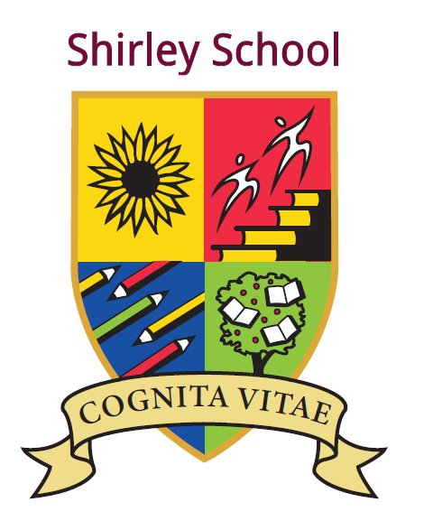

Shirley Community Primary School and Shirley Preschool

Job Description: Teaching Assistant with lunchtime duties

Responsible to: Inclusion Manager, Headteacher

Grade: Level 2 Point 5/6

Hours: 22.5 hours per week. Fixed Term contract (8.30am - 1pm, Monday – Friday, term time only)
Fixed term contract to 31/08/2025.

Shirley Community Primary and Shirley Preschool is committed to safeguarding and promoting the welfare of children and young people and expects all staff and volunteers to share this commitment. All appointments are conditional and subject to an enhanced DBS check.

Job Purpose:
Support the classroom teacher to facilitate the active participation of children in the academic and social activities of the school. Contribute to raising standards of achievement for all pupils in particular vulnerable learners. In consultation with senior staff, lead a lunchtime club for pupils who find it difficult to interact with large groups outside.

Principal Accountabilities:

Support for children

- In conjunction with the classroom teacher, adapt lessons to meet the needs of individual children and small groups.
- Take responsibility for delivering learning activities with small groups who would benefit from a different learning approach as agreed.
- Establish and maintain supportive relationships with individual pupils, small groups, and parents/carers to ensure they understand and can achieve the tasks.
- Provide learning support to children with significant care needs, or where English is not their first language.
- Support children with social, emotional, and mental health needs
- Encourage and promote inclusion in the classroom, ensuring all pupils feel involved with tasks and activities.
- Plan and lead lunchtime activities for pupils whose behaviour or social skills are a barrier to successful lunchtimes in large groups outside.

Support for the curriculum

- Support the school curriculum, providing additional support for groups of children as agreed.
- Provide additional tuition for children who need extra support with ICT.
- Arrange and deliver extra classes for pupils to improve the range or quality of subjects offered as agreed.
- Provide targeted support to enhance learning and improve attainment.

Support for the teacher

- Assist in maintaining class records and contribute to reports on pupil progress and development as directed.
- Monitor and track progress and provide feedback to assist in developing IEPs for children with special needs.
- Contribute to the planning and evaluation of work programmes for individual pupils and groups.
- Organise the learning environment and develop classroom resources as required.
- Undertake support activities for the teacher as required, e.g. photocopying, preparation of materials, mounting displays.
- Contribute to the management of pupil behaviour, including anticipating and taking action to prevent potential problems arising.

Support for the school

- Develop and maintain effective working relationships with other staff and parents or carers.
  - Contribute to the maintenance of a safe and healthy environment.
  - Attend and actively participate in staff meetings.
  - Contribute to the development of less experienced teaching assistants.
  - Act as a mentor and role model for other teaching assistants.
  - Assist in facilitating school events, e.g. school plays, events.
  - Assist in maintaining the school’s behaviour log.

NOTE;

The postholder will be subject to an enhanced DBS disclosure and suitability check to satisfy child protection requirements. The post is exempt from the provisions of the Rehabilitation of Offenders Act and all convictions or cautions must be declared.

At all times ensure that priority is given to the safeguarding of young people and that Safeguarding Policies and Procedures are followed.
This Job Description may be amended at any time, according to the changing priorities of the school as identified within the school’s strategic plan and in consultation with the post holder.

