

APPLICANT PACK

2023 - 2024 

Faringdon Community College

Assistant Headteacher

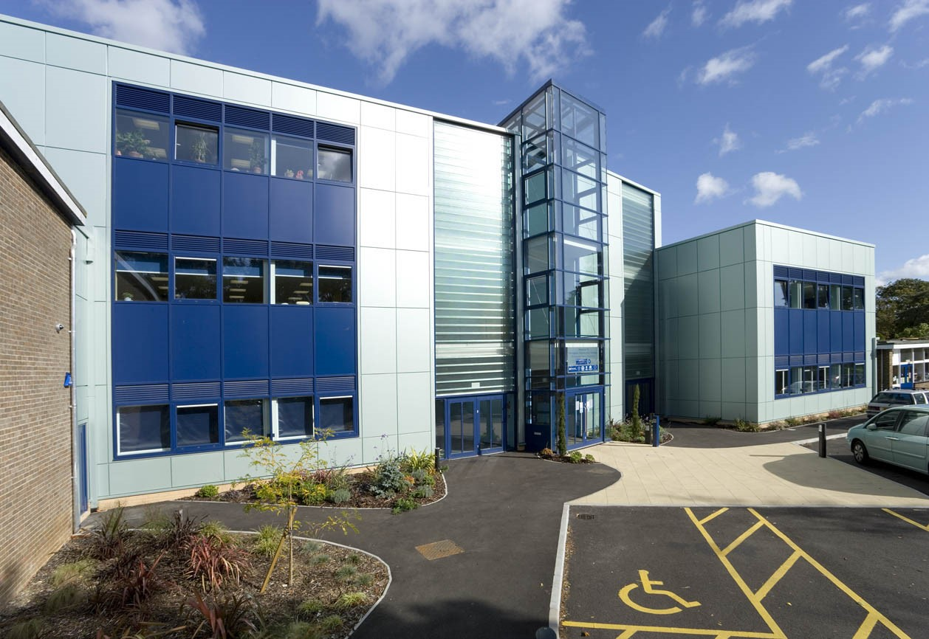

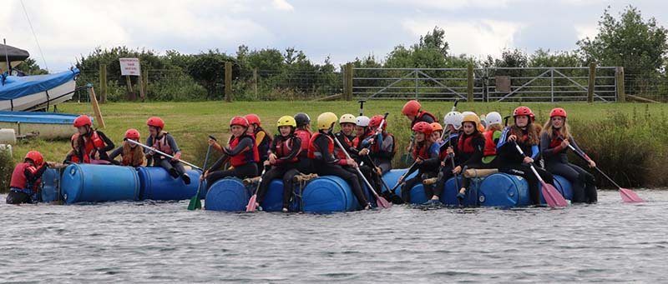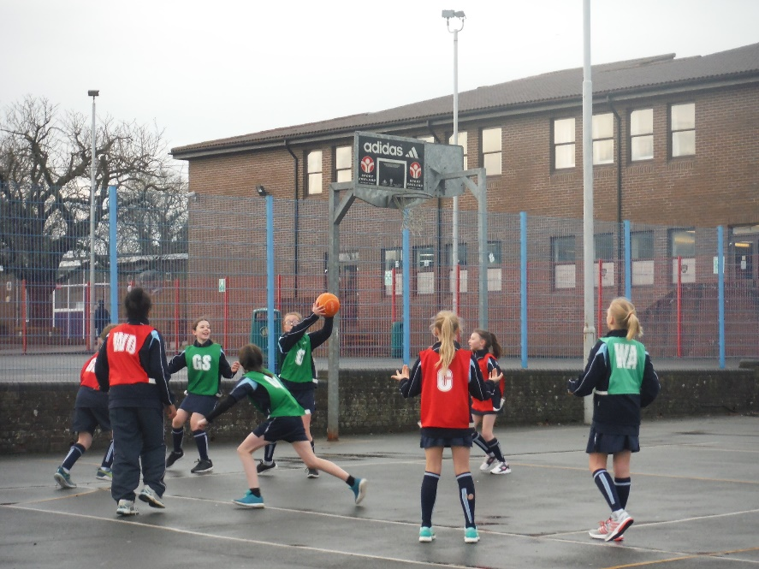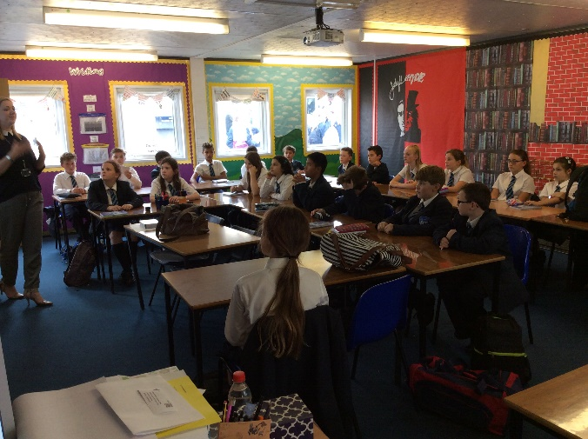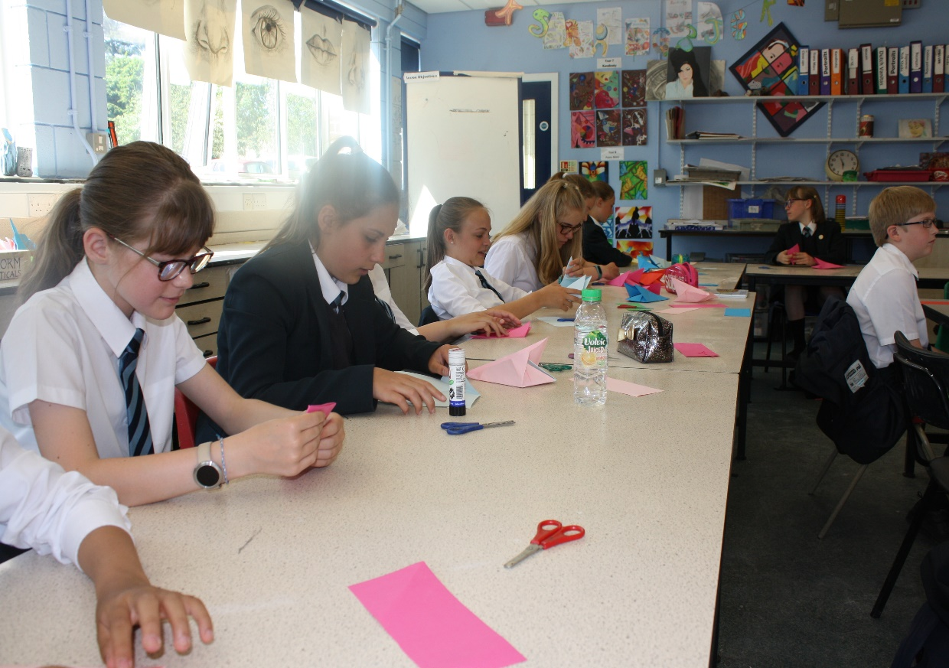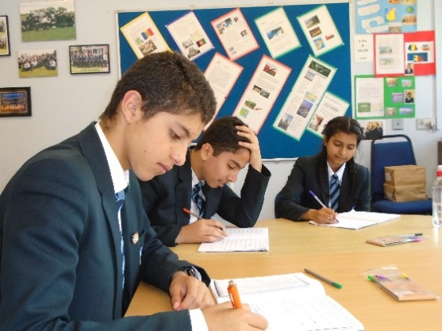

**Contents**

|  |  |
| --- | --- |
| **Page Number** | **Details** |
| 2 | A flavour of FCC |
| 3 | Contents |
| 4 | Letter from Headteacher of FCC |
| 5 | The Faringdon Learning Trust |
| 6 | Headteacher’s Welcome |
| 7 | Strategic Ambition 2023-2026 |
| 8 | OFSTED’s views |
| 9 | Staff Views |
| 10 | Teaching, Learning and CPD |
| 12 | Pastoral Care and SEND |
| 14 | The Curriculum |
| 15 | Teacher Standards |
| 18 | Vision and Values |

**Letter from the Head Teacher**

Dear Applicant

Thank you for your enquiry regarding a teaching position at FCC.

FCC is a dynamic college, where we are always keen to embrace new ideas and ways forward. We promote a strong culture of support and development, therefore benefiting from a strong team of motivated staff. Our students are keen to do well and as a school, we have an energy and enthusiasm, which makes FCC a professionally rewarding place to work.

I hope you find this information pack helpful. We have endeavoured to give you a flavour of FCC and include information that we think you may wish to refer to whilst making your decision about applying for a post with us. If you would like to know more about any aspect of this post, or would like to arrange a visit, please feel free to contact our Trust HR team on 01367 240375 or email [Recruitment@faringdonlearningtrust.org](mailto:Recruitment@faringdonlearningtrust.org) who will put you in contact with the Subject Leader.

Please ensure you provide the name, address and email address, including the status/relation of two referees, one of whom should be your current employer. Candidates should be aware that referees will be approached prior to interview. The school is an equal opportunity employer and supports the safeguarding and protection of children and individuals. All appointments will be subject to Disclosure and Barring Service (DBS) Check.

I wish you well and thank you once again for your interest in what we think will be a stimulating and rewarding post.

Yours sincerely



Phil Bevan

Head teacher



**Faringdon Learning Trust (FLT)**

Faringdon Learning Trust formed in 2012 when three schools in Faringdon; the Community College, Infant School (now Folly View Primary School) and Junior School (now The Elms Primary School), created a Multi Academy Trust (MAT). In 2013 five other schools joined the Trust:

* John Blandy Primary School
* Buckland Church of England Primary School
* Longcot and Fernham Church of England Primary School
* Watchfield Primary School
* Shrivenham Church of England Primary School

On 1st February 2023, Ashbury with Compton Beauchamp Church of England Primary School joined the Trust. The Trust also has an Alliance membership which includes:

* Longworth Primary School
* Shellingford Church of England Primary School
* Uffington Church of England Primary School
* Stanford in the Vale Primary School
* Westrop Primary School, Highworth

Great value is placed on the diversity of the Trust’s schools and in the young people they nurture and educate. Each school is driven by its own senior leadership team and governing body, with close links to the local community. The Trust provides support, expertise and inspiration. It is committed to allowing each school to maintain its unique identity.

***Together, the Trust provides a breadth of opportunity for its young people which an individual school could not deliver. The Trust works hard to support its schools in delivering the shared goals of high academic standards and excellence in teaching and learning.***

Led by the CEO, the Trust has an excellent team providing support, challenge and opportunities for collaboration. The Director of Education leads the educational aspects of the Trust, including school improvement, oversight of teaching, learning and assessment as well as curriculum development and progression across the Trust. She is supported by a team of staff including leading teachers, specialising in EYFS, English and transition; specialists focusing on SEND, Inclusion and Safeguarding as well as a curriculum enrichment lead. The Trust also has a team of subject matter experts providing dedicated support in all non-educational aspects of the work of the Trust. Led by the Trust’s Chief Operating Officer, the team leads on the strategic development and management of:

• Finance

• HR

• ICT

• Operations including Estates and Facility Management and Health and Safety

• Governance

• Marketing and Communications.

**Head Teacher’s welcome to FCC**

Faringdon Community College is a very popular 11 to 18 mixed comprehensive school located on the edge of Faringdon, a picturesque market town in rural Oxfordshire. The school is situated on a large, attractively landscaped, site with an excellent range of specialist classrooms and facilities. I believe that the ethos of school should be focused on working hard, with the ultimate goal of examination success and the betterment of individuals, but I also believe that it should create feelings of excitement and enjoyment.

My priorities are simply these: excellent examination outcomes, impeccable behaviour, great teaching and the widest possible range of high quality extra-curricular experiences for all students.

With a clear focus and lots of hard work, these things are all achievable and will deliver what I think most parents want, happy children who leave school with plenty of choices available to them and who are well-equipped to cope with the world outside. School should be an experience to evoke a lifetime of memories and friendship.

At FCC we believe that it is important for staff and students to have a sense of being an integral part of the organisation and be involved at all levels. A working example of this occurs through our ‘Visible Leaders’ programme, which has two strands and has been running successfully for four years. One aspect of ‘Visible Leaders’ uses the experience of the senior team where they visit students in lessons on a daily basis to engage with them, monitoring their effort and progress. The second aspect involves the 6th form students, when they attach themselves to a department and spend at least I hour per week in that department supporting students from all year groups with their school work. This initiative is not only designed to help students with their academic work but will also help develop positive relationships between staff and students, in addition to providing our 6th form students with a sense of duty and responsibility.

I am very proud to be the Head teacher at FCC. You are very welcome to come and join us.



Phil Bevan

Head Teacher

|  |  |  |
| --- | --- | --- |
| FCC - Strategic Ambition 2023-2026 | | |
| Excellence for All: 30/60/90  (Quality of Education and Curriculum) | Values for all: the school community  (Personal development, Behaviour and Attitudes) | Leadership for all: growth of the school  (Leadership and Management) |
| * Progress and outcomes for all learners continues to be above national standards because of effective teaching. * As such, we will achieve 30% 7+, 60% 5+ and 90% 4+ at GCSE by 2025, so all students can access the best possible post-16 provision and are well prepared for this transition * Students have high aspirations for the future that is the result of achieving excellence. They know the value of education and take responsibility for it. * We lead excellence in subject knowledge throughout the Trust, so that learners are ready for the transition to FCC. * Students remember learning because it is reiterated, carefully scaffolded, building on previous learning, developing inquisitive students who are confident in their prior knowledge * Students with a SEND need are equally able to recall and articulate their knowledge and learning because of teaching that adapts to known needs * We will teach an enriched curriculum that inherently contains exceptional opportunities, through which all students thrive, regardless of socio-economic background, such as extending Forest School to impact all students * The curriculum – in all its breadth – mean learners know their strengths and talents; they are encouraged to be individuals who are interesting and interested. They find their ‘thing’. | * FCC Values – honesty, kindness, respect – are at the heart of human interaction and are the foundation of the FCC’s school community. * All stakeholders understand and contribute to the school community, acting in the knowledge of how they impact and support the school. This develops outstanding relational currency between all parts of the school community. * There is a strongly embedded celebration of all parts of the school community, whereby students learn about the different cultures that make up the school community and respect these differences * Mental health and well-being are priorities in the community, where both students and staff develop and reflect on effective levels of resilience and a growth mindset. * Students feel secure and supported at FCC, so they are self-regulating and able to manage their own behaviour, independently. * As such, students relate well to one-another, with adults, as well as people they are not familiar with * Opportunities exist for students to be challenged beyond their comfort zone so that they can grow. They feel psychologically safe and confident enough to take risks. * Stakeholders understand the environmental challenges we face as a human race and make an active contribution towards reducing our impact. | * Leadership is developed at all levels of the school, under coherent strategic intent, with consistent approaches that all staff buy in to, such that the school can make significant, ongoing contributions to the wider Trust * Leaders develop and improve their teams and the individuals within their teams, always strengthening deliberate and considered reflective approaches * High quality staff are recruited and retained with excellent CPD growing future leaders. * FCC builds relationships with other schools, developing active collaboration that drives school improvement, grows leaders and supports constant self-reflection * Students are engaged as leaders within the school, actively contributing to the development and standards of the school. * Alongside students, parent voice and feedback enrich the school, so that we always work proactively with the wider community * Our premises are preserved and maximised. * Opportunities to benefit from business and wider opportunities are explored and exploited. * Student numbers are maximised to ensure optimum funding. Grants and opportunities for additional funding are explored and secured as far as possible to supplement the budget. |

**What OFSTED says about FCC**

Faringdon Community College underwent an OFSTED Inspection in February 2019. During their visit, inspectors visited sixty one lessons, examined students’ work, scrutinised their books, interviewed governors and members of staff, and met with students.

We are very pleased with the report, which encapsulates all the wonderful things about Faringdon Community College, and has recognised that, *“typically standards are high and pupil attainment across the curriculum is routinely above national comparators.”*

**Overall Effectiveness of the School - Good**

The OFSTED Inspectors recognised that “*Throughout the school, the environment is conducive to learning. Pupils work hard, responding well to teachers’ high expectations for their behaviour and engagement.”*

They also report that, “*The school’s work to promote pupils’ personal development and welfare is outstanding”.*

**Teaching and Learning**

Inspectors also reported that *“Teachers have consistently strong subject knowledge. They use it well to plan lessons that stimulate pupils’ interests and develop their knowledge, skills and understanding appropriately over time. As a result, most pupils make good progress and attain well by the end of key stages 4 and 5.”*

*Parents also feel well-informed about the progress their children are making.*

**Personal Development, Behavior and Welfare**

*“Pupils benefit from rich and varied opportunities that support their taught curriculum well. As a result, their personal development is very strong, and they are equipped very well for life beyond school.”*

The report highlighted “Pupils experience rich opportunities that support their personal development successfully. They play their part in enhancing the school community, for example by taking their turn to be part of the ‘happy to help’ team or being a ‘visible leader’. Pupils’ understanding of important issues such as human rights and civil liberties lead them to behave maturely and considerately towards each other. This contributes to a highly tolerant atmosphere around the school, where pupils are confident to be themselves.”

**Safeguarding**

“Pupils are taught well about how to keep themselves safe. The high-quality personal, social, health and economic (PSHE) programme develops their thinking in an age appropriate way and in response to priorities that emerge in the local area. As a result, pupils demonstrate a mature approach to managing risks.”

**Leadership and Management**

“*The head teacher unites staff with a common sense of purpose in order to nurture pupils and help them to achieve their very best. Adults demonstrate their high expectations for pupils by modelling them through their actions. Pupils respond appropriately well and a culture of mutual respect, equality and high aspiration ensues”*

**Sixth Form**

“*Leaders know provision well. They have a clear understanding of the sixth form’s strengths and relative weaknesses. Their vision for raising standards further is rightly driven by their desire for students to be happy, safe and successful.”*

The inspectors also highlighted *“Students benefit from a wider curriculum that prepares them well for life beyond school. Work experience is tailored closely to students’ career aspirations. Students are expected and encouraged to play a visible part in the life of the school, such as through being sports leaders or midday supervisors. Citizenship day experiences respond directly to students’ identified needs and relevant priorities. Consequently, they are both valuable and valued.*

**What some of our staff say about FCC**

*Faringdon genuinely is a great place to work. The staff are friendly and supportive and the students are eager to learn and succeed. Whenever I visit other schools, I’m always reminded of how lucky I am to work at FCC and am filled with a sense of pride.  Our students are polite and respectful, making walking around the school a really enjoyable experience: students and staff alike greet you or smile as you walk by and there is always a sense of calm around the school.*

SLE

*As a former teaching assistant, trainee teacher, NQT and now teacher, I thoroughly enjoy my work here at FCC. I work within a fantastic department and a fantastic school. There is a very big support network at FCC which has provided me with lots of help from lots of different members of the teaching staff about many different topics as well as supporting me with my teaching and learning. FCC provides its staff with lots of opportunities to learn new areas of teaching through internal and external CPD. FCC is also a great place to be heard and to share your ideas; it’s always trying new things and adapting to be the best it can be.*

Teacher

*I would describe FCC as a welcoming community in which colleagues support one another. The induction process and continuing CPD mean that settling in is both enjoyable and as easy as possible. The other benefit of FCC is the beautiful area which surrounds the school, with easy access to Oxford and its dreaming spires.*

ECT

*The first impression of FCC was of over-whelming friendly staff who were always prepared to take time to offer a kind or supportive word and provide practical help (often in cake form!). There is a real desire to enable staff to achieve a healthy work-life balance.*

SLE

**Teaching and Learning**

Our school mission statement is to inspire our students to be confident and open-minded through quality first teaching in a caring school community.

Our vision is to be inclusive and progressive, where everyone adopts the principles of kindness, honesty, and respect.

Our belief is that education is transformational. Our role is to support every student to succeed, irrespective of their starting points. We understand that ‘equal’ treatment is not always sufficient to give ‘equitable’ outcomes: some students need more than others. We are committed to giving students whatever support they need to ensure they make the progress necessary to get the successful outcomes that they deserve. We work to remove barriers to learning for all students. We believe that relationships are the most important thing in schools. The way that staff and students relate to each other is fundamental to the success of what we are trying to achieve.

We adopt the principle of quality first teaching, which is adaptive and effective at meeting the needs of all students.

***Teaching and learning in our school is a shared responsibility and everyone in our school community has an important role to play***

There is a common teaching framework that we encourage all staff to use.  This means students are clear of the learning expectations in every lesson.

The full teaching and learning policy can be found on the school website.

Classrooms are well-equipped and have interactive screens and we are developing our technological expertise in using Google Classroom to set lessons and homework, as well as being prepared for any remote learning that might be called for. Each classroom has a visualiser so that modelling can readily take place. Support for those new to using Google Classroom is available and has been extremely valuable to us all during the last two academic years.

Senior staff tour the school during non-contact time, dropping into lessons to develop their understanding of what teaching and learning ‘looks like’ and to make sure that everyone knows they are supported and that their teaching is appreciated.

**Teaching, learning and CPD at FCC**

 We are currently developing new measures to support the further development of all teaching staff, based on this framework. This means that our appraisal system and department quality assurance measures (such as observations and learning walks) are tied-in with the framework. Departments will have their own quality assurance procedures and can arrange in-house CPD or request external INSET to support the improvement of teaching practice. There is a vast bank of talent in the school and we believe that this is often where the best CPD can be found so we have an ‘open-door’ approach and encourage all staff to drop in to lessons to see their peers in practice. We also look to our staff to share their best practice with others. We also believe that nobody is too senior or experienced to improve so we foster a culture of everyone feeling confident in saying where they could develop and asking for support.

 We have a growing number of highly valued Teaching Assistants, who are invited to join classes on Google Classroom so they are well-informed and prepared for lessons. Many of our Teaching Assistants also engage with the Creative Education platform for their own CPD.

 Some classes also benefit from our excellent sixth form Visible Leaders, who support learning in some of their free periods.

 Training in the school’s systems, such as BromCom and the pastoral system, is available for new staff and those wanting a refresher. In our school calendar, we set-aside a dedicated CPD slot for further training that staff request or where the need is seen to have arisen.

 Those new to teaching ( Early Career Teachers / ECTs) currently follow the full Early Career Framework (ECF) programme that has been developed by UCL and which is delivered through our local partner, Oxfordshire Teaching School Hub (OTSH). Mentors are department based, experienced and dedicated, supportive professionals.

 Other new staff will have a named ‘buddy’ to support them and the Trust has developed a policy to ensure that the needs of new staff are met.

 FCC is also a training school so mentoring those training to teach is another development opportunity here.

 Opportunities to develop beyond classroom practice are embraced and one example of this is that we currently run a Challenge Leaders scheme, with seven staff of differing levels of experience, developing and implementing a new idea with the support of a member of senior staff and of one another.

 There is also an opportunity to join SLT sub-groups and contribute to the growth of the school by contributing ideas and cascading the work of these groups to departments. These cover areas such as sixth form, pastoral, curriculum and leadership.

 We hope that anyone appointed by FCC enjoys working here, with our values around teaching being kindness, development and support.



**Pastoral Care**

We believe that children learn best when they feel safe, secure and are cared for. At Faringdon Community College, we have a behaviour for learning policy, which encourages and rewards positive behaviour.

All staff, teaching and non-teaching are responsible for pastoral care. The school seeks to create a positive caring atmosphere with our core values being Focussed, Calm and Considerate. Most full time, and some part time teachers are expected to undertake the role as form tutors and are the ‘first point of contact’ for all students. We have two adults allocated to each tutor group, with the role of the supporting tutor being developed this year. This system ensures that all students have someone to talk to, so that everybody feels supported by an adult in school.

We have a firm and fair approach to discipline, which is reflected in our Behaviour for Learning System, which supports staff and provides a framework for expectations both in the classroom and around the school site.

Parents are informed if there is a concern about their child’s behaviour so that we can work together to initiate an improvement.

**Special Educational Needs**

Faringdon Community College is an inclusive establishment, which welcomes all children.  We strive to give every child the best possible chance to succeed.  Working to this aim is a dedicated team including a SENCO, a part-time Dyslexia Specialist, an ELSA Counsellor, two Inclusion Managers, a SEN Administrator and Teaching Assistants.  We also have specialist TAs with particular expertise in Communication and Interaction difficulties, including autism; Specific Learning Difficulties, such as dyslexia or Social, Emotional and Mental Health difficulties.    Our base, the Bridge, provides a safe, welcoming, and positive environment for students to work in, consisting of four classroom areas.

Our aim is to help and encourage students to become independent learners who are able to access the school curriculum and function confidently in school. We work with students to help them reach their maximum potential in class subjects and exams, developing transferable study skills and strategies that they can use throughout the school and beyond into further education or the world of work.

Intervention for students is provided at three different levels.

- For those needing a small amount of extra support we provide TAs in classes who are available to a number of students often working with groups as requested by the class teacher. We also manage and staff an after-school Homework Club which is available in the Library Mondays to Thursdays.

- For those students requiring a greater degree of intervention, we run a number of targeted small group support programmes in the Bridge.  These include interventions to build social skills, promote self-esteem and support emotional regulation as well as reading, spelling and maths interventions.  We also run a Year 7 Nurture Group, Year 8 and 9 Literacy Groups and Year 10 and 11 Study Support sessions to help KS4 students keep up with class work, assignments and homework. We also provide a Breakfast Club for our Pupil Premium students and break time and lunch time clubs for students in need of a quiet and calm environment during less structured times of the school day.

- For students needing more sustained and individual attention, we provide 1:1 targeted support.  This includes ELSA (emotional literacy support), counselling or mentoring; targeted academic interventions including Toe by Toe for reading, Power of Two for maths and dyslexia support for students with significant specific learning difficulties.

In addition to our support programmes, we are able to conduct assessments with students who staff believe may have learning difficulties.  We put in place access arrangements for students with special learning needs who are taking GCSE, AS or A2 exams and who meet the relevant criteria. We also liaise closely with Form Tutors, Heads of Year, Pastoral Support Assistants and the college Careers Guidance Officer to ensure the smooth transition of SEN students on to further and higher education programmes or apprenticeships when they leave FCC.

The Bridge at Faringdon Community College has access to and works closely with a number of specialist external services who support our students in a number of ways: working directly with the student, monitoring progress or offering advice to the teaching staff. These services include among others: the Speech and Language Therapy and Communication and Interaction Services; the Educational Psychology Service; CAMHS; Hearing, Visual and Physical Impairment Support Services; Occupational Therapy Services.

A number of students on the SEN register choose to join FCC sixth form and often go on to University success or into apprenticeships.

**The Curriculum at FCC for 2023-2024**

**School Timetable Arrangements**

Each day consists of 5 periods, each for one hour. We operate a two-week timetable to give us more flexibility in how we distribute the 50 lessons in a timetable cycle. In addition, each day the students have 30 minutes in the morning with their tutors. Year group assemblies take place twice weekly during the morning tutor time.

**Key Stage 3 (Years 7-9)**

Students cover a common curriculum meeting the requirements of the National Curriculum Key Stage 3 programme of study. The range of subjects taught and the time allocated to them is shown in the table. Most subjects are taught to mixed-ability tutor groups in Y7 with ability setting in Maths. Setting in Science and Languages is introduced in Y8 and Y9. We have been redesigning our schemes of work in all subjects to aid smooth progression across KS3 and onto KS4, based around Key Performance Indicators (KPIs) which will help them develop the skills they need for their GCSE studies.

All students study one foreign language in KS3, either French or Spanish. Parents can request which language is studied although we cannot promise that all requests can be met. Students who do well in this language in Y7 will be offered a chance to take up German as an additional language in Y8. In Year 9 students studying two languages will have 3 hours of lessons in each language per fortnight. Students studying one language will have 4 hours of lessons per fortnight and will have 2 lessons per fortnight allocated to the Unit Award Scheme, which gives an opportunity to work towards different units in a wide range of curriculum areas.

The allocation of lessons in KS3 is as follows:

|  |  |  |  |
| --- | --- | --- | --- |
| Subject | Number of hours per fortnight | | |
|  | Year 7 | Year 8 | Year 9 |
| English | 6 | 6 | 6 |
| Maths | 6 | 6 | 6 |
| Science | 5 | 6 | 6 |
| Design & Technology | 5 | 5 | 4 |
| History | 4 | 4 | 3 |
| Geography | 4 | 4 | 3 |
| RE | 2 | 2 | 4 |
| PE | 4 | 4 | 4 |
| Languages | 5 | 5 | 6/4 |
| Unit Award Scheme |  |  | 0/2 |
| Art | 2 | 2 | 2 |
| Music | 2 | 2 | 2 |
| Drama | 2 | 2 | 2 |
| ICT | 2 | 2 | 2 |
| Accelerated Reader | 1 |  |  |

**Key Stage 4 (Years 10-11)**

These years focus on the preparation for GCSE. There is a common core of subjects taken by all students, enriched by some option choices, which allow individual interests and abilities to be developed.

Most students will take GCSE or equivalent examinations in between 8 and 12 subjects but the combination of subjects varies for different individuals, with a focus on vocationally based and life-skills courses for some, and on academic study for others.

All students study RE with the GCSE exam taken at the end of Year 10. Some students will take the full-course exam and some the short-course.

English provides the opportunity for students to gain GCSEs in both English Language and English Literature. The more able Mathematicians have the opportunity to take an additional GCSE in Further Mathematics.

Science is taught as separate lessons in Biology, Chemistry and Physics, taught by subject specialists. Around half of the year group take separate GCSEs in each of the sciences and the remainder take a Combined Science qualification, which counts as 2 GCSEs, still has separate exam papers in all three subject areas and does form a suitable basis for A level study for students who do well on it.

For their options, students currently choose either three or four (depending on whether they take separate sciences or not) subjects from a range including in Art, Business, Child Development, Computer Science, Creative Media, Dance Drama, French, Geography, German, Health & Social Care, History, IT, Music, PE and Spanish. They can also choose from a range of Design & Technology specialisms including Food & Nutrition, Resistant Materials, Textiles, Graphics, Hospitality & Catering and Engineering

We expect the vast majority of our students to be aiming for at least the level 2 threshold equivalent of 5 higher grade GCSE passes, but most will go well beyond this.

**Key Stage 5 (Years 12-13)**

Many of our Year 11 students stay on to study academic A levels in our Sixth Form. They can choose from a broad selection of subjects all taught by specialist teachers. Please see the separate leaflet on Sixth Form provision.

**Teacher Standards**

**Preamble**

Teachers make the education of their pupils their first concern, and are accountable for achieving the highest possible standards in work and conduct. Teachers act with honesty and integrity; have strong subject knowledge, keep their knowledge and skills as teachers up-to-date and are self-critical; forge positive professional relationships; and work with parents in the best interests of their pupils.

**Part 1: Teaching**

**A Teacher must:**

1. **Set high expectations which inspire, motivate and challenge pupils**

* establish a safe and stimulating environment for pupils, rooted in mutual respect
* set goals that stretch and challenge pupils of all backgrounds, abilities and dispositions
* demonstrate consistently the positive attitudes, values and behaviour which are expected of pupils.

1. **Promote good progress and outcomes by pupils**

* be accountable for pupils’ attainment, progress and outcomes
* be aware of pupils’ capabilities and their prior knowledge, and plan teaching to build on these
* guide pupils to reflect on the progress they have made and their emerging needs
* demonstrate knowledge and understanding of how pupils learn and how this impacts on teaching
* encourage pupils to take a responsible and conscientious attitude to their own work and study.

1. **Demonstrate good subject and curriculum knowledge**

* have a secure knowledge of the relevant subject(s) and curriculum areas, foster and maintain pupils’ interest in the subject, and address misunderstandings
* demonstrate a critical understanding of developments in the subject and curriculum areas, and promote the value of scholarship
* demonstrate an understanding of and take responsibility for promoting high standards of literacy, articulacy and the correct use of standard English, whatever the teacher’s specialist subject

1. **Plan and teach well-structured lessons**

* impart knowledge and develop understanding through effective use of lesson time
* promote a love of learning and children’s intellectual curiosity
* set homework and plan other out-of-class activities to consolidate and extend the knowledge and understanding pupils have acquired
* reflect systematically on the effectiveness of lessons and approaches to teaching
* contribute to the design and provision of an engaging curriculum within the relevant subject area(s).

1. **Adapt teaching to respond to the strengths and needs of all pupils**

* know when and how to differentiate appropriately, using approaches which enable pupils to be taught effectively
* have a secure understanding of how a range of factors can inhibit pupils’ ability to learn, and how best to overcome these
* demonstrate an awareness of the physical, social and intellectual development of children, and know how to adapt teaching to support pupils’ education at different stages of development
* have a clear understanding of the needs of all pupils, including those with special educational needs; those of high ability; those with English as an additional language; those with disabilities; and be able to use and evaluate distinctive teaching approaches to engage and support them.

1. **Make accurate and productive use of assessment**

* know and understand how to assess the relevant subject and curriculum areas, including statutory assessment requirements
* make use of formative and summative assessment to secure pupils’ progress
* use relevant data to monitor progress, set targets, and plan subsequent lessons
* give pupils regular feedback, both orally and through accurate marking, and encourage pupils to respond to the feedback.

1. **Manage behaviour effectively to ensure a good and safe learning environment**

* have clear rules and routines for behaviour in classrooms, and take responsibility for promoting good and courteous behaviour both in classrooms and around the school, in accordance with the school’s behaviour policy
* have high expectations of behaviour, and establish a framework for discipline with a range of strategies, using praise, sanctions and rewards consistently and fairly
* manage classes effectively, using approaches which are appropriate to pupils’ needs in order to involve and motivate them
* maintain good relationships with pupils, exercise appropriate authority, and act decisively when necessary.

1. **Fulfil wider professional responsibilities**

* make a positive contribution to the wider life and ethos of the school
* develop effective professional relationships with colleagues, knowing how and when to draw on advice and specialist support
* deploy support staff effectively
* take responsibility for improving teaching through appropriate professional development, responding to advice and feedback from colleagues
* communicate effectively with parents with regard to pupils’ achievements and well-being.

**Part 2:**

**Personal & Professional Conduct**

A teacher is expected to demonstrate consistently high standards of personal and professional conduct. The following statements define the behaviour and attitudes which set the required standard for conduct throughout a teacher’s career.

Teachers uphold public trust in the profession and maintain high standards of ethics and behaviour, within and outside school, by:

* treating pupils with dignity, building relationships rooted in mutual respect, and at all times observing proper boundaries appropriate to a teacher’s professional position
* having regard for the need to safeguard pupils’ well-being, in accordance with statutory provisions
* showing tolerance of and respect for the rights of others
* not undermining fundamental British values, including democracy, the rule of law, individual liberty and mutual respect, and acceptance and understanding of those with different faiths and beliefs
* ensuring that personal beliefs are not expressed in ways which exploit pupils’ vulnerability or might lead them to break the law.
* Teachers must have proper and professional regard for the ethos, policies and practices of the school in which they teach, and maintain high standards in their own attendance and punctuality.
* Teachers must have an understanding of, and always act within, the statutory frameworks which set out their professional duties and responsibilities.

**FCC Values**

**Kindness, Honesty and Respect**

We cultivate **kindness** and compassion, creating a welcoming, inclusive learning space for everyone.

We place kindness at the heart of everything we do, as we believe acts of kindness are powerful and potentially life changing.

We develop **honesty** and integrity in all members of our community.

We recognise that being honest and truthful when mistakes have been made is brave, showing both character and a growth mindset.

We foster **respect** for ourselves, each other and our school environment.

We believe that adopting a respectful attitude towards others, even when we disagree, develops understanding and empathy.

**We do this in the spirit of trust and cheerfulness**



**Values, Culture and Character**

FCC raises aspirations, creates opportunities, develops character, and changes lives.

Our core purpose is to provide everyone with the confidence to be the best they can be.

Better people make better schools.