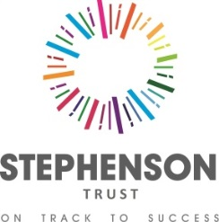

Stephenson Academy

Would you relish a challenge and rewarding opportunity? Are you interested in working with some of the most disadvantaged students in Milton Keynes? Do you have the necessary skills required to work within a SEMH educational environment? If YES we have the perfect opportunity below.

Stephenson Academy provides education for students aged between 9 and 16 years with Education and Health Care Plans for Social, Emotional and Mental Health (SEMH). Many of our students have additional social communication and/or learning needs. We pride ourselves on delivering a quality curriculum, truly individualised to meet the needs of our students, ensuring successful outcomes for all.

English Teacher

Salary: ECT/MPS/UPS plus SEN Allowance

Maternity Cover from September 2024

We require an experienced teacher to deliver English to mixed ability KS3 and KS4 groups. This position attracts a SEN point as we are a special school. We are looking for a dedicated professional who wishes to advance their career in a forward looking and dynamic organisation.

CVs will not be accepted but an application pack can be found on our website: www.stephensonacademy.org.uk or alternatively email recruitment@stephensonacademytrust.org.uk

Closing date for all applications: Monday 1st July 2024
Interview: week beginning TBC

Stephenson (MK) Trust is an Equal Opportunities employer. We are committed to safeguarding and promoting the welfare of children and young people and expect all staff to share this commitment. This commitment to robust Recruitment, Selection and Induction procedures extends to organisations and services linked to the Trust on its behalf. An enhanced Disclosure and Barring Service Certificate is required prior to commencement of this post

