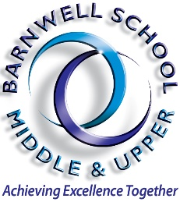 | Barnwell School  Computing & IT Teacher  April/September 2024  Full time  MPS/UPS  We are looking to secure a dynamic, enthusiastic, and inspirational experienced practitioner, with high expectations and a record of getting the best from students. Someone with the drive, energy, and a genuine passion for teaching Computer Science and IT.  Barnwell is a thriving secondary school, and sixth form located in South Stevenage, Hertfordshire, serving a diverse community. Barnwell offers a unique educational experience, with a Middle School catering to 11-14-year-olds and an Upper School for 14-18-year-olds.  The school is renowned for its strong pastoral care, vibrant extracurricular program, and a commitment to helping every student reach their full potential.  The successful candidate will:  Deliver consistently good lessons that engage, and challenge students Demonstrate excellent subject knowledge and pedagogical skills  Inspire students to develop a love of science and achieve their academic potential  Maintain effective classroom management and promote positive behaviour Experience in developing innovative teaching resources and strategies Commitment to continuous professional development  Enthusiasm for contributing to the wider life of the school  Please visit our website to find out more information about our school, including key information for applicants, and information about the Computing & IT.  Visits to the school are encouraged.  CVs not accepted as a form of application.  Barnwell is committed to safeguarding and promoting the welfare of young people and expects all staff and volunteers to share this commitment


