-=

Chief Finance Officer Job Description

Post Title: | Chief Finance Officer
Grade: | Senior Management Grade (£56,601 to £82,076)  Salary Range/Grading Structure starting point negotiable based upon experience
 | 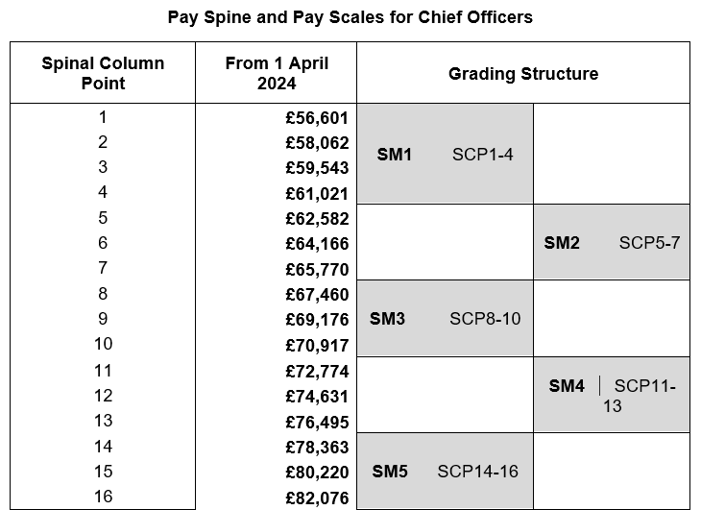
Reporting to: | Chief Executive Officer

Main purpose of the job
The primary purpose of our Chief Financial Officer (CFO) is to ensure the financial sustainability and integrity of the Trust while supporting the best possible educational outcomes. This role is focused on the delivery and development of the Trust’s financial strategy, ensuring compliance with all relevant legal and reporting requirements.

The postholder will be instrumental in driving the Trust’s financial performance, including budgeting, forecasting, and financial reporting, ensuring the Trust’s financial resources are effectively allocated to support its educational goals.

The CFO will:
- Lead the financial strategy and management of the Trust, ensuring financial sustainability and compliance.
- Undertake the statutory role of Chief Financial Officer (CFO) for the Trust, as outlined in the Academy Trust Handbook.
- Support the CEO in their role as the Trust’s Accounting Officer, providing advice and guidance on financial matters.
- Contributing to the effective leadership of the organisation, maintaining focus on its purpose and vision through rigorous analysis and challenge.
- To contribute to and to deliver outcomes for the Trust Development Plan.
- Take responsibility for the financial development, planning, and sustainability of the Trust, ensuring the organisation operates with the highest standards of financial probity.
- Provide leadership and management of the Trust’s finance function, enabling the Trust to work effectively towards its financial and educational aims and objectives.
Main Duties and Responsibilities
Chief Finance Officer
- To lead the trust’s risk register, management and maintenance, including identifying strategic and operational business risks, taking steps to mitigate these risks.
- Advise the CEO, Trustees and stakeholders on all matters relating to financial strategy.
- Contribute to the development and implementation of the trust’s strategy, providing financial analysis and guidance on all activities, setting financial objectives and monitoring performance.
- Conduct financial due diligence on schools applying to join the trust, and reporting findings to the CEO.
- Work with the CEO and executive leaders to develop, implement and monitor the trust’s business plan (including strategy for growth and trust development), using effective financial and budget modelling and benchmarking to support strong decision-making.
- Lead on the development of the trust’s financial systems and processes.
- To quality assure the capital strategy for the trust, reviewing capital funds and securing capital funding through bids.
- To lead the income and investment strategy and provide quality assurance on all investment for the MAT including the maximisation of safe investments and returns on investment.
- Establish, develop and maintain effective working relationships and engagement with internal and external stakeholders at all levels.
- To ensure compliance to the requirements of Academies Trust Handbook and Statement of Recommended Practices (SORP) and Charities Commission.
- To liaise with both internal and external auditors, on both year end and ad-hoc audits throughout the financial year.
- Reviewing, refreshing and implementing financial management policies and processes to underpin sustainable long-term financial health and reviewing performance against them.
- Ensure accurate financial management of information by way of reviewing academy monthly returns and making any adjustments as required.
- To co-ordinate the planning and budgeting processes for salaries and overall financial budget positions.
- Contributing to the effective leadership of the organisation, maintaining focus on its purpose and vision through rigorous analysis and challenge.
- To complete all statutory returns on behalf of the organisation.
- To lead asset and inventory management to ensure that assets are recorded and well documented/ reported.
Team responsibilities
- To directly line manage central finance colleagues and Trust Contracts and Procurement Manager; including completing performance management reviews, wellbeing support, absence management, mentoring and training.
- To contribute and deliver Inset sessions to the academy business teams and central finance team.

Financial management and controls
The postholder will be accountable for maintaining robust financial management of the trust and its academies.
The CFO will:
- Manage the annual and 3-year budget setting process, from planning through to approval.
- Work with CEO and executive leaders within the trust to prepare and monitor individual academies’ budgets in line with school development plans and the trust’s strategic objectives.
- Provide accurate and timely information to the CEO and stakeholders as required to enable effective budget management.
- Lead via the central finance team tracking and receipt of income for SEND and specialist grants from the ESFA/ DFE etc.
- Develop/ review, implement, and monitor the trust’s financial policies and procedures in accordance with the Academy Trust Handbook (ATH), enabling robust financial management.
- Advise the CEO and executive leaders on the development and maintenance of an effective internal audit procedure for the trust and its academies, including producing audit reports and making recommendations for improvement.
- Manage the external audit procedures for the trust and its academies and follow up on any recommendations resulting from audits including training needs.
- Establish and monitor effective procurement procedures to achieve financial efficiencies, including overseeing the tendering process.
- Oversee the trust’s commercial contracts, ensuring they represent value for money.
- Manage the trust’s tax and National Insurance arrangements, including ensuring claims for VAT and business rates (where required) are submitted and refunds are received and appropriately accounted for.
- Be responsible for the trust bank accounts and the trust’s cash position at all times, including overseeing bank deposits.
- Support the income generation strategy for the trust and its academies.

Assurance and Scrutiny
- Reporting financial performance to all parties as required.
- Safeguarding public money
- Applying strong internal controls in all areas of financial management, risk management and asset control.
- Seeking continuous improvement in the finance function.

Other
- To undertake any further training as identified in the St Bart’s Multi Academy Trust review procedures.
- To grow and nurture relationships outside of the trust, including membership to agreed professional networks within the sector.
- To contribute and attend meetings as requested
Wellbeing:
- Hybrid working offer incorporating 2 days office based and 3 days home based – flexible location by agreement.
- Some travel between academies may be required.

This job description is intended to provide a broad outline of the main duties and responsibilities only.
The post holder may be asked to carry out any other delegated duty or task that is in line with their post and level of responsibility.

Person Specification
Criteria | Essential | Desirable | Assessed*
Qualification & Training | - Degree level qualification in finance related, business management or hold a nationally recognised qualification in finance (eg AAT) supported by extensive (minimum of 5 years) education experience.  - Professional finance or finance related qualification at graduate level (eg ACA, ACCA, CIPFA or equivalent)  - Evidence of your commitment to the continued professional development of self and others | - Qualified accountant professional with a minimum of 5years post qualifying financial management experience. | - A I
Knowledge & Experience | - An extensive understanding of academy financial regulations  - Experience of strategic leadership ideally within an education setting  - Experience of managing significant financial resource budgets  - Experience of using accounts and budget software (We currently use PS Financials and IMP)  - Extensive data analysis experience and leadership level report writing. | - An awareness of academy financial regulations | - A I
Skills & Abilities | - Demonstrate skills and experience in Microsoft Office platforms  - Excellent, verbal, listening and written communication skills  - Ability to manage own workload whilst working with an open-door policy  - Proven teamwork skills | - Experience of outcome monitoring and strategic financial management | - A I
Attitudes & Values | - Committed to the values of St Barts’ Multi Academy Trust  - Business acumen and commercial awareness  - A champion for equality, diversity, and sustainability  - High level of IT competence and literacy.  - A commitment to the use of AI within the finance team  - Delivery focus  - Innovative, creative, enterprising, and driven  - Enthusiastic with a profound sense of humour |  | - A I
Other | Driving licence and own transport |  | - A

*A Application
*I Interview
*R Reference

