PERSON SPECIFICATION – Teacher of Religious Education
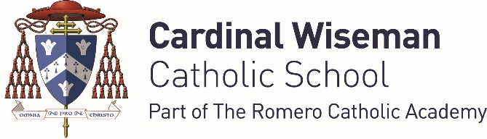
Category | Essential | Desirable
Faith Commitment | - Understanding of the distinctive nature of a faith school | - A practising Catholic  - Experience of leading acts of worship in Catholic Schools
2. Qualifications | - Qualified teacher status.  - Honours graduate
3. Experience | - Successful PGCE placement in secondary school/s.  - Successful NQT
4. Professional Development | - Ability to identify own learning needs.  - Willingness to engage in CPD.
5. Leadership | - Able to lead on the development of key materials and initiatives within the department | - Potential for promotion within the school
6. Teaching and Learning | - Knowledge of a range of successful teaching and learning strategies to meet the needs of all pupils.  - Secure knowledge of statutory requirements relating to the curriculum and assessment  - Excellent subject knowledge | - Experience of Key Stage 4 and A level teaching.  - An understanding of assessment strategies and the use of assessment to inform the next stages of learning.
7. Skills, Qualities & Abilities | - Empathy with pupils from Key Stage 3 upwards.  - Excellent communication skills.  - Excellent interpersonal skills  - Excellent organisation skills
8. References | - Positive recommendation in professional references

