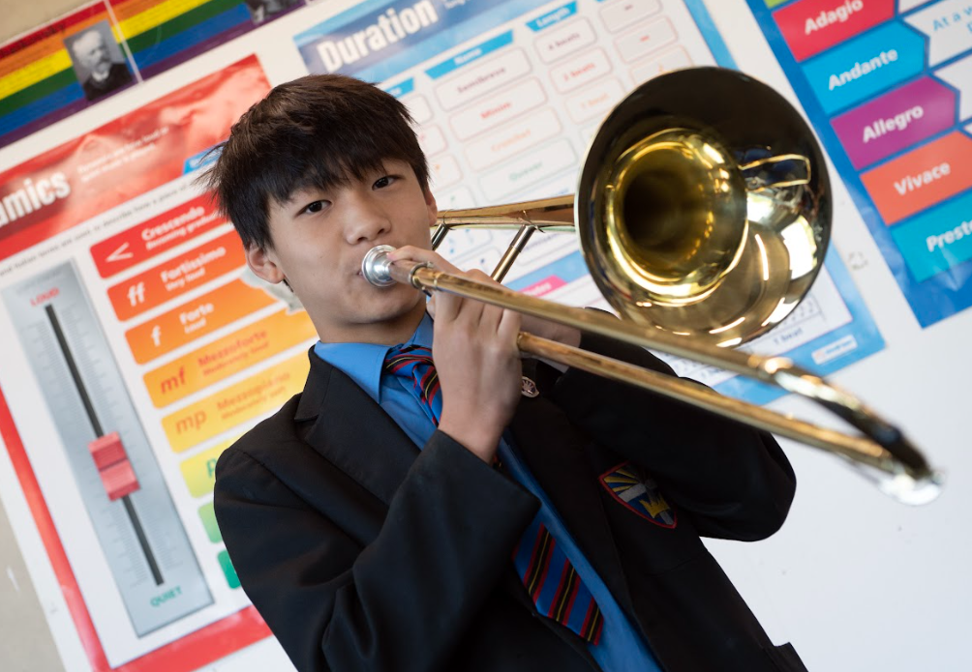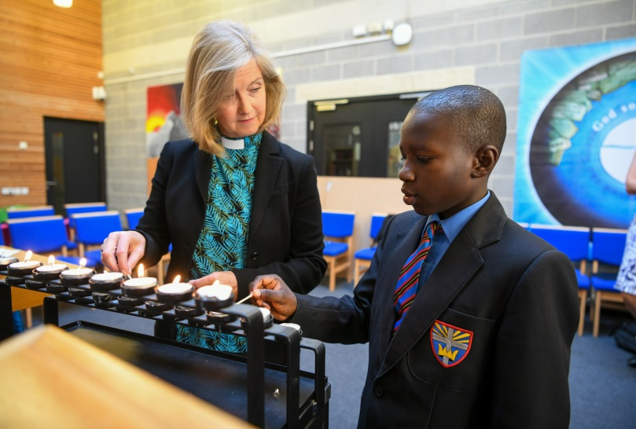

Teacher of Maths
To start September 2024
Information booklet for prospective applicants

Dear Applicant,
Thank you for your interest in the role of Teacher of Maths.
Christ’s College is an exciting place to work with dedicated staff, positive students and supportive parents. Our last inspection was in October 2022 with a very strong ‘Good’ in all areas judgement being made. The report highlighted the inclusivity of the school,
“Where students are known as individuals, challenged and supported to achieve their goals in a culture of high aspirations.”
“Positive relationships and respect underpin the calmness and cooperation in classrooms … promoting pupils’ wellbeing is at the heart of its Christian values.”
We are looking for highly motivated aspirational colleagues to join us at this exciting time in working to make Christ’s College even better.
We have a proven track record of excellent professional development opportunities. Staff are provided opportunities for career progression, with high quality training in place.
We have seen a rise in the number of families making Christ’s College their first choice of secondary education. In 2014 we increased our intake numbers from 125 to 156.
If you believe yourself to be the right candidate for this position, we would welcome your application. If you would like more information, or if you have questions about the post or the College, please contact me on jobs@christscollege.surrey.sch.uk or 01483 537373.
I look forward to receiving an application from you.
Yours Sincerely
Sarah Hatch
Principal

About Christ’s College
Christ’s College is a thriving school serving the non-Christian and Christian community of Guildford, Woking and the surrounding areas. We are proud of our Church heritage which has helped us to create an environment that is inclusive and supportive of all. Our aim for the children at Christ’s College is that they should develop the Core Values of Service, Respect, Stewardship, Co-operation and Love. We know that success only comes through hard work and perseverance; life can be difficult, and therefore we all need resilience, but we need to work with optimism and believe that our hard work will open up great opportunities for us.
Over the last few years Christ’s College has continued to grow. We have seen a significant rise in the percentage of children gaining 5 or more GCSEs. We are determined to build upon our high standards and ensure that students at Christ’s College achieve excellent outcomes.

Pupils are rightly proud of their successes nationally, for example winning a national handball competition, and winning the University of Manchester’s Alan Turing cryptography competition.
“Pupil’s personal development is promoted effectively and staff care deeply about their wellbeing.” (OFSTED report October 2022)
Outcomes are significantly improved year on year, with structures and processes in this area implemented to secure sustainability and continuous improvements.

Advantages of working at Christ’s College
- A collegiate, warm and welcoming environment where all are valued.
- A values driven educational establishment which underpins all areas
- There is a real sense of support, belonging, camaraderie and mutual respect within the whole community
- Parents/carers and governors are highly supportive of the College
- Students are aspirational and committed to their studies
- Staff are dedicated, skilful and hard-working
- There are good opportunities for internal promotion which has a tradition of acknowledging and rewarding hard work
- As a relatively small school which offers a full suite of extra-curricular activities, it is easy to be involved in a wide range of enrichment activities in Sport, Performing Arts and elsewhere
- High quality CPD.
- Our recent OFSTED report was enthusiastic about the effective teamwork and “impressive curriculum”.
- SIAMS “Excellent”.

The job profile for Teacher of Mathematics
JOB TITLE: Teacher of Mathematics
DURATION / HOURS: Permanent full-time post with effect from September 2024 or June for NQT
PAY: MPS/UPS
ELIGIBLE TO APPLY: All teachers with suitable skills and experience.
RESPONSIBLE TO: Head of Mathematics
SELECTION PROCESS: Method: Please complete the application form found on My New Term.
Interview date: TBC
Candidates will be assessed as their application is received, and we reserve the right to interview earlier than the stated vacancy closure date should we receive candidates who are suitable for the vacancy.

Job Purpose:
- To teach Mathematics to the full range of abilities.
- To ensure appropriate differentiation for students.
- To ensure high levels of attainment and progress in Mathematics.
- To assist the Principal and Head of Mathematics in challenging under-achievement with a particular focus on those who are at risk of under-achievement.
- To promote the Christian ethos of the College.
- To carry out any other specific duty assigned by the Principal or her appointed representative.

Areas of responsibility:
To work with the Head of Mathematics in the following areas:
1. Plan engaging lessons which motivate and inspire individual students and groups of students to achieve beyond what they thought possible;
2. To establish and then maintain the highest expectations about what the students are capable of achieving;
3. To arrange, wherever appropriate, Maths enrichment activities;
4. To set regular and meaningful homework which fosters independent learning skills amongst the students in Maths;
5. To assess work regularly and provide oral and written feedback on an ongoing basis so that students can make progress;
6. Maintain up-to-date records about the students’ achievements including what grade they are at and what they need to do to progress to the next grade;
7. Keep parents and other members of staff informed of the progress that is being made by the students in Maths;
8. Seize every opportunity for professional development both within the Maths curriculum and general pedagogy so that the subject and the school stay abreast of the latest educational initiatives within Maths education;
9. Implement a process of self-evaluation which informs future practice;
10. Promote educational inclusion with a wide range of teaching and behaviour strategies;
11. Encourage and listen to the “student voice” about learning within the subject;
12. Maintain the highest standards of behaviour.

General duties
- Understand, accept and follow the College’s Safeguarding and Child Protection procedures.
- To report all matters of concern in line with the school procedure.

Note: This job description is not exhaustive and will be subject to periodic review. It may be amended to meet the changing needs of the school. The post-holder will be expected to participate in this process and we would aim to reach agreement on any changes.

Person Specification –Teacher of Mathematics
 |  | Essential | Desirable
1 | Qualifications | Qualified Teacher Status  - Relevant degree | Post graduate qualification  - Further relevant professional/academic study
2 | Experience | - Experience of teaching Mathematics to a range of abilities and key stages. This could include teaching practice whilst training.  - Excellent track record of attendance.
3 | Knowledge / Skills | - Up to date knowledge of Mathematics examination specifications.  - Up to date knowledge of best practice in teaching and learning in Mathematics.  - Knowledge of effective strategies for meeting the needs of SEND and EAL learners in Mathematics.  - Knowledge of effective strategies for meeting the needs of the most able in Mathematics. | - Examiner.
4 | Personal Qualities | - Resilience, determination and enthusiasm.  - High expectations of self and students.  - Ability to work as part of a team.  - Excellent written and oral communication skills.  - A desire to keep skills and knowledge up to date.  - Commitment to safeguarding and child protection. | - A desire for further professional development and promotion.  - A willingness to contribute to the extracurricular life of the school.

Safeguarding Statement: The Good Shepherd Trust is committed to safeguarding and promoting the welfare of children and young people and expects all staff and volunteers to share this commitment. We ensure that all our employment practices reflect this commitment.

