Deputy Headteacher (Secondary)
Applicant Information Pack
Salary – Leadership Scale: L18 – L22 (£71,729 - £79,112)

Opening date: Friday 19th April 2024
Closing Date: Tuesday 7th May 2024 9.00am
Shortlisting Date: Wednesday 8th May 2024
Interview Dates: Monday 13th May and 14th May 2024
Start Date: September 2024

Contents

Welcome letter from CEO of BDAT and Chair of Governors Page 3

Welcome letter from Bradford Girls’ Grammar School Page 4

About BDAT Page 5

BDAT Mission, Vision and Values Page 6

Deputy Headteacher Advert Page 7

Deputy Headteacher Job Description Pages 8 - 10

Deputy Headteacher Person Specification Pages 11 - 12

How to find us Page 13

Selection Process Guidance Pages 14 - 15

Welcome from the CEO of BDAT

Dear Applicant,

On behalf of BDAT and the Governors of Bradford Girls’ Grammar School we would like to thank you for showing an interest in the Deputy Headteacher post at our school.

Set near the heart of Bradford, Bradford Girls’ Grammar School is a large and thriving 11-16 secondary school packed full of determined and individually amazing students.

Historically the school has operated as an all-through academy linked to Lady Royd Primary School which is co-located on the same site. However, we are excited to confirm that from September 2024, the two schools will become independent schools in their own right.

We are now looking for a special Deputy Headteacher to join Bradford Girls’ Grammar School. That person will have the skills, the track record and the personality to drive our school forward to continue to provide an exceptional educational experience for all. By being part of the leadership team, you will assist the next exciting stage of its journey of growth, building on the great progress it has seen in recent years.

The good news of course, is you won’t be doing it alone. We already have a committed, well-established and ambitious staff body at Bradford Girls’ Grammar School, including a strong leadership team who will be able to support you. The school also has an experienced governing body and of course, you will be a Deputy Headteacher within the BDAT Family of 19 Schools which means you will have other colleagues to work alongside and a peer network to lean on.

Fundamentally however by joining our team, you will have the opportunity to be at the forefront of securing the best possible outcomes for our deserving children and the best opportunities for everyone within our school.

If you are a dynamic individual with energy, drive and ambition; if you feel you can build on our many strengths and give every one of our girls every chance every day to be the very best they can be; and if you are ready for the next step in your career, then this job could be the one for you and we look forward to meeting you. Visits to the school are warmly welcomed and actively encouraged. Please ring Bradford Girls’ Grammar School on 01274 545395 and ask for Andrew Cheeseman to make an appointment to see our school at work.

Thank you again for your interest in our school. We very much look forward to receiving your application.

Yours sincerely,
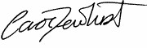

Carol Dewhurst, OBE

Chief Executive Officer, BDAT

Welcome from Bradford Girls’ Grammar School

Dear Applicant,

Thank you for the interest you have shown in the post of Deputy Headteacher at Bradford Girls’ Grammar School. I hope that the information found within this pack and on our website will encourage you to submit an application.

Bradford Girls’ Grammar Secondary School is a heavily oversubscribed school of around 690 students, located in the outskirts of Bradford city centre.

Established in 1875, the school is rich in history and has a strong record of providing an outstanding education. Previously a girls’ independent school, Bradford Girls’ Grammar School became an Academy Free School in 2013. In January 2023, the school joined the Bradford Diocesan Academies Trust (BDAT).
From establishment until 2024 the school has been an all-through school admitting students from ages 5-16. From this September Bradford Girls’ Grammar School will officially separate from Lady Royd Primary School becoming an 11-16 Academy educating 690 wonderful young ladies.

This post is integral to the continual development of Bradford Girls’ Grammar School, as we establish the school as a stand-alone 11-16 organisation. You will be the first Deputy Headteacher of our secondary school and will have the exciting opportunity working alongside the Headteacher to shape the school in the next stage of its journey. As such as we are seeking a Deputy Headteacher who will bring innovation and demonstrate resilience to the school as in partnership with our leaders, you will deliver clear, authentic leadership to our school improvement agenda.

In May 2022 the school was inspected by Ofsted and the school was judged to be Requires Improvement. The inspection confirmed that leaders have a good understanding of the school’s strengths and weaknesses. We have continued to drive school improvement forward at pace and are seeking a motivated and resilient school leader to support this journey.

All staff have incredibly high aspirations for all students and are proud to be part of the Bradford Girls’ family. Staff work hard in the interests of getting the very best out of every student in their care and so we place a strong emphasis on staff wellbeing. All staff have access to a robust performance management system, through which they can engage with a comprehensive and bespoke CPD package.

Please read the application pack carefully and if you believe that you are the right person to fill the role and that your values are aligned with ours then we welcome an application from you.
With best wishes,

Mrs J Tiller Mr C Sutcliffe
Executive Headteacher, BGGS Chair of Governors, BGGS

About BDAT

Bradford Girls’ Grammar School is an academy within Bradford Diocesan Academies Trust. If you are successful in being appointed, the Trust will be your employer.

General Information and Background

Bradford Diocesan Academies Trust (BDAT) is a Multi-Academy Trust (MAT) supporting 19 schools in Bradford. We are a Trust which prides our self in delivering great education outcomes and life opportunities for all our children. We are an inclusive Trust working with children from a rich range of backgrounds who reflect our communities and the city we serve. We are proud to be all about Bradford and developing the future generation of lifelong learners who will go on to achieve incredible things.

BDAT is a Trust which recognises each of our schools is unique. We actively encourage and celebrate difference as we know each of our schools serves very different communities. However, we also know that a key strength of being part of a Trust means together our schools can support each other, learn from each other and share great practice. As importantly we know from working our way through the COVID pandemic, that a problem shared really can be a problem halved, and by working together we can save ourselves time, money and lots of duplication of work.

We are a Trust which is value-led and we know it is important that we consistently live these values. The Trust’s mission is “to provide education of the highest quality within the context of Christian belief and practice.” We strongly believe every child only has one chance at a good education.

Our core Trust values are inclusion, compassion, aspiration, resilience, excellence (I.C.A.R.E.). We seek to model these values in all we do, including how we recruit and develop our staff, how we teach our students and how we liaise with our families, friends and partners. We are a proudly Christian organisation committed to providing high-quality education for all within our ethos. Whilst robust Christian principles underpin the work of the Trust, everyone is encouraged to explore their own spirituality and to recognise and understand that of others. We describe ourselves as having inclusive values believing these are as appropriate and important to staff and students of all faiths (and to those without faith) as they are to those who practice within the Church of England. It is for this reason we choose to support and sponsor Non-Church of England Academies, as well as those within the faith. Therefore, we welcome applications for this role from employees of all faiths as long as they understand and can promote the values which we share.

BDAT is a large Trust, however we pride ourselves in knowing and understanding our schools. We are all part of the BDAT family, and we all have the same motivation – to see our children succeed. For more information about us follow us on twitter @wearebdat or visit www.bdat-academies.org

BDAT’s Mission, Vision and Values
Our mission:
“At BDAT we want every child to have a happy and high-quality education enabling them to grow and flourish during their time at school.”

Our vision is:

“We will provide schools that develop student competence, confidence and character, driven by local community context and inclusive Christian values, ensuring every student achieves their academic potential and leaves our Trust prepared for the next stage of their life journey.
We want BDAT schools to be schools of choice for the diverse and special communities we serve.
We will recruit develop and retain highly skilled staff dedicated to making sure our children and young people have every chance to succeed."

Our values are:

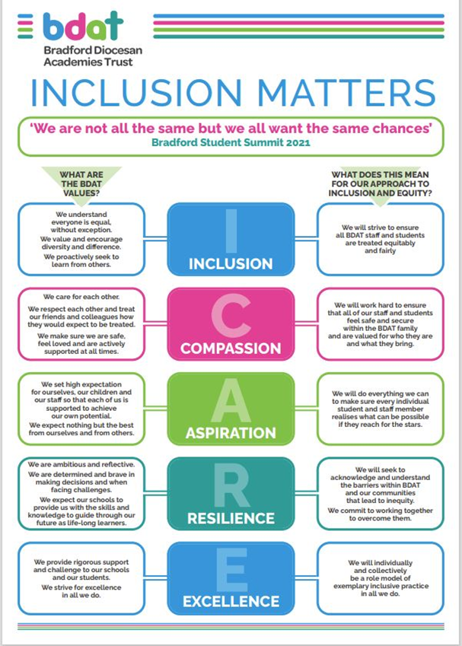

Deputy Headteacher for Bradford Girls’ Grammar School
Full-Time, Permanent, Start date 1st September 2024
Salary Leadership Scale: L18 – L22 (£71,729 - £79,112)

We are looking to appoint a dynamic, ambitious, and talented individual with a proven track record of school improvement to join us in the role of Deputy Headteacher. This role is a key member of our senior leadership team and will be instrumental in supporting the academy in the next stage of development and in our aspiration to be outstanding in all areas.

In the first instance, the key areas of responsibility will focus on all aspects of the Quality of Education.
The successful candidate will have a whole-school responsibility for this integral area of school improvement. They will also work in close collaboration with the Headteacher, and the rest of the Senior Leadership Team to facilitate joined-up thinking around all whole-school priorities.

The successful candidate will:
- Have a proven track record of whole-school improvement at senior leadership level.
- Work alongside the Headteacher and Senior Leadership Team to create a culture of success and aspiration.
- A commitment to ensuring our children achieve their biggest and bravest ambitions.
- A love of teaching and learning.
- Have excellent leadership, communication and interpersonal skills.
- A firm commitment to achieving success through partnership and teamwork.
- Drive, ambition and high expectations.
- Commitment to the vision and values of the school and Trust.

We can offer you:
- A supportive and forward-thinking Leadership Team in an inclusive Academy and Trust.
- A stimulating, attractive and welcoming learning environment.
- An approach that supports and stimulates professional growth, with a bespoke CPD package.
- Cross-Trust opportunities for collaboration and development.
- The opportunity to make a positive difference to the lives and careers of pupils and colleagues.
- A career in a forward thinking Trust.

Opening Date: 19th April 2024
Closing Date: 7th May 9.00am
Shortlisting Date: 8th May 2024
Interview Date: 13th May and 14th May 2024

For the full job details please visit: Vacancies - Bradford Diocesan Academies Trust (bdat-academies.org)

We are committed to safeguarding and promoting the welfare of all our children and we require all our staff to share this commitment. This post is subject to an enhanced criminal records check via the Disclosure and Barring Service (DBS). Please see our Safeguarding and Child Protection policy on the BDAT website BDAT Policies - Bradford Diocesan Academies Trust (bdat-academies.org)

Job Description
Job Title: Deputy Headteacher (Secondary) for Bradford Girls’ Grammar School
Accountable to: Headteacher
Salary: Leadership L18 - L22 (£71,729 - £79,112)

All BDAT Deputy Headteachers are expected to work in partnership with the Headteacher to lead and manage their school. The Headteacher standards underpin frameworks for the training of school leaders, including aspiring headteachers.
All BDAT Deputy Headteachers are required to be effective system and school leaders working across the BDAT family of schools and an ambassador for the Trust.

Overall purpose of the post:
Under the supervision of the Headteacher to provide leadership and strategic direction for the management of their Academy, in order to:
- Support the Headteacher to secure high standards in the quality of education and student outcomes, students’ personal development and well-being, behaviour and attendance and in the leadership and management of the academy.
- To provide high quality leadership and management that will contribute to the development of an outstanding learning community where high expectations are tangible and a culture of educational excellence is evident.
- Provide every child with a high-quality education and life experience, which promotes the highest possible standards of achievement and ensures they leave school ready for the next stage in their academic/life journey.
- To support the building of leadership and staffing capacity in their academy reflecting the BDAT ambition to be an employer of choice.
- To prepare, lead and support internal and external audits including Ofsted other audits e.g., health and safety, safeguarding etc. as appropriate.

Main Duties and Responsibilities:
Leadership - Under the supervision of the Headteacher
- Support the Headteacher in the strategic leadership of all areas of academy improvement, development and delivery, ensuring provision meets the needs of individual students and maximises the opportunity for each individual to achieve excellent outcomes.
- Take responsibility for one or more key strategic area and act as strategic lead on at least one school improvement priority. This may be reviewed based on the need of the academy to maximise impact, support the best interests of the academy, and ensure the ongoing professional development of staff.
- Be responsible for implementing performance management for identified members of staff across the school, including where appropriate other members of the Senior Leadership Team.
- Ensure that they participate in and lead on continuous professional development and work collaboratively with colleagues across the school and across the Trust, to the benefit of students and colleagues at the academy.
- To act as an ambassador for BDAT as a member of an appropriate Professional Learning Community.
Education Provision and Standards:
- Take responsibility for one or more key strategic area(s) and act as strategic lead on at least one school improvement priority. This will be agreed on appointment but will be reviewed on an annual basis in order to maximise impact, support the best interests of the academy and ensure the ongoing professional development of staff.
- Ensure effective teaching, learning and behaviour throughout the academy by implementing and quality assuring practice through monitoring, evaluating, challenging and developing staff and modelling excellent practice through their own teaching and behaviour management.
- Ensure that intervention, challenge and support is provided effectively across all curriculum and pastoral areas to ensure the highest possible outcomes are achieved for students.
The role of senior leaders encompasses but exceeds the specific tasks assigned. The following are generic expectations of senior leaders within a BDAT Academy.
- To show commitment to the rigorous continuous improvement of the academy.
- To contribute to, and actively support and promote, decisions made by the Leadership Team.
- To maintain a high profile around the school during the day and be part of the SLT duty rotas.
- To encourage and support staff at all times.
- To be proactive and creative in anticipating and solving problems, responding with sensitivity and flexibility to meet the constantly changing demands of the role and the academy.
- To be an effective communicator, verbally and in writing.
- To play a major role, under the direction of the Headteacher and in collaboration with other members of the SLT, in formulating, reviewing and revising the Academy Improvement Plan to demonstrate effective impact.
- To work with the Safeguarding Team to ensure that the academy remains fully committed to safeguarding students.
- To demonstrate, and consistently articulate, high expectations of pedagogy and classroom practice.
- To ensure strict confidentiality in all areas of work and ensure all elements of GDPR are implemented and upheld in a way that protects the safety and security of the Academy and Trust’s information.
- Support the Headteacher in ensuring that high quality education provision is available to all students regardless of race, religion, sexual orientation, gender, disability, economic background or special educational needs.
- Support the Headteacher in the development and sustainable culture where students feel safe, confident and can attain their maximum educational outcomes.
- Develop, support and sustain a culture of positive student attainment and progress across the academy through a consistently high quality of education for all.

Additional Responsibilities:
To Liaise and work with the Headteacher to:
- Assist the Headteacher in leading and managing the school, and to deputise when required.
- Deal with any immediate problems or emergencies according to the academy’s policies and procedures.
- Respect confidential issues linked to home/students/teacher/academy work.
- Comply with the Trust and Academy’s Child Safeguarding Procedures, including regular liaison with the Headteacher over any safeguarding issues or concerns.
- Comply with the Trust and academy policies and procedures at all times.
- Undertake other reasonable duties (with competence and experience) as requested, in accordance with the changing needs of the organisation.
- Be self-aware and to role model continuous self-development and professional behaviours.

Person Specification
Job Title: Deputy Headteacher (Secondary) for Bradford Girls’ Grammar School
Salary: Leadership L18 - L22
Accountable to: Headteacher

Qualifications |  | Essential |  | Desirable
Qualified Teacher Status (QTS)

National Professional Qualification
Experience and Knowledge |  | Essential |  | Desirable
An ability to drive and deliver transformational and cultural change under the supervision and support of the Headteacher.
A clear understanding of what constitutes an outstanding school and what needs to be done to achieve and maintain that standard.
Experience of and evidence of developing and leading the implementation of strategies to sustain whole school improvement.
Knowledge and clear understanding of education legislation, new innovation and developments.
A practising Christian or supportive of and able to promote the BDAT distinctive Christian inclusive ethos and the values of the academy.
Skills |  | Essential |  | Desirable
An innovative leader, with a clear understanding of education opportunity and how it can be translated into practical reality working in consultation with the Headteacher.
An outstanding, collaborative leader with the ability to forge positive relationships in order to promote success.
Knowledge of what constitutes quality in educational provision, the characteristics of effective schools and strategies for raising standards and the achievement of all students
The ability to build a sustainable workforce of high-quality staff and leaders in consultation with the Headteacher.
The ability to provided clear direction and shared purpose for all children, staff and stakeholders.
Ability to inspire and motivate staff, students, parents and governors to achieve the aims of the school
Excellent communication skills with all children, staff and stakeholders including the Headteacher.
Strong level of ICT skills in relation to effective use in both curricular and administration contexts
Experience that demonstrates the ability to successfully tackle and resolve problems, effectively innovate and manage change competently
Strong negotiation skills and the ability to influence other to the benefit of the school and Trust.
Understanding of the characteristics of an effective learning environment and the key elements of successful behaviour management
Other |  | Essential |  | Desirable
A proven ability to successfully manage resources effectively within your previous roles.
 | The ability to motivate staff to ensure high performance working in consultation with the Headteacher.
The ability to translate a visionary/innovative concept into a practical implementation plan and ensure that the plan is delivered effectively and efficiently with impact reported to the Headteacher.
An ability to use the full range of leadership skills and qualities including emotional intelligence as appropriate to the situation.
Resilience and determination including the ability to also provide support, demonstrate empathy and deal with staff in a sensitive and considerate manner.
A personal commitment to inclusion and diversity to ensure the maximum benefits for children and equality in employment and service delivery matters.
A strong commitment to the personal and professional development of all staff through performance management and access to high quality CPD in consultation with the Headteacher.
An ability to take training to ascertain a deep knowledge and clear understanding of health and safety legislation and how schools need to comply with this
An understanding of the Church of England distinctiveness agenda and how this can be interpreted and demonstrated on a day-to-day basis within a school.
A proven track record as a senior leader, demonstrating improvements in raising the quality of teaching and learning, educational standards and Ofsted categories.
Effective financial planning and use of financial resources within the areas of previous responsibility.
Ability to support the leading of the school in line with the Trust and school policies in conjunction with the support of the Headteacher.
Level 3 Safeguarding qualified
A commitment to networking and collaboration between schools within and outside the MAT.

How to find us

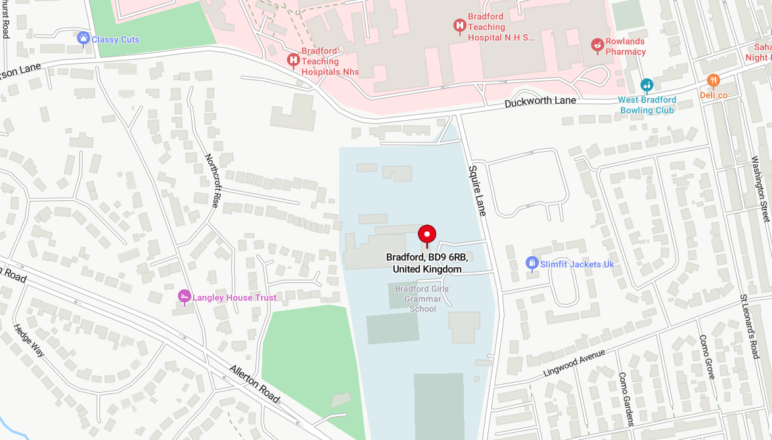

Bradford Girls’ Grammar School
Squire Lane
Bradford
BD9 6RB
Tel: 01274 545395
www.bggs.com

Bradford Diocesan Academies Trust
2nd Floor, Jade Building, Albion Mill,
Albion Road, Bradford, BD10 9TQ
T: 01274 909120
www.bdat-academies.org

Selection Process Guidance

Safeguarding
We are committed to safeguarding our pupils and will assess the candidate’s suitability for working with children as part of the selection process. We will check the accuracy of all information and investigate any perceived anomalies. We take up references prior to interview and use these to verify the information you have given us. Firm offers of employment are never made without satisfactory references. All potential employees are subject to an enhanced disclosure from the Disclosure and Barring Service.

Inclusion
As a Trust we are an inclusive employer. We welcome applications from candidates of all backgrounds, faith, ethnicities or with any protected characteristics. We are simply looking for the very best candidate for the job and will assess your application only on the information in your written application or your performance at interview should you be successfully shortlisted.

We will ensure that the selection process is fair and without discrimination for or against any candidate based on age, ethnicity, gender, religious beliefs, marital status, sexual orientation or disability. The person specification sets out the criteria used to assess candidates through the selection process.

Visits to the school
Visits to the academy are warmly welcomed and actively encouraged. Please ring Andrew Cheeseman at Bradford Girls’ Grammar School on 01274 545395 or email acheeseman@bggs.com to make an appointment to see our school.

Applications
Please ensure that all parts of the application are completed. We do not accept CVs as part of the selection process. Please ensure that you demonstrate how your experience and skills make you suitable for the position. Applications can be submitted online using the My New Term portal via Vacancies - Bradford Diocesan Academies Trust (bdat-academies.org)

Shortlisting
We assess all applications against the person specification criteria using the evidence you provide in your application. This is done by a panel of executive staff, Trustees and governors. We carefully check all applications for anomalies.

Candidates who best meet the person specification will be invited to an interview. We will notify you by telephone with e-mail confirmation to follow. If you have not heard from us within 3 days of the shortlisting date, you have not been successful at this stage.

References
We request references for all candidates who are invited to interview. Requests will be made at the same time that candidates are invited to interview. Your first referee should be your current or last, employer.

Interview Process
If you are successful in being selected for interview, we will notify you of the full interview process.
The interview will consist of several tasks and activities including a formal interview, these are designed to allow you to demonstrate your skills and abilities.

You will be asked to provide proof of qualifications and identity on the day of interview.

Final Selection
Following the tasks and formal interview, the person specification will be used as a guide to select the most suitable candidate for our academy. Each candidate will be contacted by telephone to inform them of the outcome, brief feedback will be provided during this telephone conversation.

Offer of Employment
We will make a verbal offer of employment by telephone on the day of the interview and this will be confirmed in writing. Any offer is made subject to:
- References satisfactory to us
- A satisfactory DBS check
- A satisfactory online check
- Provision of proof of identity and qualifications

Timeline
Opening date: Friday 19th April 2024
Closing Date: Tuesday 7th May 2024 9.00am
Shortlisting Date: Wednesday 8th May 2024
Interview Dates: Monday 13th May and Tuesday 14th May 2024
Start Date: September 2024

Questions
If you have any queries on any aspect of the application process, please contact Andrew Cheeseman on 01274 545395 or e-mail acheeseman@bggs.com

