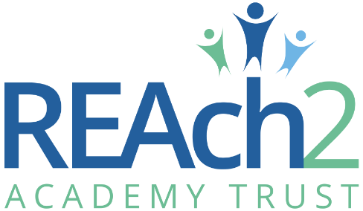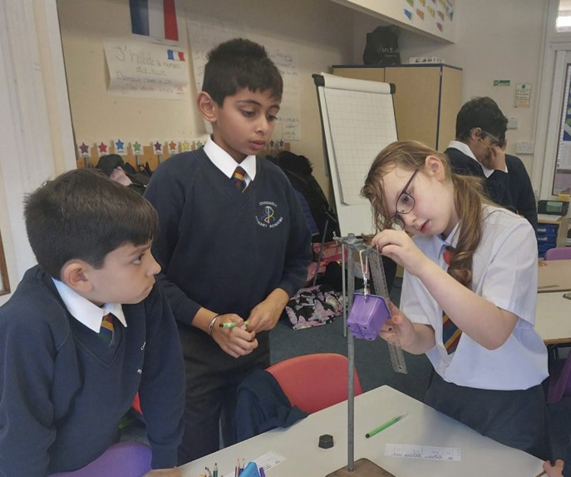



**Chigwell Primary Academy**

**Midday Assistant Application Pack**

Contents

**Letter from Cathie Paine, Chief Executive Officer** 3

Our Touchstones 5

The role 6

The application 8

The application process and timetable 8

Safeguarding, Safer Recruitment and Data Protection 9

Job Description 10

Person Specification 15

**Letter from Cathie Paine, Chief Executive Officer**

Dear Candidate

Thank you for your interest in this role within the REAch2 Academy Trust.

This is a hugely exciting time for our family of schools. The Trust has been recognised by the Department for Education as being well placed to raise standards and achieve excellence for pupils in a growing number of schools nationwide. We are presented with a rare opportunity to make a real difference to the lives and life chances of so many primary school children – many of whom haven’t previously received the educational opportunities they deserve.

The Trust includes schools at all stages of development, from those requiring significant improvement through to existing outstanding schools. As a Trust we are clear about the importance of achieving long term sustainability for our schools. Our vision is to enable individual academies to flourish with real autonomy, whilst also ensuring a strong ethos of support and collaboration across our schools.

Employees within REAch2 belong to a national community of professionals, and benefit from a wide range of networks and development opportunities across the Trust. In time, our best teachers are able to work across schools, develop specialisms and step up to leadership roles within and beyond their own academy. The Trust provides a strong culture of collaboration and support, together with high expectations for staff and pupils alike.

Those we recruit are able to demonstrate that they share our values, are highly motivated to work with colleagues within and beyond their school to continuously develop their skills and pursue professional excellence and are committed to providing the highest standards of teaching for all children. If that is you then we would be delighted to receive your application.

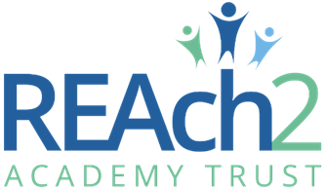**Cathie Paine**

**CEO**

# Our Touchstones

REAch2 is defined by the values of **excellence, quality, delivery and standards** – these features give the Trust its enduring attributes and its inherent reliability.

However, what gives each REAch2 Academy its uniqueness are the Touchstones of the Trust (seen on the right). Just as 500 years ago Touchstones were used to test the quality of the gold they marked, so too our touchstones find what is precious and set these things apart. They are used to express the values and ethos of the Trust and describe what the Trust wants to be known for and how it wishes to operate.

With good **leadership**, we aspire to develop children academically, emotionally, physically and spiritually. We notice talent and spot the ‘possible’ in people as well as the ‘actual’. Developing potential across our Trust becomes a realisation that there is a future worth pursuing for everyone.

Children deserve **enjoyment** in their **learning** and the pleasure that comes from absorption in a task and achieving their goals. Providing contexts for learning which are relevant, motivating and engaging, release in children their natural curiosity, fun and determination.

**Inspiration** breathes energy and intent into our schools: through influential experiences, children can believe that no mountain is too high and that nothing is impossible.

REAch2 serves a wide range of communities across the country and we celebrate the economic, social, cultural and religious diversity that this brings: embracing **inclusion** ensures that we are a Trust that serves all, believing that everyone can succeed.

We take our **responsibility** seriously. We act judiciously with control and care. We don’t make excuses, but mindfully answer for our actions and continually seek to make improvements.

REAch2 is a Trust that has a strong moral purpose, our **integrity** is paramount. Our mission is to change children's lives by providing the very best quality education we can. Through this, children can fulfil their potential, become happy, successful adults and contribute effectively and meaningfully to society. We welcome the fact that all our decisions and actions are open to scrutiny. You can learn more about REAch2 at our website: [www.reach2.org](http://www.reach2.org)

# The role

**Midday Asssistant at Chigwell Primary Academy Required for September 2024**

**Fixed Term Cover (until 31st August 2025) SCP 2, £22,366 FTE, plus £988 inner fringe allowance (to be pro rata to actual hours & weeks worked)**

This is an exciting opportunity to be part of a popular and well established school. Chigwell Primary Academy is part of the REAch2 family of Schools in London. We are looking for an enthusiastic Midday Assistant to join our collaborative and growing Academy team. You need to be committed to providing children with a safe and enjoyable lunchtime period. You will assist with pupils’ table manners and use of cutlery and will also be responsible for coordinating a range of interactive play activities, administering minor first aid and ensuring the welfare and safety of the pupils.

As a Midday Assitant, you will be passionate about ensuring the best outcomes for children and giving them every opportunity to succeed. Every child is respected and treated as an individual, with no limits placed on their learning – just opportunities to continually improve. We give all children the opportunity to challenge themselves through a range of tasks and activities – empowering children to take ownership and responsibility for their own learning.

**In particular, successful candidates should have:**

* Experience of working with young children
* Basic understanding of child development and learning
* Enthusiasm and dedication to caring and supporting pupils’ lunch time activities

**You should be:**

* A responsible and reliable person
* Confident in dealing with young people, maintaining discipline and motivation
* Able to relate well to pupils and adults

**In turn, we can offer you:**

* Great facilities to create a vibrant, stimulating learning environment for children
* A supportive Leadership team who will encourage innovation and initiative
* A wider network within REAch2 Academy Trust of support, exceptional practice and excellent CPD

If you feel you have all the necessary attributes, are highly motivated, committed to making a positive difference to children’s lives and want to be part of creating a legacy for the future - apply now!

**Background Information about the School**

At Chigwell Primary Academy we believe that all members of the school community must treat each other with respect, develop an understanding of our responsibilities and develop resilience so that we can all be active learners and reach our full potential.

At Chigwell Primary Academy we achieve this by behaving in a positive way and encouraging others, developing an ethos where all members feel safe, secure and have the highest expectations.

We are a caring employer who invests in the future of our employees, as only through their excellence can we deliver excellence for the children and families whom we serve. To see more information about the school, please visit our website [Chigwell Primary Academy](https://www.chigwellprimaryacademy.co.uk/)

As a member of the REAch2 Trust, a national family of primary academies, Chigwell Primary Academy is committed to raising standards and achieving excellent for all pupils whatever their background or circumstance. The Trust provides a strong culture of collaboration and support, together with high expectations for staff and pupils alike. Chigwell Primary Academy is committed to safeguarding and promoting the welfare of children and young people / vulnerable adults and expects all staff and volunteers to share this commitment. This position is subject to an enhanced DBS check and satisfactory written references.

# The application

You are invited to submit an application form to: **Charlotte Furia, Head teacher via:** [My New Term](mailto:https://mynewterm.com/trust/Reach2-Academy-Trust/672956683)

REAch2 Academy Trust have an Equal Opportunities Policy for selection and recruitment. Applicants are requested to complete the Trust’s online [Equality & Diversity Monitoring Form](https://forms.office.com/Pages/ResponsePage.aspx?id=EGorfMwEtEi30d9QFOXXNJ4DEcgd411KhzIQrNunT_hUMlJXTkhNVlE0SlhKV0FWTEk2Wkw1TTUwRS4u) separately.

In accordance with our Safeguarding Policy the successful candidate will be required to have an enhanced DBS check.

To arrange an informal discussion please contact: **Charlotte Furia, Head teacher via the school office on: 0208 500 2666**.

## The application process and timetable

|  |  |
| --- | --- |
| **Application deadline:** | Monday 15th July 2024 at Midday |
| **Interviews:** | TBC |
| **Contract Details:** | 6.25 hours per week Monday to Friday 12.00-1.15pm, 38 weeks per year (Term time only), Fixed term until 31st August 2025 |
| **Salary:** | SCP 2, £22,366 plus £988 inner frin g allowance FTE, (To be pro rat to actual hours and weeks worked) |
| **Start date:** | 1st September 2024 |

Candidates selected for interview will be informed after shortlisting and full details of the interview programme will be provided.

# Safeguarding, Safer Recruitment and Data Protection

At REAch2 we recognise that those who work in an academy are in a unique position in their care of children. The responsibility for all staff to safeguard pupils and promote their welfare, as stated in Section 175 of the Education Act (2002) is one that is central to our ethos, our policies and our actions. All children are deserving of the highest levels of care and safeguarding, regardless of their individual characteristics or circumstances, and we are committed to applying our policies to ensure effective levels of safeguarding and care are afforded to all our pupils.

We will seek to recruit the best applicant for the job based on the abilities, qualifications, experience as measured against the job description and person specification. The recruitment and selection of staff will be conducted in a professional, timely and responsive manner and in compliance with current employment legislation, and relevant safeguarding legislation and statutory guidance.

All information is stored securely and any information supplied by unsuccessful candidates will be destroyed through a confidential waste system six months after the decision has been communicated, in accordance with our information and records retention policy.

The Trust ensures all applicant data is stored and processed appropriately. For further details on how your information will be managed during the recruitment process please refer to our [Privacy Notice for Job Applications](https://reach2.org/wp-content/uploads/2020/01/Privacy-Notice-Job-Applications.pdf).

# Job Description

**Core Purpose**

**Role:**  Midday Assistant

**Line Manager:**  Office Coordinator/SLT

**Job Purpose**

To provide a friendly and efficient lunch experience to pupils and staff at school, serving meals as ordered and keeping all dining areas clean and hygienic.

**Duties and Responsibilities**

* Assisting with setting up the dining hall for daily lunch service
* Assisting with serving all school meals in accordance with instructions

from meal provider

* Ensure that that children with special diets receive the correct meal
* Ensure that packed lunches are in accordance with school policies
* Assist any pupils who may require additional support/encouragement
* Clean Dining areas in between sittings and after lunch has finished in accordance with Guidelines specified
* Operate the dishwasher under Supervision

The duties above are neither exclusive or exhaustive and the post holder may be required by the Headteacher to carry out appropriate duties within the context of the role.

**Person Specification**

|  |  |  |
| --- | --- | --- |
|  | **Essential** | **Desirable** |
| Right to work in the UK | **\*** |  |
| Enhanced DBS Check | **\*** |  |
| **Experience** | | |
| Experience of working with children | **\*** |  |
| Experience of working as part of a team to achieve objectives |  | **\*** |
| **Education/ Qualifications** | | |
| Current First Aid Certificate |  | * |
| Current Food Hygiene Certificate |  | * |
| **Skills and abilities** | | |
| Ability to have positive interactions with adults and children of all ages | * |  |
| Ability to work with children from a wide range of social and cultural backgrounds | * |  |
| Ability to help children resolve conflicts constructively | * |  |
| Ability to deal in a calm and confident manner with behavioural issues | * |  |
| Ability to deal effectively with minor accidents and injuries | * |  |
| Able to maintain confidentiality at all times about school issues, within school and in the wider community | * |  |
| Good organising and prioritising skills | * |  |
| Knowledge and understanding of Health & Safety standards within a school setting, particularly security |  | * |
| **Other factors** | | |
| Commitment to Reach2’s Equal Opportunities Policy and Acceptance of their responsibility for its practical application. | * |  |
| Commitment to understand and comply with the requirements of the Health and Safety at Work Act 1974. | * |  |

All staff are expected to understand and be committed and to contribute to Trust’s commitment to Equal Opportunities for all.