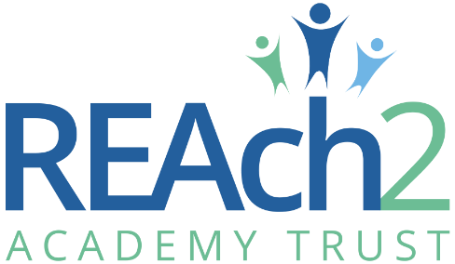
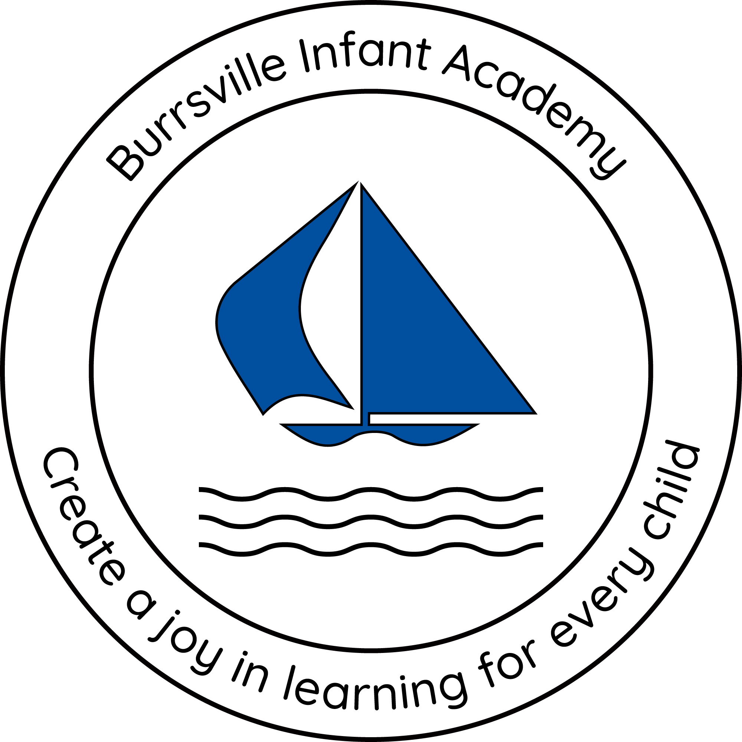

Cleaner
Application Pack

Contents
Letter from Cathie Paine, Chief Executive Officer 3
Our Touchstones 4
The role 5
The application 7
The application process and timetable 7
Safeguarding, Safer Recruitment and Data Protection 8
Job Description 9
Person Specification 13

Letter from Cathie Paine, Chief Executive Officer

Dear Candidate
Thank you for your interest in this role within the REAch2 Academy Trust.
This is a hugely exciting time for our family of schools. The Trust has been recognised by the Department for Education as being well placed to raise standards and achieve excellence for pupils in a growing number of schools nationwide. We are presented with a rare opportunity to make a real difference to the lives and life chances of so many primary school children – many of whom haven’t previously received the educational opportunities they deserve.
The Trust includes schools at all stages of development, from those requiring significant improvement through to existing outstanding schools. As a Trust we are clear about the importance of achieving long term sustainability for our schools. Our vision is to enable individual academies to flourish with real autonomy, whilst also ensuring a strong ethos of support and collaboration across our schools.
Employees within REAch2 belong to a national community of professionals, and benefit from a wide range of networks and development opportunities across the Trust. In time, our best teachers are able to work across schools, develop specialisms and step up to leadership roles within and beyond their own academy. The Trust provides a strong culture of collaboration and support, together with high expectations for staff and pupils alike.
Those we recruit are able to demonstrate that they share our values, are highly motivated to work with colleagues within and beyond their school to continuously develop their skills and pursue professional excellence and are committed to providing the highest standards of teaching for all children. If that is you then we would be delighted to receive your application.
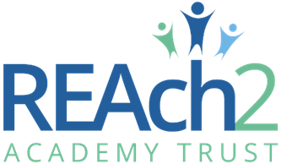
Cathie Paine

CEO

Our Touchstones
REAch2 is defined by the values of excellence, quality, delivery and standards – these features give the Trust its enduring attributes and its inherent reliability.
However, what gives each REAch2 Academy its uniqueness are the Touchstones of the Trust (seen on the right). Just as 500 years ago Touchstones were used to test the quality of the gold they marked, so too our touchstones find what is precious and set these things apart. They are used to express the values and ethos of the Trust and describe what the Trust wants to be known for and how it wishes to operate.
With good leadership, we aspire to develop children academically, emotionally, physically and spiritually. We notice talent and spot the ‘possible’ in people as well as the ‘actual’. Developing potential across our Trust becomes a realisation that there is a future worth pursuing for everyone.
Children deserve enjoyment in their learning and the pleasure that comes from absorption in a task and achieving their goals. Providing contexts for learning which are relevant, motivating and engaging, release in children their natural curiosity, fun and determination.
Inspiration breathes energy and intent into our schools: through influential experiences, children can believe that no mountain is too high and that nothing is impossible.
REAch2 serves a wide range of communities across the country and we celebrate the economic, social, cultural and religious diversity that this brings: embracing inclusion ensures that we are a Trust that serves all, believing that everyone can succeed.
We take our responsibility seriously. We act judiciously with control and care. We don’t make excuses, but mindfully answer for our actions and continually seek to make improvements.
REAch2 is a Trust that has a strong moral purpose, our integrity is paramount. Our mission is to change children's lives by providing the very best quality education we can. Through this, children can fulfil their potential, become happy, successful adults and contribute effectively and meaningfully to society. We welcome the fact that all our decisions and actions are open to scrutiny. You can learn more about REAch2 at our website: www.reach2.org

The role
School Cleaner at Burrsville Infant Academy
We are seeking a hard-working and dedicated School Cleaner to work in our friendly school. You will work as part as a team, undertaking various cleaning duties throughout the school to ensure our children’s learning environment is always clean. For a successful candidate we offer permanent contract working on a part-time basis (15 hours per week, 43 weeks per year).

In particular, successful applicants should have:
- Experience of similar work
- Ability to work constructively as part of a team
- Ability to relate well to children and to adults
- Good organising and prioritising skills
- Ability to keep accurate cleaning records
- Evidence of a commitment to safeguarding and promoting the welfare of children and young people
- Ability to work flexibly to suit school needs

You should:
- Have good communication skills
- Have the ability to use initiative
- Be willing to undertake direction and guidance

Background Information about the School
Burrsville Infant School was established in 1967. The school converted to an academy with the REAch2 Academy Trust in December 2013. Burrsville Infant Academy is situated on the Birds Estate in Great Clacton and welcomes children from around the coastal village of Great Clacton. We operate a two form entry which means each September we welcome 60 children into our Early Years classes, Maple and Rowan.

We are a caring employer who invests in the future of our employees, as only through their excellence can we deliver excellence for the children and families whom we serve. To see more information about the school, please visit our website Burrsville Infant Academy

As a member of the REAch2 Trust, a national family of primary academies, Burrsville Infant Academy is committed to raising standards and achieving excellent for all pupils whatever their background or circumstance. The Trust provides a strong culture of collaboration and support, together with high expectations for staff and pupils alike. Burrsville Infant Academy is committed to safeguarding and promoting the welfare of children and young people / vulnerable adults and expects all staff and volunteers to share this commitment. This position is subject to an enhanced DBS check and satisfactory written references.

The application

You are invited to submit an application form to Katie Siggery, Headteacher, via My New Term

REAch2 Academy Trust have an Equal Opportunities Policy for selection and recruitment. Applicants are requested to complete the Trust’s online Equality & Diversity Monitoring Form separately.

In accordance with our Safeguarding Policy the successful candidate will be required to have an enhanced DBS check.

To arrange an informal discussion please contact Miss K Siggery, Headteacher via school office on 01255 425106 or by email admin@burrsvilleinfantacademy.org

The application process and timetable

Application deadline: | Midday, Monday 08 July 2024
Interviews: | Friday 12 July 2024
Contract Details: | Permanent, Part-time, 15 hrs per week, 2.30pm-5.30pm Monday to Friday, working 43 weeks a year (Term Time plus 5 INSET days + 4 weeks during the Summer holiday, 1 week at Christmas and 1 at Easter)
Salary: | NJC Point 2 (£22366 FTE)
Start date: | September 2024

Candidates selected for interview will be informed after shortlisting and full details of the interview programme will be provided.

Safeguarding, Safer Recruitment and Data Protection

At REAch2 we recognise that those who work in an academy are in a unique position in their care of children. The responsibility for all staff to safeguard pupils and promote their welfare, as stated in Section 175 of the Education Act (2002) is one that is central to our ethos, our policies and our actions. All children are deserving of the highest levels of care and safeguarding, regardless of their individual characteristics or circumstances, and we are committed to applying our policies to ensure effective levels of safeguarding and care are afforded to all our pupils.

We will seek to recruit the best applicant for the job based on the abilities, qualifications, experience as measured against the job description and person specification. The recruitment and selection of staff will be conducted in a professional, timely and responsive manner and in compliance with current employment legislation, and relevant safeguarding legislation and statutory guidance.

All information is stored securely and any information supplied by unsuccessful candidates will be destroyed through a confidential waste system six months after the decision has been communicated, in accordance with our information and records retention policy.

The Trust ensures all applicant data is stored and processed appropriately. For further details on how your information will be managed during the recruitment process please refer to our Privacy Notice for Job Applications.

Job Description

Post: Cleaner
Salary: NJC Point 2
Responsible to: Site Manager

Core Purpose
To work under the direction and instruction of senior staff to undertake individually, or as part of a team the cleaning of designated areas to ensure they are kept in a clean and hygienic condition.

Responsibilities
Maintenance and Cleaning
Carry out cleaning tasks to include:
- Mop sweeping
- Single solution mopping
- Buffing
- Spray cleaning
- Suction cleaning
- Damp wiping
- Waste disposal
- Cleaning of toilet facilities and associated tasks required to achieve a high quality of cleanliness
- Cleaning of fixtures and fittings.
- Use of appropriate cleaning equipment and machinery.
- Ensuring the safe use of chemicals, machinery and equipment whilst carrying out the cleaning function in line with current legislation, standards and REAch2 policies and procedures for Health and Safety in accordance with training provided.

Support to School
Promote and safeguard welfare of children and young persons.
- Be aware of and comply with policies and procedures relating to child protection, health and safety and security, confidentiality and data protection, reporting all concerns to the appropriate safeguarding personnel.
- Be aware of and support equal opportunities for all.
- Contribute to the overall ethos/work/aims of the school.
- Appreciate and support the role of other professionals
- Attend and participate in training and other learning activities and performance development as required.

Person Specification

 | Essential | Desirable
Right to work in the UK | *
Enhanced DBS Check | *
Knowledge/Qualifications and experience
NVQ Level 1 in Cleaning or similar |  | *
Good standard in literacy and numeracy |  | *
Awareness of Health and Hygiene procedures |  | *
Awareness of COSHH Regulations |  | *
Experience of similar work | *
Skills, abilities and personal attributes
Ability to work constructively as part of a team | *
Ability to relate well to children and to adults | *
Good organising and prioritising skills | *
Ability to keep accurate cleaning records | *
Able to work flexibly to suit school needs | *
Evidence of a commitment to safeguarding and promoting the welfare of children and young people | *
Commitment to promote and support the aims of REAch2 | *

All staff are expected to understand and be committed and to contribute to Trust’s commitment to Equal Opportunities for all.

