
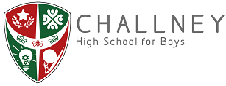

October 2024

Dear Applicant,

Teacher of Science
TMS / UPS
Permanent

Thank you for your interest in this role, we are delighted you are considering joining our team.

Challney High School for Boys has an enviable local and national reputation as an outstanding school. It is a dynamic and exciting place to work. Our staff are highly valued, well supported and benefit from extremely positive pupil relationships and a calm and purposeful working environment.

These qualities are a central characteristic of our school and have been cultivated over many years through a whole-school ethos that ensures that everyone works together to help one another succeed. Our core value statement ‘High achievement and access for all are our shared responsibilities’ reflects this ethos and is understood and embodied by every child and adult in the school.

The school is proud to be part of Chiltern Learning Trust, an outstanding and progressive mutli-academy Trust in Bedfordshire. The Trust and school work together in a very supportive and collaborative way, offering a wealth of staff professional development.

Please look at both the school and the Trust website for further details. This is an ideal opportunity to make a real difference to the pupils and their life chances. If you wish to discuss this post further, please contact Laura Miller for an informal discussion on 01582 599921 or by emailing lmiller@challneyboys.co.uk.

The closing date for applications is 9am on Tuesday 22nd October 2024.

We look forward to receiving your application.

Yours sincerely
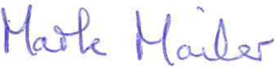

Mark Mailer
Head Teacher

