Candidate information pack

Roundthorn Primary Academy: “A Community of Learners”

Our School Values are Care-Dare-Fair-Share.

At Roundthorn Primary we place your child at the centre of the learning process

Welcome from John Taylor, Executive Principal, Roundthorn Primary Academy

Dear applicant,

Thank you for taking an interest in the Learning Support Assistant vacancy at Roundthorn Primary Academy.

Roundthorn is a rewarding place to work with great children and a staff team who are always looking for the best ways to support our children and improve outcomes. We work closely with Coppice Primary Academy, and several members of staff including myself work across the two schools. We have a joint Governing Body who are knowledgeable about the strengths and next steps for the schools and are true partners in leading the school forward with senior leaders and the Trust

We became part of Focus Trust on 1st September 2013, a Trust which now comprises fifteen schools who all share the same commitment: “Learning together, making the difference”. The schools are all distinctive in their own right with their own curriculum, staffing structure and individual ethos.

We hope that you will find this information pack helpful in finding out more about this post.

Please contact us if you require any further information.

Please return all completed documents to ka.smith@focus-trust.co.uk by 12 noon on 8th July 2024

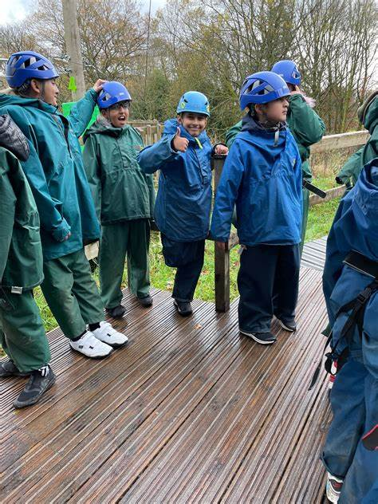

Welcome from Ken Lees , Chair of Governors

Dear applicant,

Thank you for taking the time to consider applying for the role of Learning Support Assistant. As Chair of the Governing Board, I would like to take this opportunity to tell you a little bit about the context of our school.

Roundthorn Primary Academy is a school for around 210 children aged 3-11. We were assessed as Good in the Ofsted inspection in December 2023 with a judgement of Outstanding for Personal Development. When you visit you will find well-behaved children who are happy to be in school. Good quality teaching and learning combine to make Roundthorn a rewarding and exciting place to be.

The Assistant Head of Academy will work closely with the Executive Principal of Coppice and Roundthorn Primary Academies and the Head of Roundthorn Academy, alongside a highly skilled and focussed Senior Leadership Team from across both academies. We benefit from a skilled, dedicated and motivated staff who strive to address the specific needs of our pupils. The health and wellbeing of all staff and pupils is a priority. There are ample opportunities for coaching, mentoring and career progression. We have consciously identified leaders of the future to give them opportunities to progress, most recently in the context of curriculum planning and development. The joint Coppice and Roundthorn Governing Body setup reflects how closely the two academies operate in all aspects of their work.

I hope I have given you a flavour of Roundthorn school. We have every confidence that we will successfully recruit a Learning Support Assistant who can support us to develop school further. We are a very supportive governing body with high expectations for our young people and staff, and hope that you feel encouraged to apply for the post.

3

Academy details

Roundthorn Primary Academy
Roundthorn Road
Oldham
OL4 5LN

Telephone 0161 770 8600
Website www.roundthornprimaryacademy.co.uk

Job description

Academy | Roundthorn Primary Academy
Job title | Teaching Assistant Level 2 - F-T Level 1
Grade | Grade 3 , Scale point 9 - 13
Accountable | Head of Academy
Line manager | SENDCo or SLT.

Purpose of the role
To work under the direct instruction of teaching/senior staff, usually in the classroom with the teacher, to support access to learning for pupils and provide general support to the teacher/s in the management of pupils and the classroom.

Main Duties

Support for Pupils
- Establish rapport and respectful, trusting relationships with pupils, acting as a role model and setting high expectations.
- Supervise and support pupils to undertake agreed learning activities / programmes linked to local and national curriculum and learning strategies, e.g. literacy, numeracy, KS1 or KS 2 or early years.
- Adjusting activities according to pupil responses and needs, including for those with special educational needs.
- The role may include supporting and implementing pupils’ personal programme, including social, health, physical, hygiene, and welfare matters. The pupil may also need assistance to access different areas of the school. Following appropriate training and in line with school procedures, to administer basic first aid and/or medication as required.
- Promote inclusion and acceptance of all pupils by encouraging them to interact with each other and to engage in activities led by the teacher.
- Promote self-esteem and independence amongst pupils.
- Support the implementation of Individual Education Plans and Behaviour Plans
- Provide feedback to pupils on their progress and achievement under the guidance of a teacher, in line with school policy.
Support for teachers
- Promote good pupil behaviour, dealing promptly with conflicts in line with school behaviour policies.
- Establish constructive relationships with parents and carers, promoting the School’s home/school liaison policy
- Assist the teacher with the preparation of teaching and learning materials and resources.
- Provide detailed feedback to teachers on pupils’ achievement, progress, problems etc. as requested.
- Undertake pupil record keeping as requested and assist with the collation of pupil reports as requested by the teacher, which may involve data inputting.
- Maintain a purposeful, orderly and supportive environment, in accordance with lesson plans.
- Assist with the display of pupils’ work.
- Prepare, maintain and use equipment/resources required to meet the lesson plans/learning activity and assist pupils in their use.
- Administer and mark straightforward routine tests, e.g. spelling or mental arithmetic, and invigilate tests as required
- Provide clerical support for teachers, e.g. photocopying, filing, collecting money, checking deliveries and placing goods in stock and maintaining records of stock, administering coursework, production of work sheets for agreed activities

Support for school
- To support others within the classroom and the School, contributing to the achievement of School objectives by working as part of a team
- Assist with activities outside the classroom, working as part of a team to oversee pupils and support Activity Leaders, e.g. Breakfast Club or accompanying to swimming lessons. (If this is an agreed part of the working pattern)
- Accompany teaching staff and pupils on visits, trips and out-of-school activities as required and take responsibility for a group under the supervision of a teacher

Fulfil wider professional responsibilities
- Make a positive contribution to the wider life and ethos of the Academy and the Trust.
- Develop effective professional relationships with colleagues, knowing how and when to draw on advice and specialist support.
- Liaise with external agencies with regard to pupil progress, safety and welfare.
- Work with other staff across the Trust and in other maintained schools or other academies.
- Communicate effectively with parents with regard to pupils’ achievements and well-being.
- To attend relevant meetings as required.
- To participate in training and other learning activities and performance development as required.
- To be aware of and comply with policies and procedures relating to child protection, health, safety and security, confidentiality and data protection, reporting all concerns to an appropriate person.
Personal and professional conduct
A Teaching Assistant is expected to demonstrate consistently high standards of personal and professional conduct. The following statements define the behaviour and attitudes which set the required standard for conduct throughout a Teaching Assistant's career.

Teaching Assistants uphold public trust in the profession and maintain high standards of ethics and behaviour, within and outside the Academy, by:
- treating pupils, staff, parents and visitors with dignity, building relationships rooted in mutual respect, and at all times observing proper boundaries appropriate to an adult working in an Academy environment;
- having regard for the need to safeguard pupils’ well-being, in accordance with statutory provisions;
- showing tolerance of and respect for the rights of others;
- not undermining fundamental British values, including democracy, the rule of law, individual liberty and mutual respect, and tolerance of those with different faiths and beliefs; and
- ensuring that personal beliefs are not expressed in ways which exploit pupils’ vulnerability or might lead them to break the law.

Professionals working in the Focus-Trust must have proper and professional regard for the ethos, policies and practices of the Academy and the Trust, and maintain high standards in their own attendance and punctuality.

Professionals must have an understanding of, and always act within, the statutory frameworks which set out their professional duties and responsibilities; and within the policies, handbooks and guidelines of the Academy and of the Focus-Trust.

General
The post holder will:
- Be expected to actively support work and ethos of the Focus-Trust.
- Be expected to undertake such additional duties as may reasonably be requested by the Principal or their representative.
- Respect confidentiality of staff, pupils, families and visitors and not breach this trust. Any breaches of confidentiality must be reported to the Principal immediately.
- Participate in arrangements for appraisal and in the identification of areas in which s/he would benefit from training and undergo such training.
- Proactively keep abreast of developments in relation to the post, and whenever possible and appropriate, attend professional development opportunities.
- Comply with and support all policies related to equal opportunities, child protection and safeguarding of children and colleagues.

This job description is neither exhaustive nor exclusive, and it may, after consultation with the post holder be subject to modification and amendment in accordance with the needs of the academy.

Person Specification for Teaching Assistant Level 1

Essential Criteria | How Identified | Desirable Criteria | How Identified
Skills:  Interpersonal skills to build effective working relationships with pupils and colleagues  Communication skills (both written and oral)to liaise sensitively and effectively with parents and carers  Working with or caring for children of a relevant age to those in the school  Experience of working with learning resources and helping with their preparation to support learning programmes  Experience of effectively using ICT and other technology such as digital recorders and photocopiers and resolving straightforward problems in their operation  Able to promote a positive ethos and good role model  Able to continually improve own practice/knowledge through self evaluation and learning from others  Team-work skills to work collaboratively with colleagues, understanding classroom roles and responsibilities and your own position within these | Application form and selection process.  Application form and selection process.  Application form and selection process. |  | Provide evidence by producing certificate.
Knowledge and Understanding  Basic understanding of a child’s development and learning.  Understanding of the relevant policies/codes of practice/ and awareness of relevant legislation in the context of your role  General understanding of national/foundation stage curriculum and other relevant learning programmes/strategies  Understanding of equal opportunities and an awareness of potential barriers children may have around learning | Application form and selection process.  Application form and selection process. | Appropriate knowledge of first aid.  To be aware of policies and procedures relating to child protection, health, safety and security, confidentiality and data protection. | Application form  Application form and selection process.
Qualifications / Training  NVQ 2 for Teaching Assistants or equivalent qualification or experience  Literacy and Numeracy skills equivalent to Level 1 of the National Qualification & Credit Framework  Completion of Department for Education Teacher Assistant Induction Programme  (or to complete within first term)  Willingness to undertake training in relevant learning strategies e.g. literacy/ phonics. | Application form and selection process. | GCSE Maths and / or English grades D-G  CSE Level 2  Paediatric First Aid certificate | Application form and certificate.  Application form and certificate.
Other conditions | Enhanced CRB Disclosure clearance (This will be undertaken by the school for the successful candidate)

About our School

Academy vision, ethos and values

At Roundthorn we place our children at the centre of the learning process. We aim to create a quality environment where everyone involved with the school has respect for themselves, for others and for their community.

By constantly encouraging and emphasising positive aspects of work and behaviour we seek to promote the high standards we strive to achieve.

We believe that the goals and targets we set should be high but realistic so every child has equal opportunity to achieve their maximum potential.

We actively promote healthy life-styles and give children the knowledge and understanding they need to make informed decisions about their health, safety and well-being as they grow.

Everyone at Roundthorn, be they child or adult, has a role to play and a contribution to make to the life of the school and its place in the community.

We believe that the teaching/learning environment we provide should reflect the fact that everyone’s contribution will be recognised and their views will be listened to.

We aim to have a school which provides stimulating, enriching and fulfilling experiences - a place which people enjoy coming to.

Our children are our future. At Roundthorn we work together to give children the academic and life skills they will need for a happy and successful future.

Our pupils

Our school serves a community close to the centre of Oldham with families predominantly of South Asian backgrounds. Some have a first language other than English and around 25% of children are eligible for free school meals.

Our staff

Our leadership team comprises the Executive Principal, Headteacher, Assistant Head and SENDCo. In addition to teachers and teaching assistants, we have a Home-School Liaison Officer who works with children and families, staff and outside agencies to offer support for wellbeing and develop parental engagement. The running of the school is also supported by admin, site, kitchen and lunchtime teams.

Our facilities

Roundthorn is all on one level and so is accessible to anyone with mobility difficulties. In addition to classroom accommodation, there is a hall, shared areas around school, two playgrounds and several areas of the grounds used for Forest School. We have a school Nursery, for children aged 3 and 4.

We have our own kitchen and school meals are cooked on site. A pre-school nursery operates in the same building during the day.

Our school organisation

Our pupil admission number is 30 and we are a single-form entry school. In addition to class teachers, learning is supported in classes by teaching assistants – the number of these depends on needs within classes and year groups.

Our curriculum

We provide a curriculum that provides children with stimulating and challenging experiences, developing their knowledge, understanding, creativity and unique individual skills in response to their present and future needs.

We offer opportunities to excel in activities beyond the curriculum, and equal access to the range of activities offered in school.

We provide learning and teaching experiences for children that develop their self-respect, resourcefulness and responsibility, and opportunities to raise their self-esteem and develop sensitivity to the needs of others.

Robust links to the local community and wider global community enable our pupils to become confident, independent citizens and have respect for their own and others’ cultures, beliefs and views.

Our extra-curricular activities

A range of extra-curricular activities is offered throughout the year, such as cookery, sports, science and gardening.

School Quick Facts

Type of school | Primary
Age range | 3 - 11
Location/LA | Oldham
Number of children | 210, plus Nursery
Number of teaching staff | 8
Number of learning support staff | 15
% FSM | 25%
% SEN | 16.8 %
% EAL | 54 %

Our geographical area

Roundthorn is one of several schools in our area of Oldham.

In addition to our partner academies within Focus-Trust, we work collaboratively with schools in our local partnership and with a range of secondary schools in the area to which our pupils transfer at the end of Year 6.

What you might want to know about Focus Trust
Who are we?
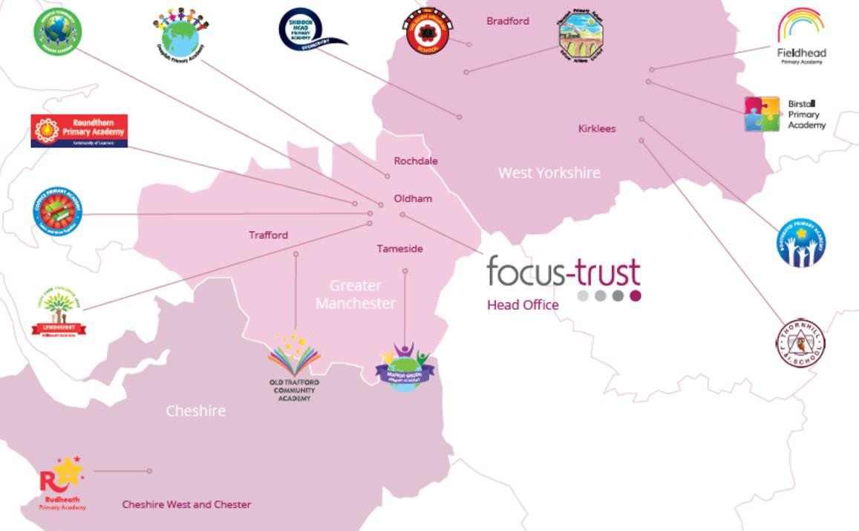
Focus-Trust was incorporated in May 2012 as a primary trust. The Trust has links with the sponsor, Focus Education, but is an entirely separate legal entity. As with all academy trusts, the Trust is a company limited by guarantee and an exempt charity. The Trust’s offices are situated in a newly converted historic mill conversion in Chadderton, Oldham with excellent motorway networks to access our schools.

The defining feature of Focus-Trust is that it is a specialist primary phase trust. This means that the work of the Trust is driven by the distinctive needs of primary schools. Whilst the Trust has robust systems for accountability, each school has their own distinctive identity, ethos and culture, and this is a commitment to every school when they convert and join the Trust.

Focus-Trust currently has a small centrally employed team. The members of the team are highly skilled and committed to the vision, culture and values of the Trust.

All the schools within the Trust are willing partners who have actively chosen to join Focus-Trust and there is a very high degree of consensus, cooperation and commitment from within the group.

The Trust has robust policies and systems in place to govern and guide its work. These have been gradually implemented as the Trust has grown. The Trust has well-established productive relationships with trade unions and meets half termly with a group of national trade union representatives to discuss policy development. This has enabled us to introduce and change a range of policies in a streamlined and cooperative way.

Equality of opportunity

Focus-Trust is an equal opportunity employer, dedicated to a policy of non-discrimination in employment on any basis including age, gender, race, colour, nationality, ethnic origin, disability, gender, religion, age, marital status, sexual orientation and/or medical condition.

Safeguarding

Focus-Trust is committed to safeguarding and promoting the welfare of all children and young people. There is an explicit expectation that all employees share this commitment and adhere to all safeguarding policies and procedures. Applicants should be aware that the recruitment process will include an assessment of your suitability to work with children.

Right to work in the UK

Under the Asylum and Immigration Act 1996, it is a criminal offence to employ anyone who is not entitled to live or work in the United Kingdom. Applicants can expect us to ask for proof of this at interview stage, where you will be asked to provide some original documentation to confirm that you are eligible to work within the UK. Photographic proof of identity will also be required.

Validation of qualifications and identity

All shortlisted candidates will be asked to bring original certificates or relevant qualifications and identity documents to interview. These will be photocopied and kept on file and, if appropriate, may be confirmed as genuine with the relevant awarding bodies. The copies of the successful candidate will be retained on their personnel file. The copies of unsuccessful candidates will be treated as confidential waste and disposed of appropriately.

References and Social Media Checks

If you are shortlisted, we will take up references before the interview date, unless you state otherwise on your application form. However, two satisfactory references must be received before we can confirm any offer of an appointment. One of your referees must be your current or most recent employer. The information we request will relate to salary, length of service, skills and abilities, suitability for the job, disciplinary record, and suitability to work with children. Copies of references or open references will not be accepted. On receipt of references, your referees may be contacted to verify any discrepancies, anomalies, or relevant issues as part of the recruitment verification process.

In line with our safer recruitment policy, on-line presence checks will be undertaken if you are shortlisted. This check is designed to complement the range of standard recruitment checks and allows us to identify a candidate’s online presence, which potentially could damage the organisation’s reputation.

Disability

To comply with the Equality Act 2010, we are legally required to consider making reasonable adjustments to ensure that disabled people are not disadvantaged in the recruitment and selection process. We are therefore committed to meeting, wherever possible, any needs you specify on the application form. Please contact the named person on the advert, if you need to discuss this in any detail. We will consider any reasonable adjustment under the terms of the Act to enable an applicant with a disability (as defined under the Act) to meet the requirements of the post.

Disclosure of a criminal record

Employment in this role is subject to an enhanced check with the Disclosure and Barring Service (DBS). Checks will also be made against the lists showing people barred from working with children. All checks must be satisfactory before any offer of employment can be confirmed and before commencement of work can take place.

Dress code

We expect all staff to dress professionally and appropriately for the roles undertaken. We pride ourselves on the high standards of dress of both our pupils and staff; these standards are led by our staff who we expect to set an example.

Knowledge and skills profile

This is an important part of your application and is your opportunity to explain how you meet the person specification for the post. You should demonstrate, using no more than 2000 characters, your skills, knowledge and experience and give short examples. Describe how you match the requirements of the role; include experience gained from previous jobs, community, or voluntary work. Ensure that the information you give is well organised, relevant, and brief. You may find it helpful to use sub-headings to keep your statement well focused. If you do not submit this profile, you will not be considered for short listing.

Policies

Focus-Trust and the schools have a range of policies and handbooks that help to make clear our expectations and ways of working. These are always shared openly with staff and are accessible to everyone. There are several policies that prospective employees should be aware of when making an application. These can be found on the Trust website www.focus-trust.co.uk and school websites. All members of staff will be asked to sign a declaration as part of the induction process to acknowledge that they have read and understand the Code of Conduct and some of the key policies, e.g. Safeguarding and Child Protection, Health and Safety, Acceptable use of IT.

Pensions

Focus-Trust contributes to Teachers’ Pensions and Local Government pensions in the same way and with the same level of contribution as local authorities.

Employer Relations

Focus-Trust has a Trade Union agreement which recognises the teacher and support staff unions. This is further supported by an ongoing and productive relationship with key trade union officials.

Thank you for taking the time to read this information pack. We wish you every success in any application you may make.

Roundthorn Primary Academy
Roundthorn Road
Oldham
OL4 5LN

Telephone 0161 770 8600
Website www.roundthornprimaryacademy.co.uk

