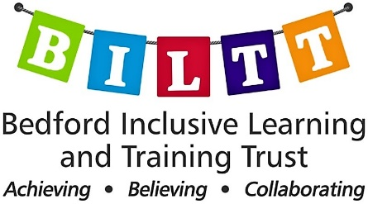

St John’s Special School & College
Austin Canons
Bedford Road
MK42 8AA
sjs.recruitment@biltt.org
https://biltt.org

ASC Instructor/Specialist
37 hours per week Term Time + 5 Training Days
Pay to be discussed at interview
St John’s School provides special education for children and young people with severe, profound and multiple learning difficulties, aged two to nineteen.

We are looking to recruit an enthusiastic, qualified and experienced ASC Instructor to join our team to engage and inspire 2 – 19 year olds with additional needs. Experience in SEND/SLD/PMLD and ASC is required.
The hours are 37 per week, term time only plus 5 training days or twilight sessions. Part-time hours would be considered. Hours to be decided and include a half hour unpaid lunch break, lunch duty/lunchtime club and/or after school club. Core hours of 8.45 am to 3.30 pm.
Start date: ASAP
Closing date: 9am Wednesday 1st November 2023
Interviews: Tuesday 7th November 2023
Teacher training could be offered to a suitably qualified, committed candidate. Membership of the Local Government Pension Scheme is offered.
What we can offer you:

- 183 incredible young people with severe and complex learning difficulties, aged 2-19
- A real commitment to staff wellbeing
- A specialist, determined, committed and friendly staff team
- A thorough induction programme and continuing professional development that is responsive to individual needs, interests, and aspirations
- A well-resourced and inspiring learning environment
- A school that is part of a dynamic multi-academy trust (BILTT). BILTT has been selected to set up and operate a new Free Special School, which will create many exciting future opportunities.
- New challenges every day – balanced with lots of joy!

For further details for the above post please email sjs.recruitment@biltt.org
The post is subject to satisfactory references, social media checks, enhanced DBS & health clearance and a 6-month probationary period. Visits to the school are welcomed and encouraged.
BILTT is committed to Safeguarding, Prevent, the welfare of pupils and ensuring equality of opportunity for all pupils, staff, parents and carers; irrespective of age, disability, gender reassignment, marriage & civil partnership, pregnancy & maternity, race, belief, sex or sexual orientation and expects staff to share that reassignment, marriage & civil partnership, pregnancy & maternity, race, belief, sex or sexual orientation and expects staff to share that commitment.

