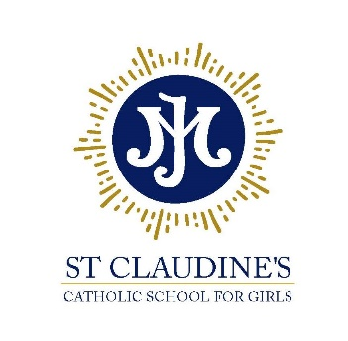

Diocese of Westminster Academy Trust

St Claudine’s Catholic School for Girls
Crownhill Road, London NW10 4EP
Tel: 020 8965 2986 | email: office@stclaudines.co.uk
Headteacher: Dr L McGowan, BMus (Hons) MA EdD NPQH FRSA

Championing excellence and equality in all-girls’ education

School Admissions Officer

Scale Point SO2, Range 26-28, starting on Scale Point 26, 40 weeks per year – 38 weeks term time plus 5 INSET days and one additional week, permanent contract

Required for: September 2024
Closing date: 12th July 2024
Interviews: 17th July 2024

*******

St Claudine’s Catholic School for Girls is a highly-successful Catholic girls’ comprehensive school (ages 11-19), where behaviour is outstanding and students are educated via a rich and diverse, holistic curriculum to become confident, articulate and independent young women.

We require a skilled and preferably experienced School Admissions Officer to undertake this important role. The role will also encompass data work on Arbor, our management information system and will involve meeting with prospective parents and students and being present at our open events for recruiting students to the school. The role will also encompass some administration work to support and assist the school’s SEND department
This critical role requires attention to detail, a calm and methodical approach, accuracy and the ability to work under pressure during busy seasons. Candidates should have excellent ICT skills and administration competencies.

Learning at St Claudine’s is rooted in the Gospel values in a warm, supportive and nurturing community. Even though we are a Catholic School, it is not a requirement to be Catholic and our international community welcomes staff and students of all faiths and none.

Further details of this post are available on the school website.

St Claudine’s is committed to the safeguarding and welfare of its students. All school staff are required to undertake an enhanced DBS check and safeguarding training.

