Qualifications we will accept (LSA roles and above):
English | Maths
English Language or English Literature  GCSE / IGCSE grade 4 or above (C or above)  O level grade C or above  CSE grade 1 | Maths, Further Maths or Arithmetic  GCSE / IGCSE grade 4 or above (C or above)  O level grade C or above  CSE grade 1
Level 2 Functional Skills English - Pass | Level 2 Functional Skills Maths - Pass
Level 2 Key Skills in Communication - Pass | Level 2 Key Skills Application of Number - Pass

Prospective staff who do not have English or Maths qualifications at the right level:
Level 2 qualifications in English and Maths are an essential part of the job specification for an LSA (or any higher role at West SILC).
We will still interview you if you do not have them, but if successful we will not be able to offer you a permanent contract initially. We would offer a temporary contract for 6 months, with the expectation that you will gain the ‘qualification/s’ in that time. Once achieved your contract would become permanent and there would be no need for a further interview. For any legitimate reasons we may extend beyond this period, but any temporary contract will not exceed beyond 18 months, irrespective of the circumstances.
Our recommended process to gain either English and / or Maths at level 2 (and the support we will offer for you):
If you do both, you may want to do one followed by the other, rather than trying to do them both at the same time.
- Register with Reed: https://www.reed.co.uk/courses/functional-skills-maths-level-2-functional-skills-english-level-2/290079#/courses/?keywords=level%202%20functional%20skills%20in%20english
This will cost you £12 (accurate March 24) and will give you access to lessons for Maths and English so mini tests and a final assessment but as it is only 12 questions its not the proper qualification, you will then move to step 2.

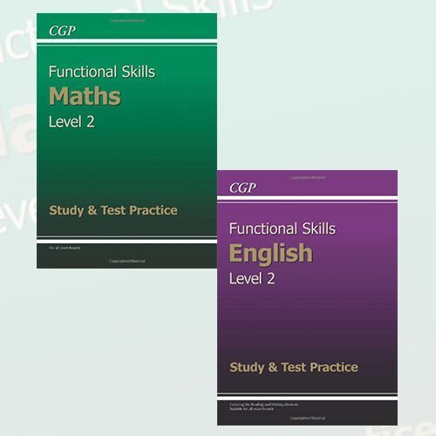
Once you have completed these and you share screen shots of your results, we will buy you: Functional Skills Level 2 Study & Test Practice Collection 2 Books Set (Functional Skills Maths Level 2 - Study & Test Practice, Functional Skills English Level 2 - Study & Test Practice)
Functional Skills Level 2 Study & Test Practice Collection 2 Books Set (Functional Skills Maths Level 2 - Study & Test Practice, Functional Skills English Level 2 - Study & Test Practice): Amazon.co.uk: 9787421175371: Books
Use these to practice an prepare for the full ‘exam paper’. If you are stuck with anything and would like some 1-1 support, please raise with HR or SLT.

- Once you are ready you will sit the actual paper in school with a member of SLT under exam conditions. This will be marked by school.

- Once you pass our exam, within the time scales, you will be offered a permanent contract.

- Having done all this preparation and learning, if you wish to sit the papers formally with exam board Pearsons we can formally enter you for the exam (we will pay the fee) - usually held monthly. Please not this is not necessary for your contract but you may want to gain the formal qualification.

